Overthrown “Communists” in Nepal Defeated by Liberal Landslide
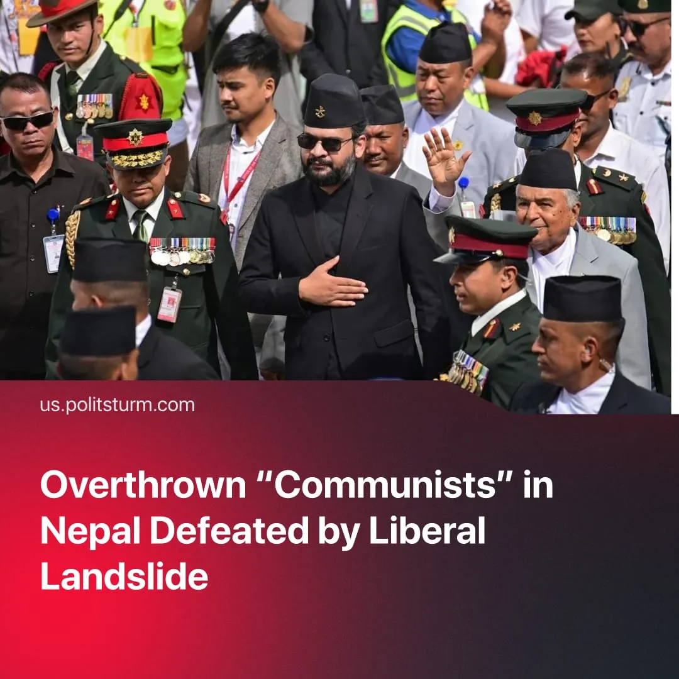

Original article
2026-03-23
2 min read

Nepal’s pro-Chinese opportunists enabled a liberal victory. The new right-wing ruling party secured a majority not seen since 1991.
Details. Balendra Shah – a rapper-turned political candidate of the 3-year-old, liberal-leaning National Independent Party (RSP) – became prime minister, with his party winning 182 out of 275 seats in the federal parliament. Such a majority has not been seen since 1991.
► The overthrown 'Communist Party of Nepal (United Marxist-Leninist)' finished far behind with 22 seats, while the newly formed Nepali Communist Party gained 16 seats, and the centrist Nepali Congress won 37. Voter turnout was around 60%.
► The RSP’s programme focuses on administrative reforms aimed at preventing the concentration of power and corruption. Notably, the party proposes to reshape its leadership by limiting it to two terms and introducing mandatory bill review procedures.
► The party’s economic promises are framed within a liberal, market-driven model: private-sector-led job creation, curbing cartels, and support for businesses, alongside limited state intervention under what they call a “social market economy.” For example, assets identified as “illegally acquired” would be nationalised.
Context. The RSP was founded in June 2022 around Rabi Lamichhane, a former TV journalist and media shareholder. The party won 20 seats in parliament in 2022 and entered government twice, forming coalitions with both the Maoists and the UML. Even before the protests, the RSP had adopted a liberal-centrist rhetoric focused on youth and anti-corruption, favouring political debate over mass mobilisation.
► The overthrown 'CPN (UML)' is an opportunist party representing the interests of the pro-Chinese Nepali bourgeoisie. Under its leadership, Nepal saw over 10% unemployment and rising social inequality, while the government signed agreements with China under the Belt and Road Initiative.
► In 2025, mass “anti-corruption” protests broke out across Nepal, triggered by mounting frustration over unemployment, rising inequality, and repeated corruption scandals under the 'CPN (UML)' government. The movement drew tens of thousands, mainly young people, into major cities, escalating into clashes with police, leaving 19 dead and 200 injured, intensifying the crisis and leading to the seizure of government buildings, paralysis of parliament, and the government’s resignation.
► Despite promises to fight corruption, improve living standards, and create jobs, the transitional government failed to improve living conditions, leaving the task to a future elected government. Many Gen Z protesters expressed frustration with the government they had helped bring to power.
Important to Know. The RSP government will not resolve the contradictions of capitalism that gave rise to the uprising. The turnout indicates that the masses have cooled. The liberals, aided by existing opportunist pseudo communists, will now seek to demobilise workers and prevent the formation of any real communist alternative.
► The opportunism of the CPN (UML), alongside the proliferation of other opportunist “communist” parties, discredits communist leadership and shows how revisionism weakens the workers’ movement and aids the capitalist ruling class.

Original article

