Clarifying The Position, Pt.1: British Communist Organizations on the Russia-Ukraine Crisis
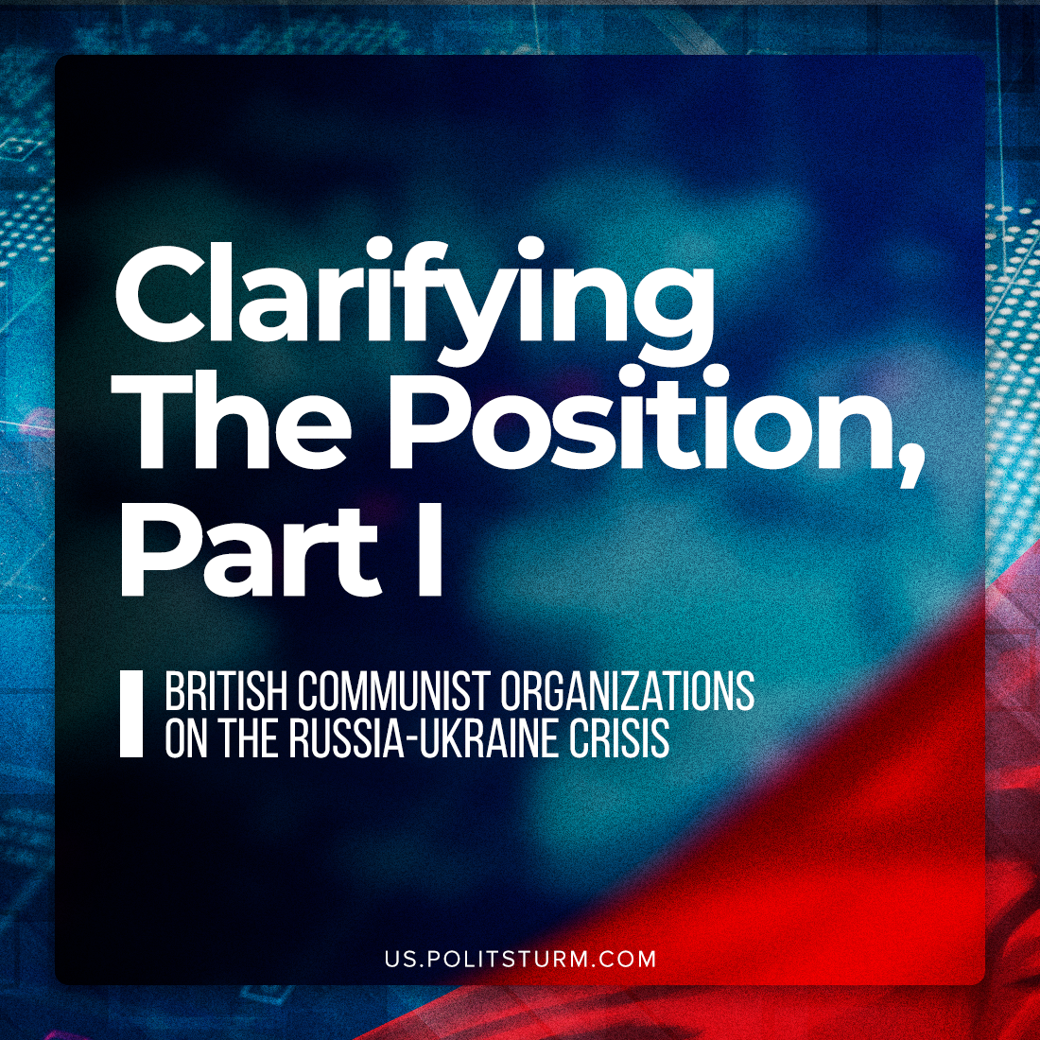

Original article
2022-03-21
6 min read

Following the beginning of the so-called “special operation” launched by Russia, some communist groups in Britain have endeavored to forge their position on the events that now engulf the Ukrainian and Russian workers. This material of ours is opening a series of publications, reviewing the positions of the communist organizations in different countries.
The Communist Party of Britain posted their statement, claiming that the current events are one of inter-imperialist competition between the NATO bloc and Russia. As such it has repeatedly called on both Russia and Ukraine to implement a ceasefire and is resolutely opposed to any escalation by NATO, further adding that they ‘express [their] solidarity with the working classes of Ukraine and Russia who will pay the heaviest price for this instance of Russian military adventurism’. Its youth branch the Young Communist League has gone further and reiterated the CPB’s policy of withdrawing the United Kingdom from NATO and ending all the imperialist policies of the British bourgeoisie.
Unfortunately, this position is more of a lucky coincidence, then of being consistent, as the CPB seems to be standing on the positions of right-wing opportunism. For example, it supports imperialist regime in China.
And PRC is profiting and collaborating with both sides of those events. While Russia’s ties are well known, PRC was communicating well with the regime which is claimed to be “neo-Nazi” by the Russian government. Just 6 months ago the representative of the current ruling party in Ukraine said “they will adapt the experience of CCP”. MP Arakhamiya said he even read “Xi Jinping’s book on the state management” and supported its publication in Ukrainian.
Similar to the CPB, Red Fightback (an up and coming group) has squarely pointed out that there is an inter-imperialist whiff in the air. In its Twitter account, the group has stated its opposition to any NATO aggression and called for proletarian resistance towards any attempt at an escalation. However, its condemnation has very little extending to the Russian bourgeoisie. Russia is mentioned only as being “threatened by NATO” and “competing to supply Europe”. Red Fightback takes aim solely at Britain and her imperialist allies: the US and EU, stating: ‘Leave the working and oppressed people of Russia, Ukraine, Europe and the U.S. to fight their bourgeois classes. We’ll handle ours.’

What is going on in Ukraine? Why is this happening, and what should we do? pic.twitter.com/tvApWuP505
— Red Fightback (@RedFightback) February 24, 2022

Taking into account the fact that a lot of Western social-chauvinists point on NATO as the biggest evil and Russia as “progressive side”, it’s very important to uncover the real way of things. The Western “democracies” and the Russian Federation (as a part of the Chinese bloc) are imperialists. It’s obvious now that despite the brave words, both sides used the conflict to increase nationalist, chauvinist, anti-communist hysteria in their countries, and the working masses in the West and in the East are losing.
Whilst undoubtedly the actions of communists must be directed the bourgeoisie of their own nation first, Marxist-Leninists are also fierce internationalists; neglecting to extend their fraternal solidarity to the Russian and Ukrainian proletariat is an oversight that might lead to opportunists advocating for a line that alienates comrades in different countries.
This is not mere rhetoric: the Communist Party of Great Britain (Marxist-Leninist) and its front the Workers Party of Britain have in essence lent its support to the Russian bourgeoisie as it believes that NATO is the only imperialist bloc and as such all criticism must be directed against it.
In fact, the CPGB-ML has actually spoken warmly of Putin’s Russia. They praise him, claiming that under his reign ‘key sectors of the economy came into state ownership, oligarchs found themselves in the dock or forced to flee justice and Russia began to reassert her national dignity on the world stage.’ Clear admiration for the man that has worked hand-in-hand with the Russian oligarchs and their parasitic exploitation of the former Soviet proletariat. This can be attributed from its links to Russia Today – a Kremlin-supported news organization, thus one must wonder if these rosy words are due to this relationship.
Instead of a mature and detailed analysis of the nature of this conflict between two capitalist nations, the CPGB-ML spends most of its breath attacking the decades long encirclement of Russia by NATO forces, a very correct fact to point out, to be sure but this obfuscates the nature of this conflict (an inter-imperialist one): implying that revolutionary defeatism means not working to undermine one’s own bourgeoisie but the explicit desire for an opposing imperialist power to be victorious.
Such an approach is called social-chauvinism, and this is exactly how most social-democrats acted 100 years ago. Such an approach is unacceptable for every conscious communist. This is dangerous, as it will alienate the Russian proletariat from their comrades who they believe is supporting the bourgeoisie that is sending them to die and suffer as sanctions bite hard. There can be no proletarian internationalism between Russian, Ukrainian and Western workers if such “communists” openly wish for the triumph of the Russian capital.
And all of that happens while the international communists across the world have an objective view on the situation. The “Urgent Joint Statement of Communist and Workers’ Parties”, signed by such parties as CP of Greece and CP of Turkey, shows the real positions of proletarian internationalism. Our position on the Russian military operation shows the same main principles: this is a clash between two imperialist camps, and none of them is “progressive”. You can take a look at what “progressive” Russia is actually doing with its Soviet legacy here and here:

Western social-chauvinists: “Russia is progressive and almost socialist”.
Russia: demolishing Lenin’s monument with a sign on it saying “Let’s Defend Peace!”. pic.twitter.com/12o1hvhWXh
— Politsturm International (@PolitsturmInter) March 17, 2022

As can be inferred, communist groups in Britain leave much to be desired, especially the CPGB-ML. Not all the organizations are shown in this material, but those currents are typical. On one side we have truly communist position, defending proletarian internationalism and objective point of view, supported by the active communists across the world. On the other: openly social-chauvinist rhetoric, justifying alliances with one imperialist against another, and “centrist” position, standing very close to the social-chauvinist one.
With dedication and a mature understanding of Marxist and Leninist observation of capitalism in its monopoly stage, communists can use the aggravated contradictions between and within imperialist blocs and establish socialism which is the only way wars can be abolished and true peace can be established.

Original article

