One Year of Fascisation Since Kirk Assassination
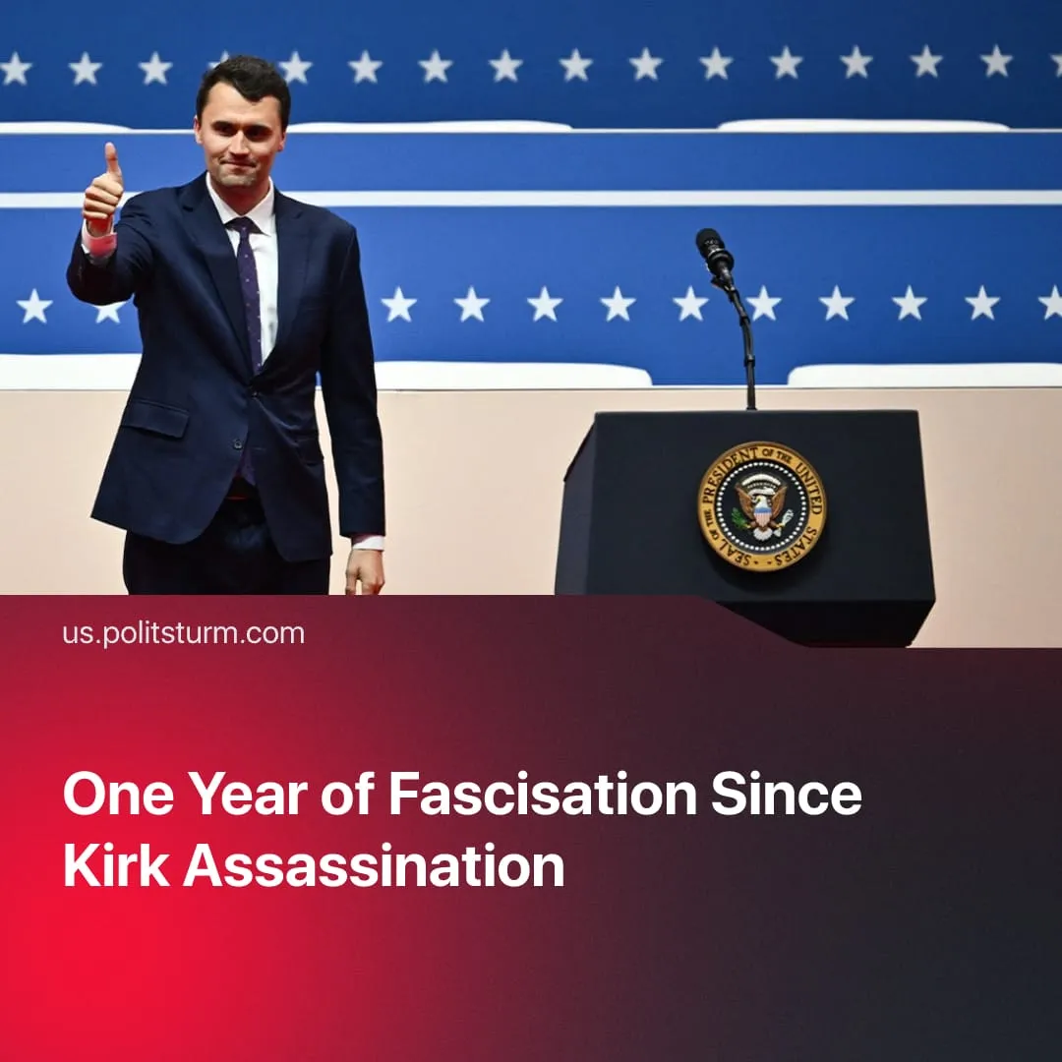

Original article
2026-09-10
3 min read

Charlie Kirk’s assassination one year ago has been exploited by the Trump administration to expand the US police state, ban anti-fascism, and purge the media.
Details. One year ago today, Turning Point USA chief Charlie Kirk was assassinated while speaking at Utah Valley University. The Trump administration immediately weaponised his death, declaring a national day of mourning, flying flags at half-staff, and at his memorial promoting Kirk as a "martyr" for reactionary American nationalism. In the year that followed, his killing has been repeatedly invoked to justify the expansion of US government powers and a surge in far-right militarism.
► Kirk's alleged assassin, who didn't identify with any specific ideology, now faces the death penalty. His act was used to justify a legal crackdown on "radical left maniacs" – the US banned "Antifa," declaring opposition to fascists "terrorism," a way to make communist activity illegal. Immediately after the assassination, the Pentagon began planning a military recruitment campaign centred around Kirk, with the slogan "Charlie awakened a generation of warriors", and Turning Point USA chapters used as enlistment centres.
► Unfriendly media voices were suppressed. Trump threatened federal licensing removals to get ABC to take Jimmy Kimmel off the air, following his critical comments about Kirk’s death. Similarly, a journalist at Jeff Bezos’ Washington Post was fired for refusing to mourn Kirk. Judges found that Trump stifled First Amendment free speech rights 75 times.
► Meanwhile, Trump has consolidated his control of the Department of Justice, using it to suppress political opponents and cover up the Epstein files. Monthly ICE arrests are at their highest level recorded, and inmate deaths in ICE detention camps are surging.
► The US State Department has begun regularly posting anti-communist propaganda, calling the movement a “mortal threat” and “the greatest danger to our country” as if we were at the peak of the Cold War and the USSR were still around.
► In July, the 250th anniversary of US independence was used to further promote nationalism. Hundreds of fascist “Patriot Front” members were allowed to march in Washington DC to celebrate, without any condemnation by the US government. Instead, Trump’s speech at the 250th event denounced “communists”, despite no genuine Communist Party being active in the USA.
► Republicans have been preparing emergency powers and district manipulation to secure a MAGA victory in the upcoming Midterms, where they are forecast to suffer heavy losses driven by the Iran war and worsening living conditions. Trump also announced a $5,000 “dividend” would be given to every American adult if Republicans retain Congress.
► On the first anniversary, Trump used the Republican National Convention in Dallas to deliver a tribute to Kirk, stating "a far-left extremist assassinated my great friend… because Charlie Kirk spoke the truth" and using the occasion to mobilize voters against Democrats ahead of the Midterms, saying "those same people are trying to get power over you in this election".
Context. Historically, similar authoritarian measures constituted the process of fascisation in the lead-up to WWII – whereby the ruling capitalist class moves toward the open terroristic dictatorship of reactionary finance capital through the gradual disintegration of democratic forms, the merger of corporate and state interests, concentration of executive power, and militarisation of public life.
► Just like the US today, in the 1930s, both Nazi Germany and the "democratic" French Republic used repressive laws to criminalise anti-fascism and ban the Communist Party. Already in 1927, the communists knew where this was leading. In that year, Stalin explained why the capitalists resort to open dictatorship:
Quote: “No capitalist country can wage a serious war without first strengthening its own rear, without first curbing its ‘own’ workers, without first curbing its ‘own’ colonies. Hence the gradual fascisation of the policy of the bourgeois governments”.
► As representatives of the capitalist class, both the Democrats and Republicans have contributed to fascisation during their terms. Biden raised military spending to $850bn, armed Israel, suppressed Palestine protests, crushed a rail workers' strike, and expanded ICE – carrying out more deportations in his final year than Trump's first-term peak.

Original article

