One Million Infected in the United States
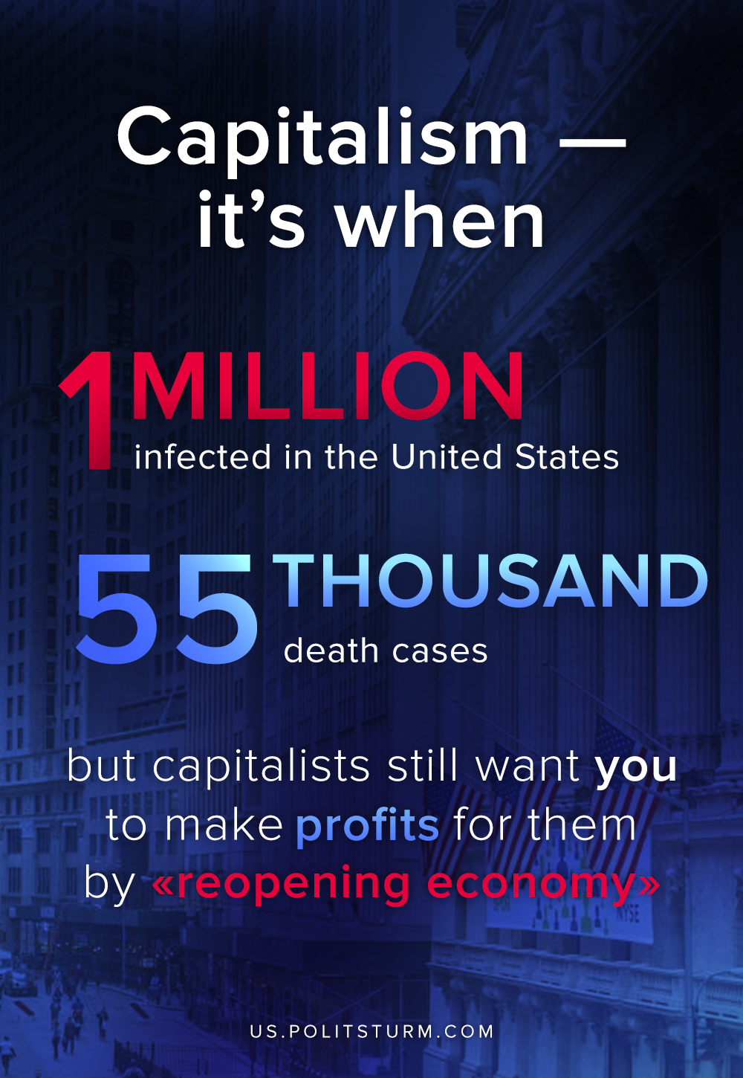

Original article
2020-04-28

Meanwhile Treasury Secretary wants U.S. economy to reopen in May and June

Original article

