One in Seven Children in Italy Are Now in Poverty
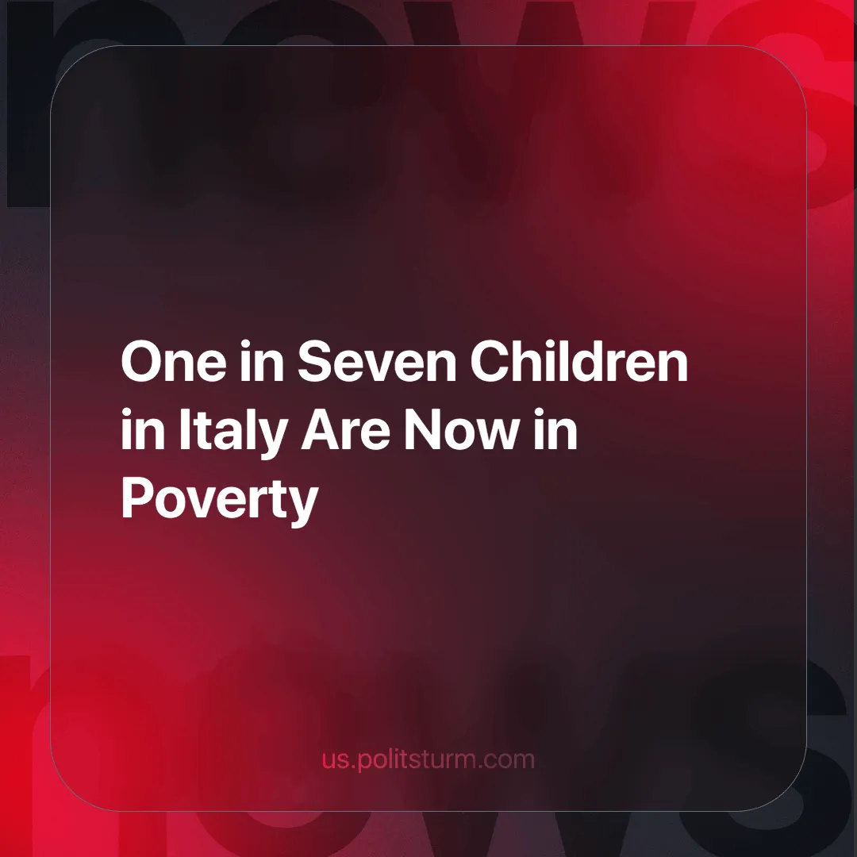

Original article
2024-06-19
4 min read

Recently, ISTAT, the Italian National Institute of Statistics, which handles general censuses of population, services and industry, agriculture, household sample surveys and general economic surveys at the national level, published a report on absolute poverty in Italy revealing an alarming increase in poverty among children, with an incidence of 14% in 2023, or one in seven children. This is the highest poverty level since 2014. This figure is not surprising but rather confirms the contradictions and class disparities inherent in the capitalist system. Many Italians think it is only their country's problem, an exclusive peculiarity inherent only to their country. Of course, every capitalist country has its own characteristics, but the problems in every country are always in essence very similar. It certainly has nothing to do with the Italians' thinking that only Italy is made that way [1].
As mentioned above, ISTAT concluded that 14% of children live in poverty, but how reliable is this figure really? The absolute poverty line, which varies by geographical area and family composition, does not always reflect the true cost of living, nor does it consider unexpected expenses that can plunge a family into poverty. Relative poverty, which includes those living on an income below 60% of the national median, was 22.5% in 2023, highlighting a broader picture of poverty. In addition, 13.5% of children under 16 lived in material and social deprivation, which is higher than the EU average. The youth unemployment rate, above 27%, also indicates widespread economic hardship not always captured by official statistics [2] [3].
This situation also exacerbated the “Southern Question,” the economic gap between northern and southern Italy, which historically even led to a split in the labor movement.
Analyzing the situation through the lens of Marxism, several critical aspects emerge that highlight how capitalism perpetuates inequality and exploitation, hitting the most vulnerable, including the working-class youth, hard. Returning to the topic we wrote about a few months ago about the mafia in Italy, we can again see that the very conditions of capitalism lead to the creation of ever new generations in which crime, the mafia, increased drug trafficking and street death are increasingly common. In addition, we can see unemployment, child labor, poverty, discord between different nationalities, social degradation and fragmentation rising. This is due not only to Italy's particular circumstances, as these trends can be observed across the rest of Europe and the World. The increase in child poverty in Italy is a concrete manifestation of this dynamic. Child poverty has an especially devastating impact on the reproduction of the future labor force.
The low birth rate is directly caused by this social degradation, economic instability; families increasingly think first about providing for themselves and their partners before thinking about children. This is proven by the survey also conducted by ISTAT on having children. According to ISTAT data, the birth rate in our country is at an all-time low. In 2022, births fell below the threshold of 400,000. When polled, 42% of Italians, if they could, would have a child but fears over economic stability and lack of growth prospects for young people weigh heavily. One in two Italians believe that having children risks seriously damaging a woman's career [4]. Lack of access to education and adequate health services deprives children of the opportunities they need to develop their skills. Inequality and lack of opportunity lead many people to seek success through criminal acts, others by drowning in drug addiction, and still others by finding solace for their misery in religion.
Save the Children (STC), is one of the largest international organizations with consultative status with the United Nations Economic and Social Council. It claims to be an independent, nonprofit nongovernmental organization (NGO), but this is questioned as it has sometimes been found to be involved in acts of corruption [5]. This published a research study “Domani (Im)possibili” (Tomorrows (Im)possible) which shows that 67.4% of young people aged 15 to 16 in poverty fear that future work will not lift them out of poverty. The lack of hope and real opportunities to get out of their condition shows how the capitalist system not only fails to provide resources but also fails to nurture the aspirations and talents of young people. More than ¼ of poor young people think they will not finish school, reflecting a deep disillusionment about the possibilities for their improvement through education [6]. Under the rule of capital, education loses value and economic success appears more attainable through get-rich-quick schemes, the promotion of entrepreneurial endeavors, and illicit means than through honest work and effort. It is self-evident to most people that the richest people within society did not earn their wealth by stint of hard labour.
In conclusion, we can see what capitalism leads to. Young people are forced to sacrifice their childhood, their human potential, and schooling in order to survive, while private capitalist profit grows. The only way to change the future of humanity is to change the socioeconomic system – the destruction of capitalism and the establishment of socialism is the only way for humanity to survive. As Lenin said:
“Outside of socialism there is no deliverance of humanity from wars, from hunger, from the destruction of still more millions and millions of human beings.”
To do this the workers, the proletariat, the truly revolutionary social class capable of changing society must unite in a communist party, in order to affect events in a cohesive and coherent way. Join us.
Sources:
- savethechildren.it - “Povertà assoluta: in aumento tra i minori in Italia” dated May 15, 2024;
- istat.it - “Stime preliminari povertà assoluta e spese per consumo - anno 2023” dated March 25, 2024;
- ansa.it - “Save The Children: un ragazzo su 10 in povertà, il 67,4% teme di non uscirne” dated May 31, 2024;
- tg24.sky.it - “Sondaggio, per oltre un italino su 2 avere un figlio danneggia la carriera di una donna” dated April 17, 2023;
- antonioamorosi.it - “Save the Children, tutti i conflitti di interesse nel business immigrati con i soldi degli Italiani” dated August 17, 2017;
- ansa.it - “Almost 10% of 15/16-yr-olds in poverty - Save The Children” dated May 30, 2024.

Original article

