One in Five Renters Behind on Rent
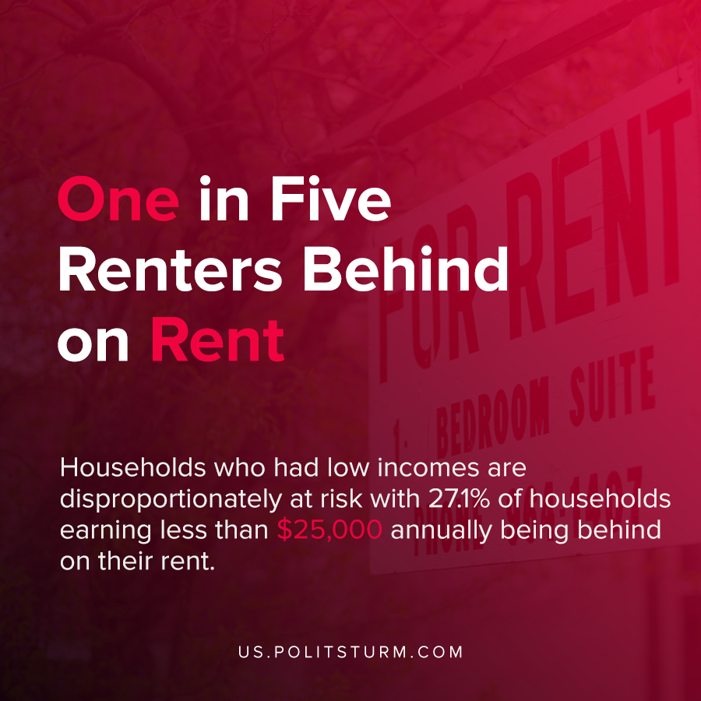

Original article
2021-03-06
1 min read

New research suggests that the housing situation for many Americans is precarious, notwithstanding the looming expiration of the CDC eviction moratorium. As of December 2020, over 11 million renters and homeowners were past due on their housing payments.
Households who had low incomes are disproportionately at risk with 27.1% of households earning less than $25,000 annually being behind on their rent. Renters are collectively behind by $44.1 billion, which on average is three months rent.
Nearly one in five renters in the United States were behind on their rent payments. Insecurity in housing can lead to homelessness, chronic health conditions, depression, and many other negative consequences.
In an effort to prevent evictions during the coronavirus pandemic, the CDC issued a moratorium on evictions. The CDC eviction moratorium is set to expire at the end of the month, and the current legislation is unable to extend it.
The most recent crisis has further strained the lower-wage workers who are at the greatest risk of eviction. Under capitalism, housing is a commodity which serves to enrich the landlords and capitalists. If workers lose their employment they risk eviction or homelessness for themselves and their families. Only through the elimination of private ownership of the means of production and housing can workers have stable housing that is not founded upon exploitation and profit.
Source: 1 , 2

Original article

