On the Military Insurgency in Russia
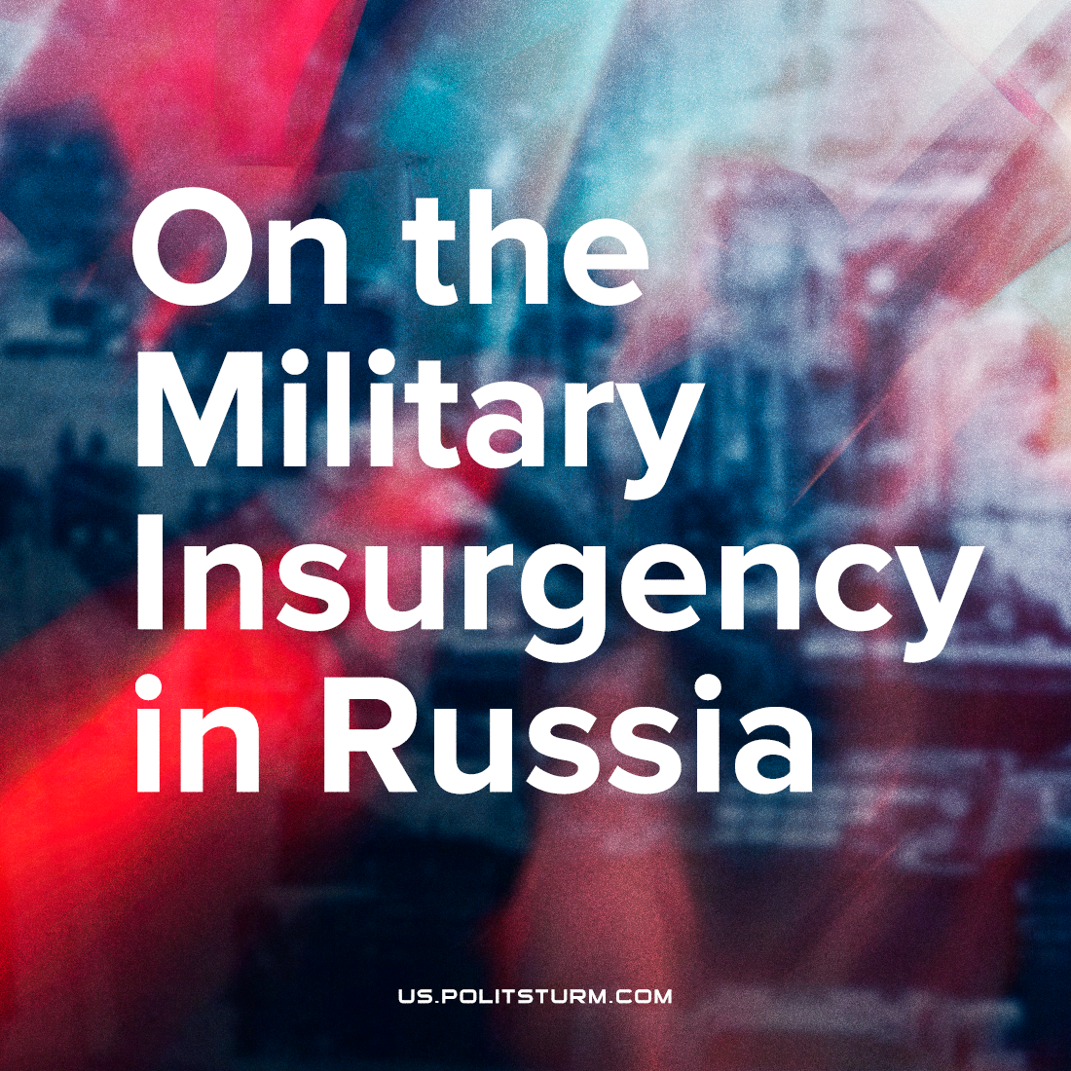

Original article
2023-06-24
1 min read

1. The unfolding events are the result of contradictions that have accumulated in Russia for decades and were intensified by the military conflict that began in 2022.
2. Prigozhin's actions are characterized by an aggravation of the struggle of individual factions within the capitalist camp. Each side is trying to appeal to the masses and gain public support.
3. Regardless of the outcome of these events, the workers and broad masses of the Russian population will lose. The struggle between the representatives of the ruling class will inevitably lead to a worsening of the situation of the people.
4. Once again, the main shortcoming of the Russian communist movement – the lack of a vanguard party – becomes apparent. It is only possible to seriously influence events in the interests of workers and communists if there is a strong organization.
5. Communists must refrain from mindless actions, hysterical urges, or passive observation "from above", as single-minded revisionist groups and bloggers try to do.
6. The main tasks of the current day remain the same:
– Communist agitation and propaganda;
– Fighting against all kinds of distortions, against those who capitulate to bourgeois theories and represent their interests in the communist and workers' movements;
– Uniting workers and communists into a single organization;
– Creating a Communist Party.
Make the right choice – support Politsturm.

Original article

