On the Capitalist Democracy


Original article
2021-07-17
5 min read

“Democracy” – how much freedom we have in this word! Freedom of elections, freedom of conscience, freedom of speech. But is there real freedom in bourgeois democratic elections? In capitalist society every citizen of this or that state is supposed to be equal under law. According to bourgeois constitutions, all power belongs to people. Is it so? In this article we will analyze such concepts as bourgeois democracy and principles of elections under capitalism.
Bourgeois democracy its one of the forms of political structure of the capitalist state. It originates from the victory of the bourgeois revolutions in England and France. This process continued for several decades, during which people masses fought hard for consistent realization of ideas of democracy, which have been proclaimed by the radical thinkers of revolutionary bourgeoisie.
The economic basis of bourgeois democracy is the prerequisites of the capitalist mode of production, such as the ability to buy and sell labor, the exchange of goods in the market according to the law of value. Whole complex of institutions of bourgeois democracy has been formed on this basis. For example: universal suffrage, separation of powers and official recognition of legislative power, individual rights and freedoms, active and passive suffrage, inviolability of person and home, secrecy of correspondence, freedom of conscience, freedom of speech, press, assembly, movement, public trial and trial by jury in the organization of the judicial system, system of elected local government, etc.
However, democratic institutions under capitalist conditions are inevitably limited and in many ways hypocritical and deceitful, since the formal equality in the political sphere proclaimed by democracy is in irreconcilable contradiction with the economic system of capitalist society with its exploitation and oppression. The benefits of individual freedom are enjoyed above all by the wealthy; freedom often becomes an empty word for those who are forced to earn their livelihood by their hard labor.
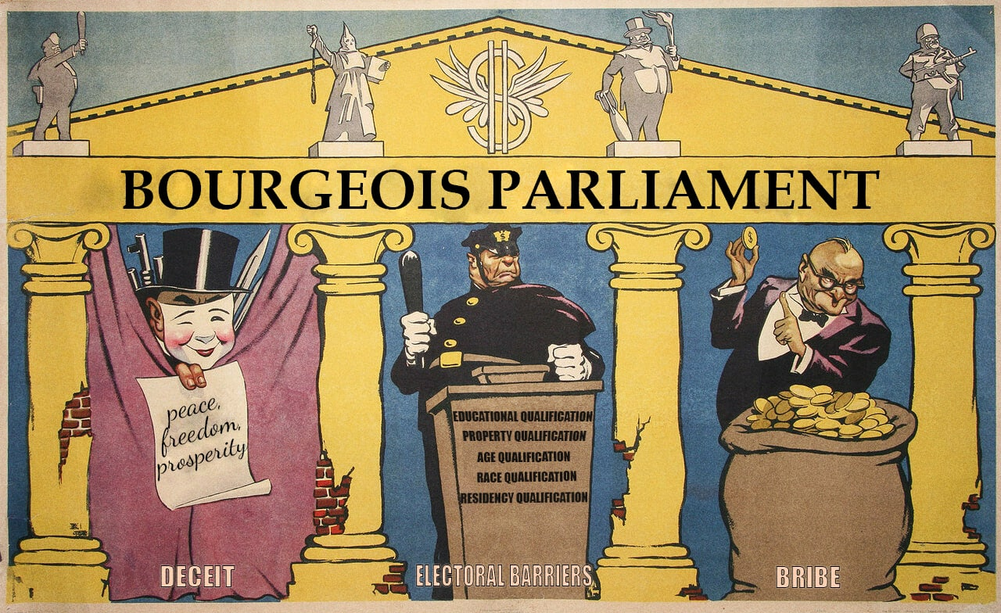
“Bourgeois Parliament”, a Soviet poster by Briskin and Ivanov, 1954. (translated)
The oligarchy (the bourgeoisie) owns media platforms and therefore has the power to promote their values. They pass laws to suit themselves and dictate their conditions to society. Their representatives legitimize economic exploitation and create a fiction of a stable society.
Why do they create this fiction? To avoid revolutions! Stalin said about bourgeois democracy: “Earlier, the bourgeoisie presented themselves as liberal, they were for bourgeois democratic freedom and in that way gained popularity with the people. Now there is not one remaining trace of liberalism. There is no such thing as “freedom of personality” any more, – personal rights are now only acknowledged by them, the owners of capital, – all the other citizens are regarded as raw materials, that are only for exploitation. The principle of equal rights for people and nations is trodden in the dust and it is replaced by the principle of “Full rights for the exploiting minority and the lack of rights for the exploited majority of the citizens”. The banner of bourgeois democratic freedom has been flung overboard. I think that you, the representatives of communist and democratic parties must pick up this banner and carry it forward if you want to gain the majority of the people. There is nobody else to raise it.”
As for elections in so-called bourgeois democracy: only personalities and parties change from the results of elections, but the system remains the same. Whoever wins, the exploited will remain exploited, and the masters will remain masters.
The nominated candidates undergo a complicated and expensive nomination process, which, in addition to being a de facto property census, also makes it easy to find a formal reason to remove any undesirable candidates. That is why any of the admitted candidates is known to be quite satisfactory to the capital. Politicians are not accountable for their promises to the people, except to the bourgeois elite.
Lenin wrote: “Once every few years to decide which member of the ruling class will suppress, crush the people in parliament – this is the real essence of bourgeois parliamentarism, not only in parliamentary-constitutional monarchies, but also in the most democratic republics".
In an effort to hold on to power, elected representatives pass laws that may temporarily make people’s lives easier, which will ensure the image of such representatives at the time of the next vote. But after the election, the new laws already elected representatives pass laws that may temporarily make people’s lives easier, which will ensure the image of such representatives at the time of the next vote. But after the election, the new laws already violate the stability that they supposedly created in society.
Thus, bourgeois democracy is a legalized method of economic exploitation, the rule of the rich by the poor. Any bourgeois regime satisfies the interests of only one class – the class of capitalists and exploiters.
However, it doesn’t mean that the workers are helpless under bourgeois democracy. In order to influence the capitalist system using all possible methods, the workers and communists must have the main thing – the Communist Party. Being the vanguard of the proletariat and its class organization, it acts as the leader of the class struggle and serves as a guard against sliding into bourgeois reformism. We advise you to read our material about Lenin’s type of party.
Stay tuned!

Original article

