On The Anti-Communist Attacks in Venezuela And The Essequibo Referendum
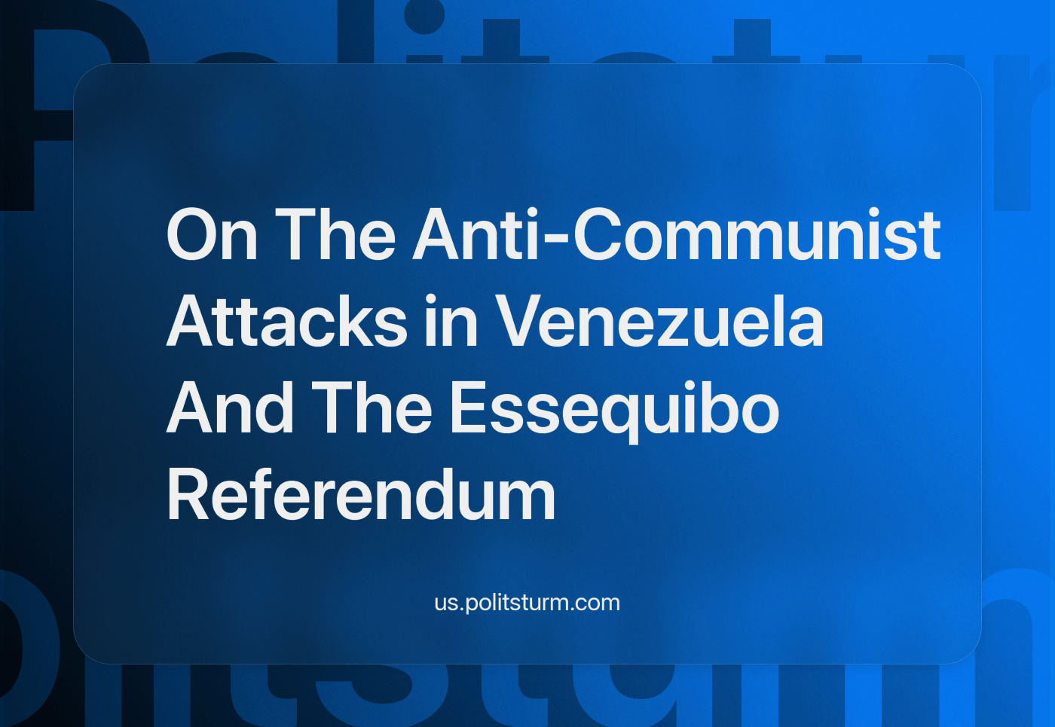

Original article
2023-12-10
13 min read

This summer the Communist Party of Venezuela (PCV) has announced that a group of supporters of the current government requested the judiciary (Supreme Tribunal of Justice) to intervene in their organisation. This follows previous attempts to supplant the PCV with the intention of exposing a supposed internal division of the Party, comprised of an internal faction of Maduro supporters that approve of the government’s alliance with the right-wing opposition [1].
Later, on August 11, 2023, the Supreme Court of Venezuela declared the activities of the PCV illegal and appointed new party leadership to 'eliminate violations'. The party leadership accused PSUV of creating an alternative structure of the PCV locally to usurp the legal name of the Communist Party of Venezuela.
This is not a novel tactic, neither regarding the method nor the underlying conflict: the Supreme Tribunal of Justice (TSJ) already intervened in the left-radical Tupamaro Movement, replacing their directive policy with a pro-government one selected by the judiciary authority back in 2020 during the formation of an alliance between the Tupamaros, the PCV and other political movements in an independent coalition [2].
We already wrote a critique on “Chavism” [3] in which our organisation exposed the causes of the economic crisis of Venezuela as resultant from the conciliatory and reformist character of the “Chavist” political movement the ruling United Socialist Party of Venezuela (PSUV).

The Story Behind The PSUV
The PSUV phenomenon is a part of a bigger Latin-American trend to make charismatic leaders the exclusive centre of political movements (with their military machismo) and distort concepts like anti-imperialism or socialism in order to divorce them from their class revolutionary content. These leader-centric movements have as their goal the subordination of the working-classes struggle to petty-bourgeois reformism.
The breakup between PCV and PSUV became official in 2020 with the creation of a coalition against Maduro’s “neoliberal policies”, known as APR – The People’s Revolutionary Alternative. The split manifested due to the non-fulfilment of an agreement signed between the Chavist United Socialist Party of Venezuela (PSUV) and the Communist Party of Venezuela in 2018. The agreement outlined the “consolidation” of the “socialist Bolivarian” project; a “revolutionary” way out from the current crisis and as the condition for the latter to support Maduro in the presidential elections [4].
The APR suffered official censorship from the media [5] and repression, for instance with the judiciary intervention we mentioned at the beginning, but also “Bolivarian” violence of which they are not the only victims. Recently the World Federation of Trade denounced the Venezuelan state-security organ that abducted and kidnapped two steelworkers’ union representatives [6]. Many other independent labour union leaders had been intimidated, detained, harassed and even murdered with accompanying silence from the government institutions [7].
In sharp contrast with the Venezuelan government’s attitude towards the working-class and their organisations lie their policies towards both the “patriotic” (pro-government) and the “traditional” (old capitalists who opposed Chávez from the beginning) bourgeoisie, and its “socialist” rhetoric.
As the wave of terror against PCV rages on, the capitalists are left untouched. Regarding the “traditional” bourgeoisie, we can see how their main class organisation, the Venezuelan Federation of Chambers of Commerce and Production (FedeCámaras), is allowed to maintain itself as a legal entity and even plans to hold their regular assembly this year in the country [8], despite the fact that this same entity supported the failed coup against Chávez in 2002 [9] and is referred to as a coup plotter organisation by the government [10].
Another expressive example of this relationship is the existence of companies of the Cisneros family which are untouched by repression, including even a nationwide open TV channel [11]. Cisneros is a media conglomerate, based in the US and operating in Latin American countries.
The whole existence of the big bourgeoisie [12], both “old” and “new”, is a demonstrative symptom of the non-socialist character of Chavism, and it doesn’t matter if they reached their position because of market competition and intra-class struggle, as a side effect of the policies of Chávez and Maduro, or by means of state corruption (which is just another unavoidable effect of market competition).
One of the key features of socialism is overcoming capitalist market relations by forming a single binding economic plan, governed by the workers of a country, consciously organized as a class. The elimination of some individual capitalists and their replacement by the other ones, on the contrary, is something that occurs every day, not under socialism, but under “usual” capitalism. This fact applies to any strange theories about any “national” bourgeoisie or self-managed independent cooperatives within a “market socialism” or any other flavour of wage slavery trying to mask its true nature, even with red flags and humanist rhetoric.

The Reality of "Socialism in Venezuela"
Obviously, the capitalists of Venezuela couldn't keep their organisations and properties in the country until today if Chávez was an actual socialist. It’s not that Maduro is just a traitor, as many seem to be inclined to affirm. Even during the Chávez government banking, telecommunications, food industry, commerce and many other economic areas were kept private and market regulated. He didn’t outlaw the very political and economic groups that organized the several coups attempts against his government, but instead he signed a non-aggression and coexistence pact with the head of the Cisneros family in 2004 [11].
At the same time both Chávez and Maduro liked to show their support of Trotsky – world-famous renegade of the communist movement.
In 2007, when the new Minister of Labour said that he was a Trotskyist, Chávez remarked, "Well, what's the problem? I am also a Trotskyist!". The leader of PSUV was also big friends with "International Marxist Tendency" – one of the tens of Trotskyist "internationals".
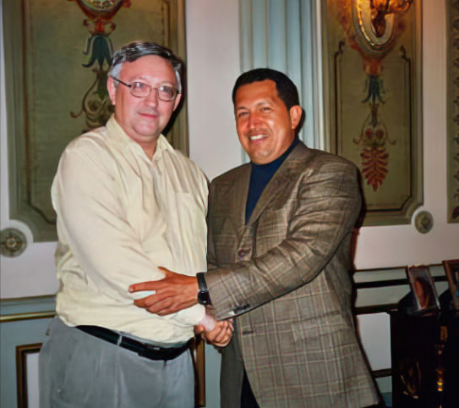
Alan Woods – the leader of the IMT – and Hugo Chavez in late 2000s
On November 7, 2023, the October Revolution Day and Trotsky's birthday, Maduro praised Trotsky as the one of the "greatest Marxists" of the last century.
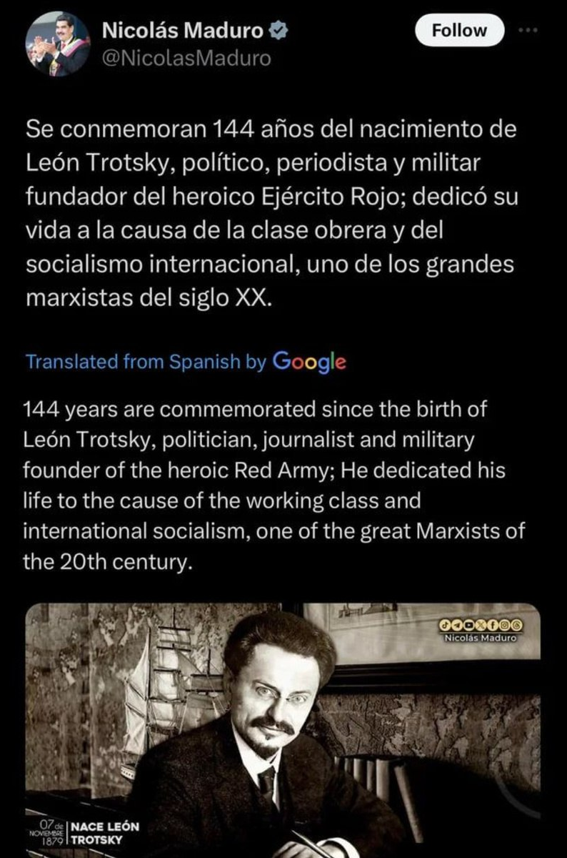
With this background it’s no wonder that Maduro’s government continues performing the sad comedy of starting and breaking negotiations with the right-wing opposition (the political representatives of traditional bourgeoisie) – a Venezuelan tradition since 2014 [13] that is still in place [14].
It should be no surprise from this government which desires so much to seem pro-worker. At the same time, they suppress the Communist Party of Venezuela and bridge both Russian and American capitalists, now that the US oil sanctions have ended in a deal for "fair elections".
These and other things apply to the statement of the Communist Party of Venezuela about the government attack: they only mention their opposition to the current “neoliberal policies” of Maduro [1] but seem to ignore the fact that these are just a consequence of the necessary failure of Chávez reformism, of an attempt to apply Keynesian economic policies after their failure in the 80’s of the past century.
We must remember that:
“The transition from capitalism to communism takes an entire historical epoch. Until this epoch is over, the exploiters inevitably cherish the hope of restoration, and this hope turns into attempts at restoration. After their first serious defeat, the overthrown exploiters—who had not expected their overthrow, never believed it possible, never conceded the thought of it—throw themselves with energy grown tenfold, with furious passion and hatred grown a hundredfold, into the battle for the recovery of the ‘paradise’, of which they were deprived, on behalf of their families, who had been leading such a sweet and easy life and whom now the ‘common herd’ is condemning to ruin and destitution (or to ‘common’ labour...). In the train of the capitalist exploiters follow the wide sections of the petty bourgeoisie, with regard to whom decades of historical experience of all countries testify that they vacillate and hesitate, one day marching behind the proletariat and the next day taking fright at the difficulties of the revolution; that they become panic-stricken at the first defeat or semi-defeat of the workers, grow nervous, run about aimlessly, snivel, and rush from one camp into the other — just like our Mensheviks and Socialist-Revolutionaries.
In these circumstances, in an epoch of desperately acute war, when history presents the question of whether age-old and thousand-year-old privileges are to be or not to be—at such a time to talk about majority and minority, about pure democracy, about dictatorship being unnecessary and about equality between the exploiter and the exploited! What infinite stupidity and abysmal philistinism are needed for this!” — V.I. Lenin, Proletarian Revolution and Renegade Kautsky.
Another comment is necessary about Bolivarianism – the political ideology that mostly centres, apart from opposing US imperialism, on creating a confederation of Latin-American and Caribbean countries as a means to counteract foreign imperialism. Communism recognises the convenience for small countries to ally with bigger ones or to enter in wide political coordination with neighbouring small or medium sized countries. Communists support the peaceful and cooperative integration of all countries on the basis of a new society without class divisions and organised violence, that is, under Communism.
Despite how both projects could appear as complementary, to have a continental integration as a mandatory and non-skippable step before socialism — that is, under capitalism — means to subordinate the struggle of the working peoples for socialism to the interests of national groups of capitalists. Revolutions occur in single countries, as a result of escalated class struggle because of the particular impact of worldwide imperialist crisis in their national economy. It would be delusional to expect parallel successful revolutions in a short time in such a wide region as Latin America with conditions amongst each different countries varying greatly. In fact, it’s more reasonable to expect coordinated counter-revolutionary policies in the vicinity. In addition, it’s cynically opportunistic to tell to the workers of these countries stop fighting for socialism until all of their neighbouring countries unite under a capitalist basis.
Another evident defect of the Bolivarian project is that it doesn’t consider the currently unsolved national problem among Latin-American mestizos and the possible claim for total independence from some indigenous peoples as a legitimate part of their own national self-determination. Communists cannot hide national realities under the identities given by our former colonisers.
It’s important to be conscious of errors and to be able to acknowledge them publicly, but in order to correct and not repeat them we need to investigate and determine their causes.
We hope for the Communist Party of Venezuela to succeed with their struggle against the Venezuelan government’s corruption and anti-worker policies, but that won’t be possible without deep self-criticism: why did it happen that this government was supported for decades?
Communists across the world would only welcome tlear statements about PCV’s positions towards the government, both past and present, and relying on a Marxist-Leninist scientific understanding of reality and class struggle.

The Essequibo Referendum
It is especially important today, as PSUV tries to replace PCV with "loyal" faction and justifies a war for resources.
At the beginning of December this year, the situation around the Essequibo region, which belongs to neighboring Guyana, became widespread in the media. Maduro's government is counting on "national unity" to deflect attention from domestic problems and repressions against communists for the sake of a territory almost the size of Greece and full of a variety of natural resources.
Venezuela's national referendum has ratified its claim on Guyanan Essequibo, which Guyana states is in pursuit of an illegal, unilateral annexation of the majority of its territory.
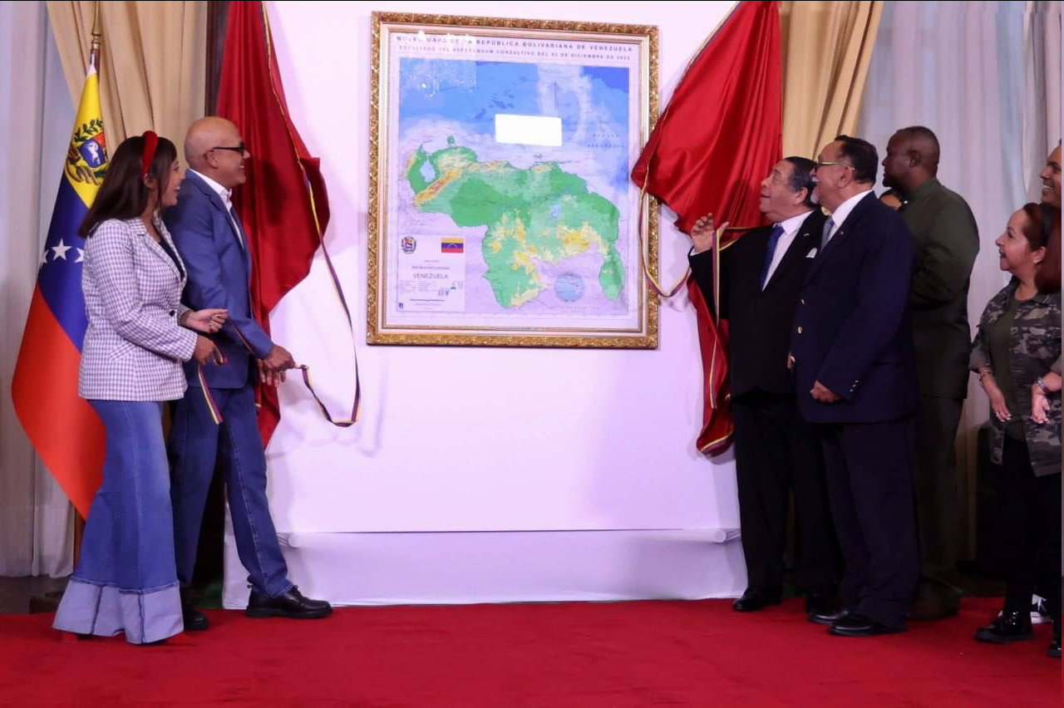
“This is the map of the liberator Simon Bolivar, the map that he liberated with his sword, which we must protect, like every inch of our territory,” said Rodriguez, President of the National Assembly of Venezuela. He said the map should remind Venezuelans that they “are not obligated to defend foreign interests”.
Recently, Guyana has become one of the fastest growing economies in the world due to the discovery and auction of huge oil and gas fields in the maritime area encompassed by Venezuela's claims. Guyanan oil exports more than doubled from 2021 to 2022. Mining of gold and uranium has also expanded in the Essequibo, under Guyanan approval.
For decades, the dispute over the territory has obstructed the expansion of drilling by international oil monopolies. This situation has created a void of undeveloped waters which are hungrily eyed as an easy acquisition by companies on both sides.
America's Exxon has license to huge claims (https://en.ultimasnoticias.com.ve/news/oil-country/Guyana's-huge-debt-and-exxonmobil-with-Venezuela/) in Guyana in conglomerate with Chevron at 30% and China's CNOOC, in an area overlapping the contested waters.
On the Venezuelan side, America's Chevron and China's state-owned CNPC, among a handful of national companies from Russia, Belarus, India, and the EU, hold major oil stakes and facilities like Chevron's offshore Loran platform.
Changing hands of the Essequibo would simply unite monopoly holdings – by both American and Chinese capitalists – separated by the formality of the borders of Guyana and Venezuela. Venezuela's actions will, in the meantime, just undermine the auction prices of Guyana's fields, improving Venezuela's own selling position, and benefiting the monopolies which want to pay the smallest possible amount in licensing costs. This action has united Maduro and the Venezuelan opposition (but not the communists, of course), securing Maduro's political leadership and demonstrating strength to the public.
Whichever side wins out, the multi-national ownership of the oil capital means international finance capitalists have guaranteed access to new fields. Imperialist contradictions continue to play out, worsening antagonisms between neighbors and risking war just to gain the edge over competitors in the world market.
Only a strong Communist Party, the vanguard of the working class, led by Marxist-Leninist theory, can lead a successful struggle against capitalism.
Sources: 1, 2, 3, 4, 5, 6, 7, 8, 9, 10, 11, 12, 13, 14

Original article

