On Putin’s announcement and the dismissal of the Russian government
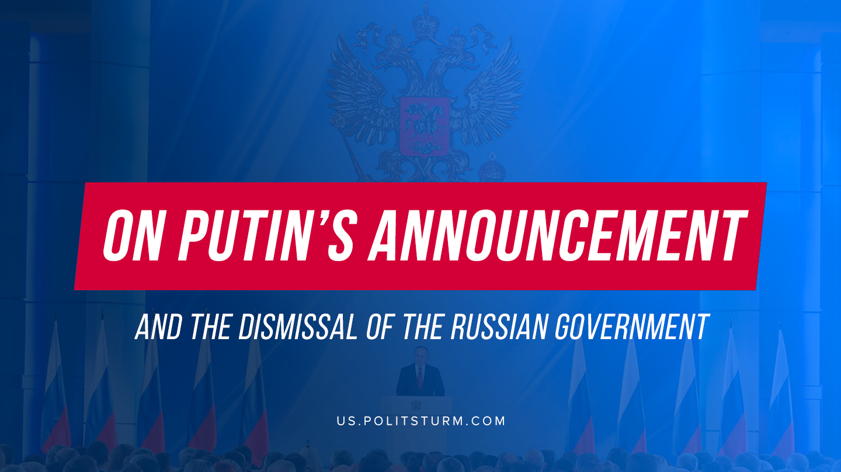

Original article
2020-01-16
5 min read

Putin’s announcement did not portend anything out of the ordinary: standard populist phrases and promises, a game in “national leader” and ostensible concern for the needs of the people.
But in today’s announcement, the president unexpectedly touched on the topic of changing the Constitution and even proposed making amendments to it. Almost immediately after his speech, the Russian government, led by Medvedev, resigned.
What does this mean for the country and how should we relate to this?

Main points of the announcement
Most of the president’s proposals are phrases devoid of meaning and designed for an unconscious layman imbued with petty-bourgeois patriotism.
For example, raising the qualification of settledness, the prohibition of foreign citizenship and residence permits for the country’s leadership, maternity capital for the first child, payments to teachers, benefits for students, repair of hospitals and clinics throughout the country, the proposal to prescribe mandatory indexation of pensions and a minimum rate the amount of wages equivalent to the subsistence minimum in the Constitution – all this is cheap populism.
Separately worth noting is the proposal to grant the parliament the right to approve the Russian government, to ban more than two presidential terms in general (and not just consecutively), on the right of the Federation Council to remove judges of the Supreme and Constitutional Courts, as well as on the right of the Constitutional Court to verify the constitutionality of federal laws before they are signed by the president.
These and other high-profile phrases about ensuring the supremacy of the Constitution are designed to create the illusion of the possibility of the government “democratization” and are designed to draw attention to parliamentary elections with the aim of deceiving the workers.
The most important parts of the message are the proposal to put the Constitution above international law and, at first glance, an inconspicuous phrase about the constitutional status and role of the Council of State, which Putin called the “effective body”.
Currently, the State Council is a deliberative body, which includes speakers of the Council of the Federation and the State Duma, leaders of factions of the lower house of parliament, heads of regions, plenipotentiary representatives of the head of state in the federal districts. The chairman of this body is the president.
It is obvious that a change in the status of the State Council, headed by the president, will significantly increase its political role in the bourgeois state and put it over other authorities.
Given the worsening socio-economic situation in Russia, the growing crisis and the impoverishment of the working class, this decision will strengthen the position of the ruling group of the bourgeoisie, which is preparing for a possible bourgeois coup and future class clashes.

Dismissal of the government
A few hours after Putin’s speech, the Russian government, led by Dmitry Medvedev, resigned with the motivation that the president should be given the opportunity to make “all necessary decisions.”
Putin has already nominated the head of the Federal Tax Service, Mikhail Mishustin, as prime minister, and Medvedev will take the post of deputy chairman of the Security Council.
Such actions reveal the character of a bourgeois state in which democracy and a people’s representation exist only in words, and the capitalists change the laws and take whatever decisions they need, spitting on the needs and interests of the working people.

What’s coming for the working class
Behind the floods of magnificent phrases, populist slogans and democratic promises lies the continuation of the growing tendency of the bourgeois dictatorship strengthening, the fascization of Russia.
The ruling capitalist elite feels its precarious position in the current situation of the growing crisis of capitalism and is striving to strengthen its power by all means, preparing for impending upheavals and class battles.
Will the policy of reducing social guarantees, rising prices and taxes, an attack on the rights of workers with increased repression and bourgeois propaganda cease? Of course not.
Opposite, the bourgeoisie seeks to free its hands in the suppression of the working masses, and precisely for this reason the president announced the desire to limit the effect of international law in favor of the Constitution. One should expect an even greater buildup of the police repressive apparatus of the bourgeois state, speeding up the adoption of new repressive laws and prohibitive measures against the working class.
The only way out of this situation for all class-conscious workers is to unite on the positions of Marxism-Leninism and fight for their rights. No change of faces in the capitalist state will change the existing order in which few capitalists continue to plunder and exploit the labor of millions of working people.
Only the establishment of workers’ power will allow crushing the class domination of the capitalists, overcoming inequality and poverty, fundamentally changing the lives of the people, getting rid of the horrors of capitalism and ensuring the stable development of the whole society on socialist principles.

Original article

