When the Market Stops Working: On a Planned Economy Under Capitalism
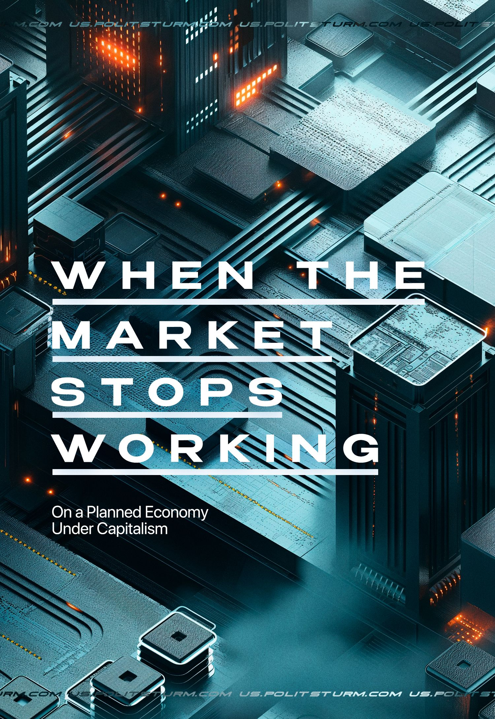

Original article
2024-05-21
56 min read

It is believed that planning in the economy is characteristic only of socialism. However, it is also present in capitalist economies, but not in full, only in the form of disparate elements:
● Large corporations actively use some planning tools, which serve them to increase the exploitation of workers, monopolization, and concentration of capital. The need for planning arises naturally, due to the needs of capitalist production and reproduction, capital management;
● Planning as such is divided into three main types: strategic, indicative, and directive. However, the first two are the more common ones. Most often, capital resorts to strategic and indicative (which was especially popular in the last century);
● The need for planning for capitalists greatly increases during periods of acute crises, especially global wars. During the world wars, the imperialist powers established centralized control over the economy in the interests of military operations, while simultaneously intensifying the exploitation of labor;
● Planning under capitalism is always used to benefit the capitalists and results in even greater oppression and exploitation for the working class. Those developments in the scientific management of social production that arose under capitalism will fully reveal their potential only under socialism.

1. How do corporations use elements of planning?
In modern conditions of capitalist anarchy of production, crises and competition, questions of “survival” in the market arise for transnational and state corporations (hereinafter referred to as TNCs and SCs).
For better economic control and protection of one’s interests, depending on the assigned tasks and the obligation to fulfil them, the following main forms of planning are used: indicative and directive (centralized).
In terms of internal content, depending on the time frame for which the plan is drawn up and the degree of its detail, the following planning systems are distinguished: strategic (long term), tactical (medium term), and short-term (day-to-day calendar). [1][2]
In a market economy, the state uses both indicative and directive planning. The first is considered the most adequate and effective way to regulate the economy. The directive form of planning is generally discredited by market economists. At the same time, all large companies are developing strategic plans for running their production and business. Let's look at these aspects separately.

1.1. Strategic Planning: Strategic Marketing and Management
Strategic planning — determination of the main objectives and planned end results, considering the means and ways of achieving the set long-term goals and providing the necessary resources [3]. This type of planning is most popular among private TNCs.
The task of strategic planning in business is to ensure the stability and consistency of its components. Planning must ensure the interconnection between the individual divisions of the company, including the entire technological chain - research and development, production, and sales - increasing the ability of top management to control the activities of the organization. Planning is based on identifying and forecasting consumer demand in the market, as well as analyzing the availability of resources and prospects for economic development in a particular country [4]. In this case, the organization is considered an integrated system, and its divisions are interacting elements, while the focus is on long periods (3, 5, or more years).
Strategic planning, on the one hand, is flexible in order to be able to adapt to chaotic market changes. On the other hand, it allows strict adherence to one or more intended goals - the main one of which is increasing the company's profits.
Strategic planning is closely related to marketing - one of the management systems within the company, which involves detailed accounting of processes and changes occurring in the market for constant monitoring and necessary adjustments to production and sales plans. The marketing working group provides the planning group with the necessary information that forms the basis for developing goals for the internal divisions of the company.
The essence and task of marketing is quite simple: the manufacturer must release a product that will in advance provide the company with high profits and a stable position in the market. These tasks reflect the objective conditions of market development, where entrepreneurs try to influence the anarchy of production by first establishing certain economic connections.
There are many methods and tools of strategic planning, as well as bourgeois theories and concepts of strategic marketing. At different stages of a company’s existence, in the process of planning and further implementation of the plan, different methods are used. Planning begins with defining the company's mission and vision. Specific strategic plans are then developed to achieve them.
The most famous methods of strategic planning:
- SWOT analysis — identifying factors in the internal and external environment of the organization and dividing them into four categories: 1) strengths, 2) weaknesses, 3) opportunities, and 4) threats.
- PEST analysis — analysis of the external environment, taking into account the political and economic situation, features of the social environment, and technological factors.
- "Value Chain" by M. Porter — focuses on increasing added value at each stage of production from raw materials to the consumer, maximizing resources and reducing costs.
- Balanced Scorecard (BSC). Develops overall performance indicators that combine financial and non-financial indicators with assessments of the performance of marketing, advertising, sales, and the business as a whole, giving managers a complete understanding of the company's performance.
- Matrix BKG (Boston Consulting Group). Classifies a company's business units or products based on two dimensions: market growth and market share. Allows you to determine which business units or products to invest in.
- Ansoff matrix. Used to define growth strategy and opportunities by product and market. It is used to determine whether it is worth concentrating on creating new products, developing new markets, or diversifying activities.
- Scenario planning. Creating different scenarios for the future of the company, helping to be prepared for unexpected changes.
- VRIO methodology - identifying the company's resources and capabilities to help provide a solid competitive advantage.
- Portfolio analysis. Allows you to evaluate and compare a firm's various business units and products for the best allocation of resources [5].
To apply these methods and tools, private and public corporations form a separate staff of employees within the company - managers involved in management issues, development and adjustment of plans, and implementation of developed strategies.
In order to correctly determine goals and objectives, top management needs to have reliable data on the state and development of each specific market as well as each individual product on the market. Otherwise, the company will not be able to compete effectively. The higher the degree of market monopolization, the more accurately the corporations determine its size and will be able to have a stronger influence on its development and effectively use the listed methods, since they have access to a larger amount of information about the market and the movement of goods on it, compared to small firms.
Monopolies strive not only to adapt to existing indicators but also to directly influence the state of affairs: their goal is to subjugate the market and increase influence on the formation of consumer market demand. Thus, strategic planning and marketing includes not only the development of a management strategy but also product, assortment, advertising, and pricing strategies [6].
The state also actively uses strategic planning - it provides influence on the development of affairs within the country and at the international level, shapes the external economic environment in connection with the strategic goals of the state, and ensures an active position in the global market [7].
Further, using the examples of several large TNCs, we will show how strategic planning, marketing, and management and their methods are used, what importance they have, as well as what tasks monopolies set for themselves and how they implement them.

Apple
In 1997, Steve Jobs returned to the company and carried out a reorganization. Before this, Apple was divided into business units, each with profit and loss responsibilities. Jobs fired all the general managers of individual divisions in one day and put the company under unified accounting, uniting disparate technical departments into one functional organization.
The functional structure is typical for small firms, but Apple retains it to this day. Formerly Steve Jobs, and now Tim Cook occupies the only management position in the entire organization. The CEO oversees the design, engineering, marketing, operations, and retail of every major Apple product. Apart from the general director, the company does not have general managers who control the entire process [8].
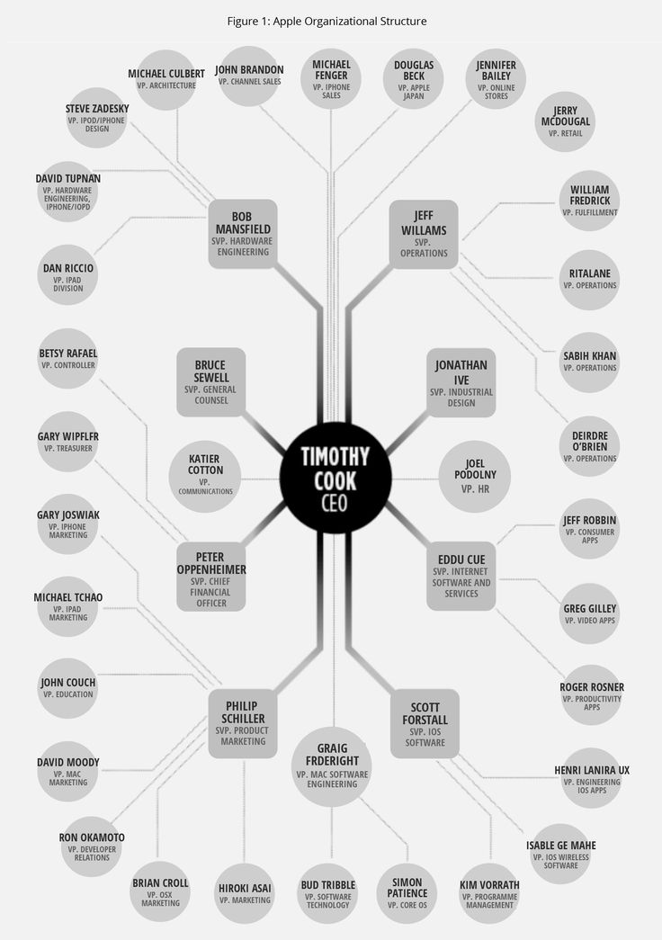
Apple's management structure
Apple's commitment to a functional organization does not mean that its structure is static: thanks to artificial intelligence (AI) and other new information technologies, this structure has changed. The development of AI provided new capabilities like platforms for developing plans, huge computing power, and data storage to help in managing the company.
Apple actively bought startups and financed development and research in the field of AI. As of 2021, spending in this area since 2016 has reached $22.61 billion for the fiscal year, which is approximately $3.12 billion more than the previous year [9].
At the beginning of 2024, it became known that Apple plans to introduce generative AI directly into the iPhone in the near future. This will allow Apple to use user settings data, device experience, health information (collected by Apple Watch), etc., to provide a specific iPhone owner with more accurate answers and recommendations to their queries, experiences, and interests [10]. This innovation will allow the corporation to improve its marketing strategies and increase its influence in creating certain demand among consumers.
Having taken a monopoly position, Apple was able to effectively use strategies in the production, sales, and promotion of products. Some of their most well-known strategies are "Public Relations" (PR), "high prices", "business ecosystem", and "localization of production" [11].
“PR” made it possible to make Apple products a brand and consolidate a high position in the market. Its goal is to create and maintain a positive brand image in the community and among potential customers. The “high price” strategy is setting prices at a higher level than the market average. It is effective if 1) the absence of competition is guaranteed (at least in the near future); 2) if the costs of developing a new market for competitors are too high, and raw materials, materials, or components are limited; 3) if the sale of new goods is difficult. In the case of Apple, all these conditions apply to them.
When selling new products, the company changes its pricing strategies. For example, use the installation strategy "price anchor" - a common manipulative marketing technique in trade. By setting an initial inflated “anchor price” for consumers, with each subsequent price reduction, the product supposedly appears to be a profitable and desirable purchase. This strategy allows you to make a profit first from those who are willing to pay a lot, before lowering the price and attracting the bulk of buyers. For example, when the iPhone 6s was released, its price was from $499 to $599, i.e., the primary cost anchor was set. A few months later the price was reduced, again stimulating sales [12].
When creating its own “ecosystem,” the company strictly controls the chain of production and sales of products, maximizing profits at each stage, concentrating on the development of devices and software and partly on sales. The company leaves less important and profitable activities to its partners. The Apple ecosystem is closed to non-ecosystem members. Within its platform, the company creates barriers for users by not allowing them to choose other devices and applications [13].
At the production stage, Apple uses a "localization of production" strategy - this is the process of transferring the production of goods and services closer to the end consumer and adapting the product to the local market, which serves to increase competitiveness in the international arena [14]. One of Apple’s important advantages, which allows it to effectively use this strategy, is its independence in the production chain - the company produces both the product itself and the software for it. In fact, “localization of production” is just another name for the main tool of large monopolies - the export of capital.
The main target of capital export for Apple is China. The main reasons are cheaper labor and lower costs compared to the United States. An important advantage for the company is the sale of created products in the same Chinese market, which remains the largest consumer of Apple products. In 2022, more than 90% of Apple's products, including iPhones, iPads, and MacBooks, will be made in China by the company's key suppliers [15]. Against the backdrop of political disagreements between China and the United States, the company is going to partially transfer production to India and Vietnam. However, China still remains an attractive location for production [16] [17].
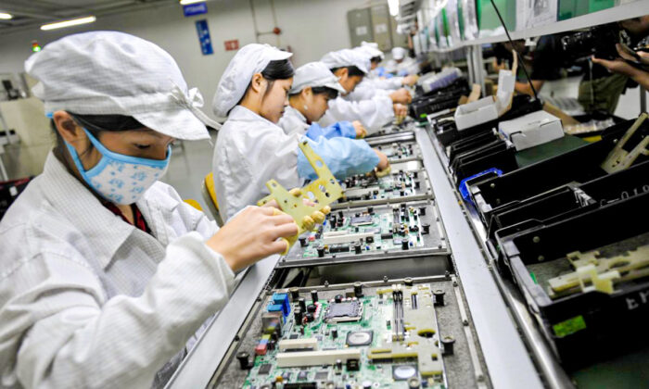
Chinese workers assemble electronic components at a plant of Taiwanese technology giant Foxconn in Shenzhen city, Guangdong province, China, 26 May 2010.
Monopoly dominance in the market with the advantage of investing heavily in marketing and planning, with access to modern technologies and tools, allows the company to apply these methods and strategies with greater impact. To inform marketing strategies, serious analytics is used: customer data is analyzed to gain insight into what types of products and promotions will be most effective at one time or another. The company uses this data to personalize marketing messages and create targeted campaigns that are more likely to lead to increased sales.

Amazon
The company began operating in 1994. Initially, Amazon sold books on the Internet and was one of the first companies in this segment. From the very beginning of the company, Jeff Bezos sought to take as large a share of this market as possible until serious competition appeared.
Three years after its creation, the company went public to sell its shares and raise capital. However, Amazon had been losing money for years due to competition and had no profit. Bezos convinced investors that the company might not be profitable for the first 20 years, since the main goal is to create extensive infrastructure, which will bring much more opportunities in the future. In his first letter to shareholders, he put it this way:
“Our goal is to act quickly to strengthen and expand our current position while we begin to pursue online commerce opportunities in other areas. We see significant opportunities in the large markets we target. This strategy is not without risk: it requires serious investment and the brutal destruction of established franchise leaders. It's all about the long term» [18].
Thus, it is clear that the company acted according to a specific plan from the very beginning. Bezos made it clear to shareholders that Amazon's strategy is the monopolization of the online trading market; and that losing money now will lead to the eventual exit of companies that cannot afford to lose money. To combat this, the company invested heavily in technology and marketing. Also, the shareholders perfectly understood and recognized the initial advantage of the Amazon online store over physical stores - the absence of collecting sales tax from customers.
Jeff Bezos characterized the company's low turnover in senior management positions as its strength. Many of them have been working in the company for years and decades. After 27 years of leading the company, Bezos left the post of CEO, transferred powers to Andrew Jesse, who previously led Amazon Web Services, and moved to the position of chairman of the board.
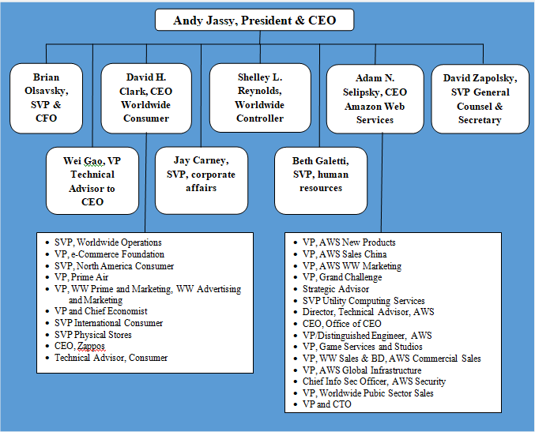
Amazon's main business strategies used in the manufacturing stage are the concept of "cost leadership" and "business diversification" [19].
The company has many processes that ensure reliable operation. The most important of them are the annual planning process, the process of goal building by the “S” team (S-Team, which consists of senior vice presidents and direct subordinates of Bezos), and the compensation (salary) strategy.
Amazon relies most heavily on autonomous, focused teams. These teams create agility for the company and allow it to move quickly with minimal delays. However, autonomy must be combined with precise goal setting to connect the independent plans of each team with the overall goals of the company.
Planning the calendar year begins in the summer, continues through the fall, and ends at the end of the year. This is a painstaking process that requires intensive work by managers and many employees of each team in the company. A poorly designed plan, or worse, no plan, can result in much higher downstream costs.
The S-Team begins by creating a set of the most important shared goals and expectations for the entire company. After establishing these goals, each group begins to work on its own more detailed operational plan (OP1), which outlines the individual group's upstream proposal. The main components of OP1's narrative are the evaluation of past performance, including goals achieved, goals missed, and lessons learned; key initiatives for the next year; detailed profit and loss statement; requests (and justifications) for resources, including costs for new employees, marketing expenses, equipment, and other fixed assets.
Each team works with finance and human resources to create a detailed plan, which is then shared with the leadership team. Once planning is complete, at the beginning of the year, OP1 is adjusted as needed to reflect fourth-quarter results and update the business path—a shorter process called OP2. He forms a business plan for the calendar year. OP2 aligns each group with company goals. Each department knows the overall goals, revenue goals, cost goals, and productivity goals. OP2 makes it clear exactly what commitments each group has made, how they plan to achieve those goals, and what resources they need to get the job done. Any changes to OP2 require formal S-Team approval.
During OP1, while reviewing the various operational plans, the S-Team selects each team's initiatives and goals that they consider most important to achieve. S-Team targets have three characteristics: they are very numerous, they have a high level of detail, and they are aggressive. Each year the number of targets increased to many hundreds, scattered throughout the company.
Amazon executives don't focus much on broad strategic issues. More attention is paid to details and their execution. Managers work according to the principle of leadership Dive Deep (deep dive) which reads:
“Leaders work at all levels, know all the details, check in frequently, and are very skeptical when metrics differ from reality. Not a single problem is solved without their knowledge.”
Amazon's compensation program and compensation for Amazon S-Team members and all senior executives is largely based on capital earned over a period of several years. The bulk of the remuneration consists of company shares. This is how Amazon selects employees aimed at long-term work [20].

BOSCH
The company was founded in 1886 in Germany by Robert Bosch. Already in 1906, Bosch took the path of internationalization, with the advent of a sales office in the USA and in some European countries. Almost all automobile companies of that time were Bosch customers for the purchase of electrical equipment.
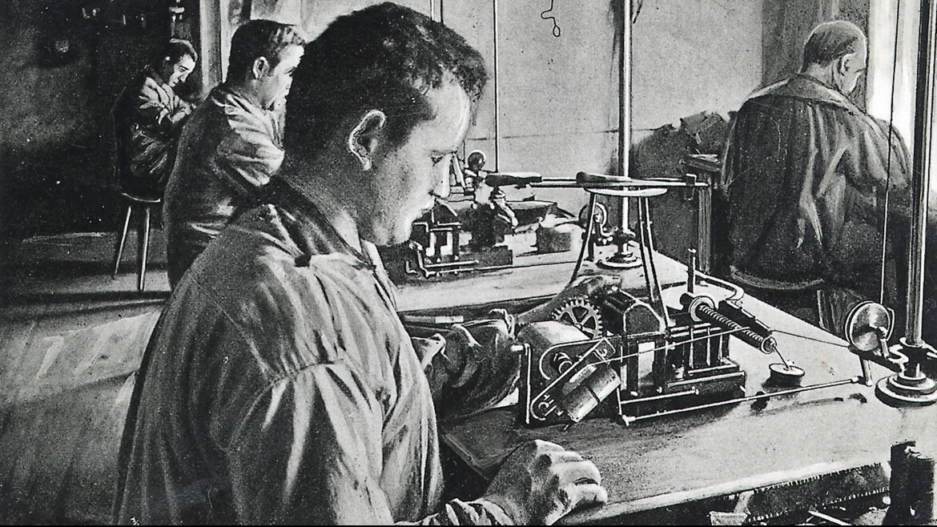
Bosch employees manually wind the wire around the magneto ignition coils. 1900
By 1926, Robert Bosch had stepped away from direct management of the company, but still controlled the business strategy, having previously retained a majority of the shares (51%) and selling the remaining 49% to his directors.
The economic crisis of 1929 also affected the Bosch company, but they managed to survive thanks to the diversification strategy, expanding the scope of activity and creating a product line that included household goods: radios, televisions, and refrigerators [21].
Bosch currently operates in four business areas: mobility solutions, industrial technologies, consumer products, building technologies, and energy. Bosch, a leader in the Internet of Things, offers innovative solutions for the smart home, Industry 4.0, and connected cars [22].
The department responsible for the strategic planning process at Bosch is corporate planning. The plan is based on two documents.
Three-year business plan. It sets out the budgets of the corporation at all levels (budget plan) and all investment costs (investment plan).
10-year strategic plan. It is a strategic vision that asks questions of broader scope and perspective.
Both plans are reviewed annually as part of the annual planning cycle. The planning process is managed by the designated strategy department as resources are distributed heterogeneously between firms and they cannot be simply transferred from firm to firm.
The corporate planning department was created in 2001 when the then-CEO realized that previous planning methods were insufficient to address the complex issues arising in a global, multi-faceted organization.
The planning department is responsible for setting guidelines and parameters for business units. The divisions then conduct an analysis of their area, which includes, for example, market forecasts, projected growth rates, and sales distribution.
Among the new measures, the company is trying to obtain additional strategic information on a regional basis (regional strategies) rather than just planning at the departmental level. To this end, regional strategy meetings were introduced in 2005.

1.2 Indicative planning
This type of planning plays an important role in the planning process of states, as a tool in the hands of capitalist monopolies.
Indicative planning — drawn up by the state, these economic plans serve to inform all economic entities about the long-term goals of state economic policy but are not binding. This process is similar in content to consulting, where the main functions are information, orientation, and stimulation.
There are three historically established forms of development of indicative planning:
1) Opportunistic - when the purpose of planning is to improve economic conditions (conjuncture) and connections with the help of macroeconomic regulators (fiscal, monetary, etc.).
2) Structural, a more detailed form of indicative planning, which places emphasis on structural policy in relation to industries, economic sectors or regions through the coordination of plans and interests of enterprises and the state through the implementation of contractual relations. These may be preferential loans, tax breaks, government procurement and other measures;
3) Strategic, when indicative planning has a significantly expanded time frame (from 10 years) and there is a deeper coordination of the interests of all economic entities. This form of planning arises with the development of productive forces when the scale and complexity of the economy reach a certain value [23].
The state carries out the functions of control, stimulation, and coordination during indicative planning using the following tools: programming, price regulation, tax system, state budget, monetary policy, creation of enterprises with state ownership, and government orders [24].
Examples of companies on the international stage that are formally private, but largely supported by the state, are Boeing, ExxonMobil, and Lockheed Martin, all included in the top 100 enterprises of contractors of the US military-industrial complex in terms of the volume of orders from the US government agencies [25].
In Russia, the list of large corporations and conglomerates, which indirectly through dependent enterprises, institutions, and constituent entities of the Russian Federation, or due to vague laws, are partially or fully owned by the state, includes: Rosneft, Gazprom, Sberbank, VTB Bank, VK Group, etc [26].
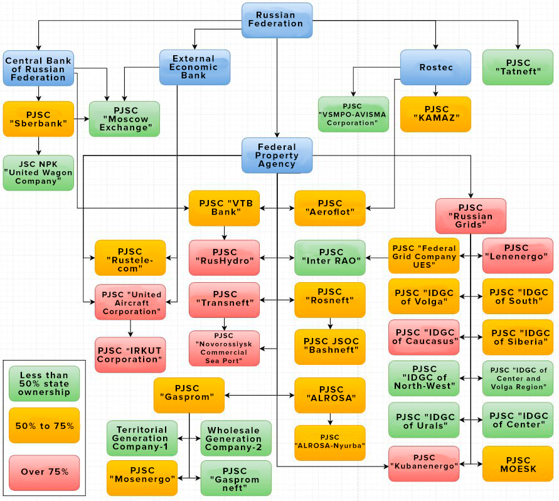
Russian public state assets management system

France: the politics of «dirigisme».
France is considered the leader of indicative planning in Europe, as it began to actively use this method after the Second World War. At that time, the French government gave priority to the development of heavy industry, mechanical engineering, and oil refining.
Under pressure from the French Communist Party and labor strikes, the nationalization of the main industries, the national bank and insurance companies was carried out, and progressive social and economic legal reforms were implemented (the right to work, rest, health protection, collective determination of working conditions, enterprise management, etc. .).
However, in conditions of maintaining private ownership, the increased intensity of concentration of production led to the formation of financial and industrial monopoly associations. From the second half of the 60s. 10% of monopolies owned 40% of private property, produced 11% of industrial products, and concentrated more than 35% of industrial investments. They had a decisive influence on the management of nationalized industries and the development of economic state policy.
This economic policy of active state intervention in the economy, based on the principles of indicative (recommendatory) state planning, was called “dirigisme” and was based on the theory of the French economist François Peroux.
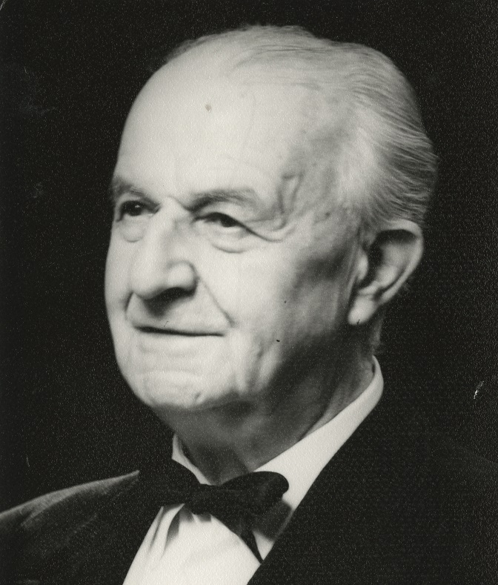
Francois Perroux
To implement indicative planning in France, in 1946, a General Planning Commission was created that drafted seven successive national development plans.
The first plan (1947-1953) was aimed at restoring the economy after the war and modernizing the entire nationalized sector of the economy. The second plan (1954-1957) was aimed at strengthening the competitiveness of the private sector of the economy. The third plan (1958-1961) carried out the transition from a policy of protectionism to a system of “open economy”. During the fourth and fifth plans (1960s), a course was set for the growth of production and the creation of national companies. The sixth plan (1971-1975) set the goals of expanding national companies to an international scale, increasing the rate of profit, and stimulating capital accumulation. Seventh (1976-1980) was aimed at adapting the country's economy to international integration based on the creation of TNCs and strengthening ties with the world market.
By the end of the 60s, with the creation of the “European common market” - the concept of economic integration of the states of the European Union - and the inclusion of France in international relations with more intense competition, interest in the indicative planning system began to decline.
In the 70s, the government began to encourage the development of those industries that could compete more effectively in the world market. In this period and continuing into the 80s, the deliberative planning mechanism was seriously limited, although it continued to exist at the broad economic level.
In 1982, economic development priorities were revised, more than 200 reforms were carried out, and the second stage of nationalization was carried out. Unlike the post-war period, when nationalization was carried out with the goal of “proportional” development of all sectors of the economy, nationalization in the 80s covered the five largest industrial monopolies in the non-ferrous and chemical industries, in electronics and electrical engineering, in the production of glass and building materials, in the steel industry, in aviation and rocketry, and the two largest financial groups (Paribas and Suez). As a result, the largest public sector of the economy was formed in France, covering approximately 1/3 of production in the industrial sector, and in the sphere of finance and credit, the share of the public sector was 96% [27].

French bank BNP Paribas
After 1986 however, a policy of denationalization, privatization, and a reduction of the role of the state in the economy has been implemented.
Since the beginning of 2005, the French state again began to introduce some elements of state regulation of the economy, but in different forms [28] [29] [30].
The example of the history of planning in France shows how, depending on the interests and goals of large monopolies at certain stages, the economic policy of the state changes and adjusts.
In the post-war period, when national capital was weak and interested in accelerated modernization, measures were necessary to consolidate and smooth out the interests of the working majority and private business. For these purposes, the French ruling class actively used state planning methods.
When the national capital strengthened and was ripe to enter the international arena for further expansion, the policy changed, the capitalists eliminated state restrictions in general and methods of economic planning in particular.

China: the «Alibaba Group»
In the PRC, as it fully transitioned to a market economy in the late 70s the already weak elements of centralized planning began to be replaced more by indicative (guiding) planning. The economy has completely moved from unified planning to planning by management levels, and the role of sectoral and regional planning has increased. State planning in relation to plans for the development of regions and industries is of a guiding (recommendatory) nature.
In fact, throughout the history of the PRC, directive socialist planning, which originated during the first Five-Year Plan, was never fully consolidated. Measures of state economic control were generally minimal and were of a capitalist rather than socialist nature [31].
The main changes in the preparation of state plans for the development of the national economy occurred during the 10th Five-Year Plan (2000-2005) under the conditions of China's accession to the WTO (World Trade Organization). This period is characterized by the acceleration of the restructuring of the world economy, the development of high information technologies, computerization, an increase in the number of global TNCs, and the expansion of the range of their activities.
How the principle of indicative planning is used in the PRC can also be seen in the documents of the plenums of the CPC and the National People's Congress, where very few specific planned indicators for economic development are given, most of them being descriptive in nature. Also, the largest part of the economic tasks for the 11th Five-Year Plan (2006–2010) and until 2020 was published not in the form of mandatory directives, but in the form of abstract problems posed to society [32] [33].
The example of the Alibaba Group corporation clearly shows how indicative planning is implemented in China and how large TNCs are created with the support of the state.
Alibaba Group is the largest online trading platform in China, one of the largest in the world, providing services in the field of e-commerce (carrying out trading and purchasing activities via the Internet), electronic payments, search engines, cloud computing, financial services, digital media, and other related areas. Alibaba Group operates three of the largest online shopping platforms in China - Taobao, Tmall, and Alibaba.com.
The history of Alibaba is part of a broader history of the development of economic public policy in China, which began in the 90s, with the so-called "openness policy". This was followed by the emergence of the e-commerce market, the rise of the private capitalist sector, and the expansion of the use of the Internet.
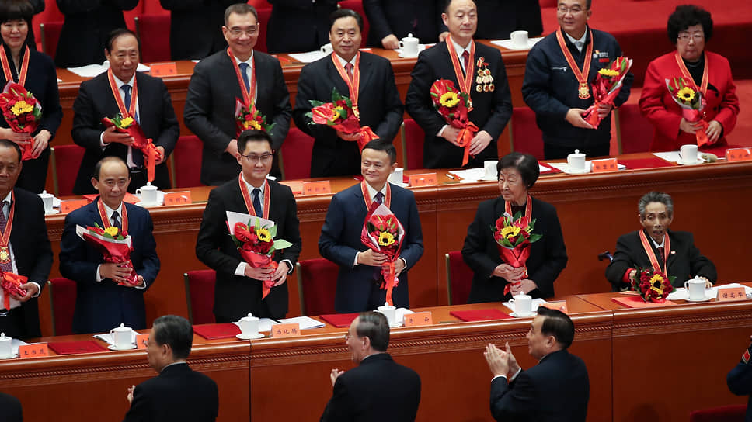
Jack Ma, founder of Alibaba, at the 40th anniversary of reform and opening up at the Great Hall of the People in Beijing. December 18, 2018
Together with the State Council, the Committee on Science and Technology, as well as the People's Bank of China, and the People's Insurance Company, a number of ministries and departments have been involved in the introduction and promotion of electronic information technologies. A coordination group has been established for the promotion and use of electronic data interchange. There is also a program called “State Plan for the Priority Implementation of Scientific and Technical Achievements”[34]. Through joint efforts, government agencies have created a coordination group to promote and use electronic data interchange. To obtain new technologies, the State Planning Commission program was aimed at improving relations with other countries. According to this plan, it was necessary to actively use the external licensing system of the Ministry of Foreign Trade and Economic Cooperation and the Chinese foreign trade transportation management system. It was also necessary to promote export trade and the work of companies involved in this area.
Since 1990, the volume of exports of Chinese goods has been growing (by an average of 12.4% per year), and there was a need to create a resource to facilitate the expansion of trade. 1997-1999 are considered to be the years of the formation of the e-commerce market in China. It was during this period that Alibaba was created [35] [36]. Foreign investors who gained access to the Chinese market played an important role in the early formation of the corporation - in 1999, Alibaba received large investments from Investor AB (Swedish investment and holding company), Goldman Sachs (US multinational investment bank), and SoftBank (Japanese multinational investment holding company).
At an early stage, Alibaba Group focused on attracting small and medium-sized entrepreneurs. By collecting large amounts of information on the Chinese market, researching the market requirements of small and medium-sized enterprises, classifying and integrating registration information, and providing enterprises with free information services, the corporation quickly took a leading position.
The main holding companies subordinate to Alibaba Group Holding are registered in offshore zones: Taobao Holding Limited (Cayman Islands) and Alibaba Investment Limited (British Virgin Islands) [37]. It is significant that the “Communist” Party of China, which is presented as keeping its businessmen in check, allows the general assets of one of its largest companies to be kept in offshore foreign accounts.
The site itself Alibaba.com, intended for wholesalers around the world, is cheaply purchasing goods directly from Chinese plants and factories. The platform does not produce goods and does not handle inventory - it is an intermediary, earning money primarily due to the cheapness of Chinese labor, as well as from sellers’ contributions and advertising [38].
To solve capital flow problems, Alipay was created, closely linked with the People's Bank and the Central Bank of China, implementing online payment functions and managing intermediate payment funds.
It is an obvious fact that the development of e-commerce in China in general, and the development of the Alibaba Group corporation, in particular, was directly or indirectly supported by the state and manifested itself in the form of direct assistance to domestic enterprises involved in e-commerce, and in the form of allowing foreign investment and providing foreign companies certain freedom in this area. To obtain new technologies, China's policy has been and remains aimed at opening access to its multimillion-dollar market of cheap labor in order to attract foreign investment.
The use of modern technology has allowed the government, together with Alibaba, to obtain detailed social information, better understand public opinion, develop strategic plans, and determine appropriate policies.

Indicative planning in the Russian Federation: Russian state corporations.
In 1991, with the liquidation of the State Planning Committee of the USSR, directive planning was abolished. Reformers at that time declared any planning untenable and unnecessary and tried in every possible way to eliminate it as incompatible with the market [39].
The subsequent crisis made Russia think about the use of planning in a market economy. In 1995, a law was passed “On state forecasting and programs for socio-economic development of the Russian Federation”.
Based on the law, it was intended to develop state forecasts of economic development for the long, medium, and short term. However, neither the constituent entities of the Russian Federation nor the scientific staff were involved in the work of collecting information and scientific research [40] [41].
Since the 2000s, during the inclusion of Russia in global economic processes, and the centralization and monopolization of capital, a system began to form indicative planning, and the development of economic theories, forecasts, strategies, and plans has intensified. From the period 2000-2010s, and to this day, the development of ideas about combining “the best'' elements of planning in the USSR with the principles of a market economy has magnified. As imperialist tendencies intensify, the idea of ​​strengthening state control and economic planning is promoted, and market anarchy and the “liberal model” are criticized and assessed as ineffective. [42]
For example, in the second half of 2007, the creation of “state corporations” (SCs) became an important direction of government policy. The practice of creating a civil corporation in Russia is one of the ways of government intervention in the economy, with the aim of helping businesses develop industries that are unattractive, risky, and do not bring quick profits - primarily nuclear energy, space technology, innovative developments, and high technologies.

"Rusnano"
In 2007, the Russian Nanotechnology Corporation State Corporation was officially registered (Rosnanotech). To ensure the activities of the corporation, the government of the Russian Federation made a property contribution of 130 billion rubles. In 2011, through the reorganization of the Rusnanotech State Corporation, an open joint-stock company (JSC) “Rusnano” was created, to which all the powers of “Rusnanotech” were transferred. At the time of 2017, 100% of the corporation's shares were owned by the state. From the beginning of its creation until 2020, it was managed by Anatoly Chubais [43].

Anatoly Chubais, former CEO of Rusnano
The company was created to develop the nano industry in Russia and invest in new technologies. The corporation's mission was “promoting the implementation of state policy, the goal of which is Russia’s entry into the ranks of world leaders in the field of nanotechnology”. The main task was “support and commercialization of nanotechnological developments, creation of an effectively operating business based on them” [44].
The corporation's strategy established indicators for achieving goals - by 2015, the volume of production of nanoindustry products by enterprises created by the corporation and co-investors should have amounted to at least 300 billion rubles per year. The total production volume of the entire Russian nanoindustry was supposed to be 900 billion rubles [45]. That is, the strategy was determined using an indicative planning method.
As a result, the corporation failed to cope with the tasks assigned to it, and slipped into a pre-default state and a high probability of bankruptcy. In 2022, the Ministry of Finance paid off part of Rusnano’s debt from treasury resources in the amount of 9 billion rubles, plus paid income to creditors in the amount of 560 million rubles. [46], and “Rusnano” came under the control of another Russian group of companies - VEB.RF [47] [48].

1.3. Directive planning
Directive planning - these are decisions and tasks that are binding, accompanied by strict control and responsibility. It is also known as a command economy. This type of planning can be used most effectively only on the basis of a socialist planned economy with public ownership of the means of production.
Bourgeois economists distort the nature of the directive planning used in the USSR, presenting it as blind party orders coming down “from above”, not subject to discussion, not taking into account the capabilities and proposals of individual enterprises, and ignoring the needs of people.
Despite criticism, directive planning is still used by capitalist states, but not on the scale of the entire economy, but in a targeted manner. Especially so during periods of preparation and introduction of imperialist wars at strategically important military-industrial enterprises, during crises, natural disasters, pandemics, etc.
During the First World War, the tsarist government of the Russian Empire tried to establish a centralized distribution of raw materials, fuel, and other energy resources between private enterprises and introduced mandatory grain supplies to supply the army.
These tasks were assigned to the defense conference, which was supposed to mobilize industry for the needs of the front. Of course, this military-state regulation did not affect the foundations of private property, and led to the growth of monopoly capital, to increased centralization of production, and to an increase in the profits of the formed monopolies.
The same process of strengthening financial capital occurred in other warring countries - the German military-industrial complex increased profits by 3-5 times; the net income of US monopolies reached $27.3 billion. For the working class, such a policy brought an increase in the length of the working day, a reduction in wages relative to rising prices, unemployment, and worsening need and poverty. For example, in the Moscow region, wages grew by an average of 70-90%, and prices by 200-300% [49] [50].

A penniless veteran of the First World War runs next to the carriage of King George V. Great Britain, 1920.
Lenin characterized the policy of “regulating” the economies of the countries participating in the war as follows:
“Both America and Germany "regulate economic life" in such a way as to create conditions of war-time penal servitude for the workers (and partly for the peasants) and a paradise for the bankers and capitalists. Their regulation consists in “squeezing” the workers to the point of starvation, while the capitalists are guaranteed (surreptitiously, in a reactionary-bureaucratic fashion) profits higher than before the war.” (V.I. Lenin - PSS. Volume 34, p. 166).
A more modern example of strengthening the role of the state in the economy are the measures introduced during the coronavirus epidemic and the growing crisis after it. Many countries have used methods of centralized distribution of resources and finances. However, they were primarily aimed at supporting business.
In March 2020, the UK Treasury announced measures to support businesses. Companies were provided with £330 billion ($400 billion) in loan guarantees. The maximum loan size was increased from £1.2 million to £5 million (from $1.5 million to $6 million), with interest waived for the first six months. Small retail, hotel, and tourism businesses were exempt from business tax during the pandemic. At the same time, Britons experiencing financial difficulties were only given a three-month mortgage deferment.
In Germany, a fund to help large enterprises was created for €600 billion (the state reserves the right, if necessary, to buy out shares in strategically important companies). Of these, 400 billion would go to guarantees for loans to companies, 100 billion would go to real financial assistance to medium and large enterprises, and another 50 billion was allocated to support small businesses and freelancers. German hospitals, in turn, received support of more than €3 billion [51] [52].
Some elements of a directive management method are actively used within large TNCs and SCs in the form of specific mandatory instructions and goals from management to employees, subject to strict verification of their implementation [53]. This method is usually used by management in complex projects and crises when it is necessary to solve a problem quickly and on time, as well as to develop discipline among employees and instil "corporate culture" in them.
For example, former Apple CEO Steve Jobs had an "authoritarian" personality management style. According to former employees, he was picky and meticulous, supervising the work of all departments from beginning to end.
Bill Gates, the head of Microsoft, is known for his rudeness and bullying towards employees and constant harsh remarks about their work. According to the rules of the company's corporate culture, Gates is always right, and the decision is always his [54].

2. Conclusions on the application of planning under capitalism
The planned economy and the introduction of its elements under capitalism are primarily generated by objective reality. The need for planning in modern TNCs and SCs stems from:
1) the enormous scale of socialization of production carried out on an international scale;
2) organizing production cooperation between enterprises manufacturing certain products, within the framework of broad economic and industrial complexes, but maintaining independence;
3) close intercompany ties with suppliers of raw materials, semi-finished products, and components included in a single technological process;
4) necessity to quickly take into account and master the latest achievements of science and technology from the requirements of scientific and technological progress. In the same direction, the factor of TNCs’ desire to subjugate the market, strengthen their influence on the formation of consumer market demand, and, thus, maximize profits by all possible methods.
The technical development of productive forces naturally leads to the need for reasonable management and planning of the economy. However, under capitalism, this planning does not extend beyond private corporations and does not extend to the entire economy. Managers of TNCs and SCs plan their production, but not the economy as a whole. The plan in individual capitalist corporations or unions of corporations, even those responsible for important sectors of the economy, does not lead to planning on the scale of the entire society, nor does it work in its interests. Planning under capitalism is private and is used to increase the exploitation of labor. It does not overcome the anarchy of production, on the contrary, it only aggravates it.
Control systems and methods such as marketing and management are becoming reactionary and distorted. The financial oligarchy is completely divorced from the process of production and management and is forced to transfer these functions to representatives of a specific social stratum of hired professional managers among the workers and petty bourgeoisie.
This is how a labor aristocracy is formed: managers, administrators, directors of enterprises or individual divisions. They, in turn, also suffer from the market system and its consequences. The growth of productivity and modern technologies, for example, developments in the field of AI and robotization, do not lead to improved working conditions or a reduction in working hours, but to the simple replacement of management employees with modern computing programs, leading to increased unemployment and increased labor intensity.
Bourgeois management systems and the managers themselves are used to increase the oppression of workers, commercialize various human interests, and temporarily cover up the main contradictions of capitalism.
Contradictions arise between growing production opportunities and the relative and absolute deterioration in the lives of workers. Between the tendency towards the systematic organization of production and marketing of goods within a separate enterprise or monopolistic association on the one hand, and the persisting anarchy of production on the scale of the entire society on the other.
The universal law of capitalist accumulation, discovered by K. Marx, proves that the accumulation of capital leads, on the one hand, to an increase in the wealth of the capitalist class, and on the other, to a deterioration in the position of the working class.
“...The law, finally, that always equilibrates the relative surplus population, or industrial reserve army, to the extent and energy of accumulation, this law rivets the labourer to capital more firmly than the wedges of Vulcan did Prometheus to the rock. It establishes an accumulation of misery, corresponding with accumulation of capital. Accumulation of wealth at one pole is, therefore, at the same time accumulation of misery, agony of toil slavery, ignorance, brutality, mental degradation, at the opposite pole, i.e., on the side of the class that produces its own product in the form of capital." (Marx K. and Engels F., Works, 2nd ed., vol. 23, p. 660)
The use of innovative technologies and modern scientific advances, which should lead to improved working conditions and living conditions for society as a whole, in fact, leads to an improvement in the lives of only a minority of the world's richest people.
State regulation of the economy does not solve the basic contradictions of capitalism. However, many reformist and revisionist concepts try to prove that as a result of the influence of the state, capitalism has undergone such changes that it has ceased to be capitalism.
Adherents of the theories of state capitalism represent the state only as a “regulator”, supposedly not fixated on commercial goals. They believe that the state, through indicative and strategic planning, provides reliable information and forecasts for economic development and the protection of “national interests,” and directive planning is used, as necessary, only in strategically important areas: public, military, nuclear, and space.
In reality, there are some formal differences in the application of planning and management between private and public companies, but the theory of the state "regulating" the relationship between society and monopolies is a bourgeois myth. The state under imperialism is an aggregate capitalist, who also owns the means of production and exploits the workers; it is a tool that serves the interests of the financial oligarchy. The power of monopolies in the economy leads to the power of monopolies in politics. Private and public monopolies are intertwined and use the same types of planning and management, depending on the conditions and goals.
In terms of the content of economic activity, there is no fundamental difference between private and public companies. All of them are subject to the objective economic laws of capitalism at its imperialist stage. With the continued power of private ownership of the means of production, the possibility of direct centralized systematic distribution of investments, the formation of income, prices, etc. is excluded, and public administration affects mainly the sphere of government financial transactions and credit.
State “regulation” of the economy, whatever form it takes, does not occur separately from the general system of monopoly capitalism. Management of state-owned enterprises in capitalist countries is in fact decentralized, and the enterprises themselves have relations of market competition both with private companies and with state-owned companies similar in their type of activity.
The state supports those sectors of the economy that do not provide monopolies with appropriate income, but which are necessary for the functioning of the economic system. Using public funds, including municipal funds, infrastructure is created and expanded to support the activities of capitalist monopolies. Healthcare, social security, and education become for capitalists only “social costs” that are borne by the state.
Thus, the socialization of labor and production reaches the highest point possible under capitalism. This is how the prerequisites for socialism emerge within the capitalist society, and how a historical need to replace the old capitalist production relations with more progressive socialist ones arises. The desire of the class of large capitalists to preserve this system, at the same time, is bringing it ever closer to destruction.
“...The latter must be emphasized because the erroneous bourgeois reformist assertion that monopoly capitalism or state-monopoly capitalism is no longer capitalism, but can now be called "state socialism" and so on, is very common. The trusts, of course, never provided, do not now provide, and cannot provide complete planning. But however much they do plan, however much the capitalist magnates calculate in advance the volume of production on a national and even on an international scale, and however much they systematically regulate it, we still remain under capitalism - at its new stage, it is true, but still capitalism, without a doubt. ”(V.I. Lenin “State and Revolution”, PSS, ed. 5, vol. 33, p. 68).

3. How to unlock the potential of planning?
State-monopoly capitalism takes all the contradictions of imperialism to the limit and thus creates material prerequisites for socialism. These are class contradictions within each capitalist country, the contradiction between labor and capital, the contradictions between imperialist states, and contradictions between large and small imperialist countries.
“State-monopoly capitalism is a complete material preparation for socialism, the threshold of socialism, a rung on the ladder of history between which and the rung called socialism there are no intermediate rungs'" ... "It is a step forward on the basis of modern monopoly capitalism, a step towards the regulation of economic life as a whole, in accordance with a certain general plan, a step towards the economy of national labour and towards the prevention of its senseless wastage by capitalism.”(V.I. Lenin. “The Impending Catastrophe and How to Combat It.” PSS, ed. 5, vol. 34, p. 193)
The growth of technical progress and the socialization of labor and production can reach a high degree, but only under socialism, on the basis of public ownership of the means of production and the political power of the working class, truly effective planning of the entire economy is possible. Socialist scientific planning, corresponding to the level of development of the means of production, overcomes market anarchy and crises of overproduction.
For example, new achievements in the field of AI, powerful computing machines and information technologies, production automation, and robotization could significantly change and improve the lives of the majority of the working population. The absence of the main feature of capitalism under socialism is profit orientation, — which makes it possible to set and solve knowledge-intensive high-tech problems and allows for the full development of the necessary areas of science and industry that humanity urgently needs.
The plan in the Soviet Union was created on the principle of “from the general to the specific,” and could not be implemented without the broad participation of workers in economic management. Under the direction of the General State Planning Committee of the USSR, first in the Union republics, then also at the regional level, plans were formed through planning commissions, which were specifically implemented by local enterprises.
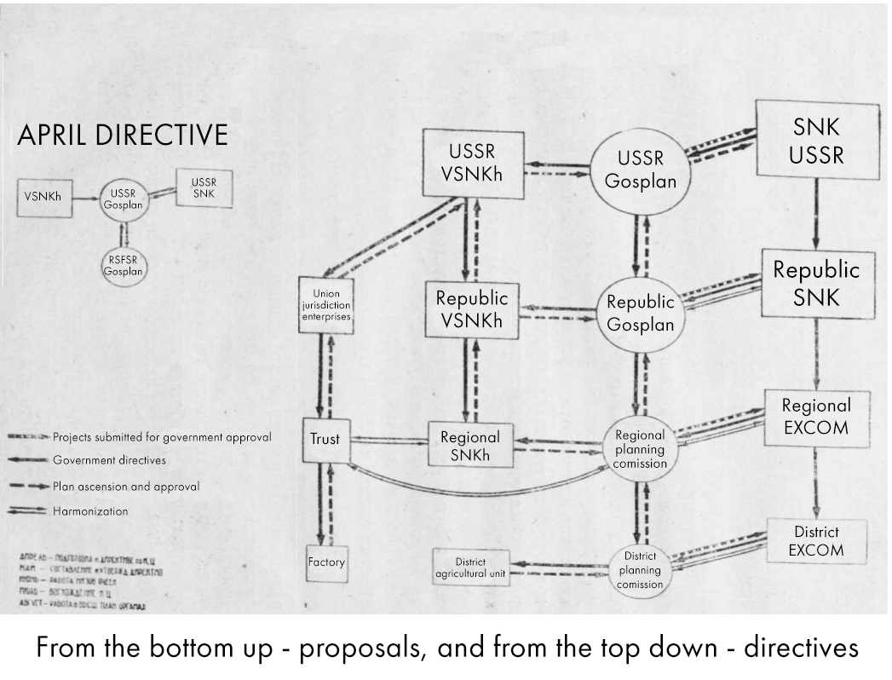
How planning worked in the USSR
For example, in Leningrad in 1926-1927 during the meetings on the first five-year plan, 12 thousand proposals were submitted, of which 2/3 were accepted, and in 1965, more than 30 million workers of all kinds took part in these meetings, and about one and a half million proposals were accepted [55].
I.V. Stalin defined the nature of Soviet economic plans and their difference from capitalist ones:
“Reference is sometimes made to American and German economic bodies which, it is alleged, also direct their national economy in a planned way. No, comrades, those countries have not yet achieved this, and never will achieve it, as long as the capitalist system exists there. To be able to lead in a planned way it is necessary to have a different system of industry, a socialist and not a capitalist system”
“True, they also have something in the nature of plans; but these are forecast plans, guess-work plans, not binding on anybody, and they cannot serve as a basis for directing the country's economy. Things are different in our country. Our plans are not forecast plans, not guess-work plans, but directive plans, which are binding upon our leading bodies, and which determine the trend of our future economic development on a country-wide scale.”(I.V. Stalin “The Fifteenth Congress of the C.P.S.U.(B.), December 2-19, 1927)
This is a characteristic property of planning under socialism. It is fundamentally different from market planning, in which the majority of workers are alienated from managing the means of production, and, accordingly, are cut off from managing the distribution of the public goods they produce.
The history of the USSR clearly shows the practical achievements of the application of scientific planning under the leadership of the working people and the Communist Party.
Plan GOELRO (abbreviated from “State Commission for Electrification of Russia”) was the first unified state long-term plan for the development of the national economy based on the electrification of the country and the creation of large industries. It was approved by the Council of People's Commissars on December 21, 1921. The implementation of the GOELRO plan, designed for 10-15 years, began in the difficult conditions of the Civil War and economic devastation, but by its minimum deadline, it was fulfilled according to the main indicators. Annual electricity production in the USSR reached 10.7 billion kWh, and the installed capacity of regional power plants is 2105 thousand kW.
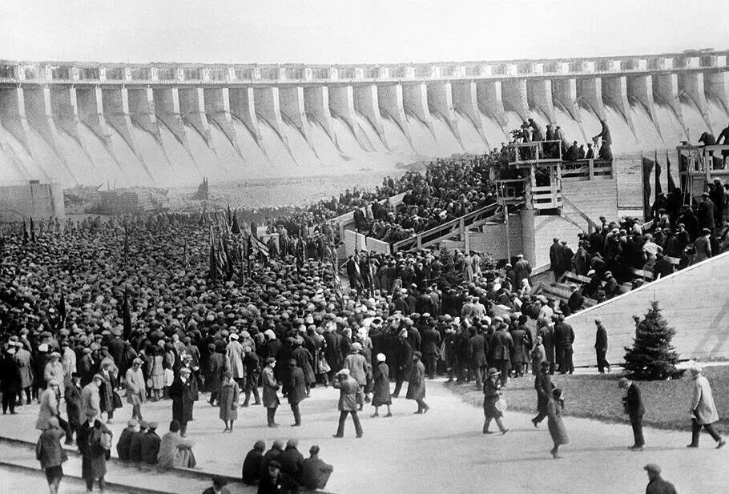
On March 15, 1927, construction began on the Dnieper hydroelectric station according to the GOELRO plan.
The First Five Year Plan (1929–32) — was a continuation and development of the ideas of the GOELRO plan. The program for the construction of power plants, outlined by the GOELRO plan, was exceeded - the capacity of power plants over these years increased almost 2.5 times, and electricity production - 2.7 times. The main task of the 1st Five-Year Plan was to build the foundation of a socialist economy, oust capitalist elements, and strengthen the country's defense capability. Socialist industrialization and collectivization were accompanied by an expansion of the cultural base, and an increase in the number of higher educational institutions and skilled workers and specialists. The number of students in higher educational institutions in the 1932-33 academic years tripled compared to 1927-28, in technical schools - by more than three times, and the number of students in primary schools doubled.
The implementation of further plans was interrupted by the outbreak of World War II. But the system of Soviet economic planning continued to work, showing in practice its strength and making a huge contribution to the victory over fascism. During the war, the construction and restoration of large industrial enterprises continued - 3,500 new industrial enterprises were built and 7,500 were restored.
After the war, the fourth five-year plan (1946–50) was developed. The main economic and political task of the 4th Five-Year Plan was to restore areas affected by the war and enemy occupation, achieve the pre-war level of industrial and agricultural production, and then exceed this level to a significant extent. The plan's objective was completed ahead of schedule. Production was completely restored and increased. In 1950, gross industrial output increased by 73% compared to 1940, production assets by 24, and national income by 64%. Major successes have been achieved in the development of science and technology, and significant discoveries and inventions have been made.
The early history of national economic planning in the USSR provides valuable experience and shows what successes the working majority can achieve by applying the theory of Marxism-Leninism in practice. The fundamentals of Marxist-Leninist political economy and an analysis of the economy of the USSR provide a real path and the means to transition to a more progressive stage of the development of society.
State-monopoly capitalism inevitably leads to strengthening class struggle, and an increase in the number of strikes and protests on a global scale. The main driving and progressive force in this struggle is the proletariat, - a class of wage workers involved in the sphere of material production, but deprived of the means of production, whose labor, along with nature, is the only source of all social material goods.
Only the proletariat, armed with Marxism-Leninism, will be able to use all modern positive achievements in science, economics, technology, and management to truly unlock and realize our full potential as a species and abolish class distinctions once and for all.

Sources:
[1] Burganov R. A. “Planning at the enterprise.” — 2023
[2] Shalyapina, I. P. Planning at an agro-industrial complex enterprise: textbook - 2nd ed., 2022.
[3] Cyberleninka — Strategic planning — 2018
[4] I.N. Gerchikova -I.N. Management: Textbook. - 2nd ed., revised. and additional - M.: Banks and exchanges, UNITY, — 1995
[5] Cyberleninka — Strategic planning: methods and tools for effective company management — 2023
[6] Cyberleninka — Strategic marketing as an element of strategic management — 2017
[7] Cyberleninka — Market economy and state planning: foreign experience — 2015
[8] Harvard Business Review — How Apple Is Organized for Innovation — November-December 2020
[9] Inc. — Apple buys startups every three to four weeks — February 24, 2021
[10] "Russian newspaper" -iPhone will receive artificial intelligence — January 29, 2024
[11] Cyberleninka — Product promotion strategies using the example of Apple — 2020
[12] Cyberleninka — Pricing strategy using the example of Apple - 2016
[13] Cyberleninka — STRATEGIES FOR BUILDING BUSINESS ECOSYSTEMS OF APPLE AND HUAWEI COMPANIES: CASE STUDY — 2023
[14] Cyberleninka — APPLE'S LOCALIZATION STRATEGY IN GLOBAL BUSINESS — 2023
[15] Interfax -Apple is going to increase production volumes outside of China — May 23, 2022
[16] Bloomberg — Apple Suppliers Are Racing to Exit China, AirPods Maker Says — February 28, 2023
[17] “Izvestia” -Apple suppliers in China intend to move production to Vietnam and India — March 1, 2023
[18] Amazon.com — Amazon's original 1997 letter to shareholders — March 21, 1997
[19] Business Research Methodology — Amazon.com Inc. Company Report — 2022
[20] Colin Bryar, Bill Carr — «Working Backwards: Insights, Stories, and Secrets from Inside Amazon»
[21] Andrianova, I.D. “BOSCH CORPORATION STRATEGIC PLANNING MODEL” - 2022
[22] bosch.ru — Overview of the Bosch Group — 2024
[23] Cyberleninka — Theoretical aspects and experience of indicative planning of socio-economic development — 2014
[24] Sudakova, A. E. Budget planning and forecasting - 2022.
[25] Washington Technology — Top 100 - We rank the largest government contractors in today's market — 2022
[26] Gazprombank Investments —"Companies with state participation on the Moscow Exchange" — February 17, 2023
[27] Zaslavskaya, M. D. History of Economics: textbook - 3rd ed. access date: 12/12/2023
[28] Cyberleninka — FEATURES OF INDICATIVE PLANNING IN FRANCE — 2015
[29] Cyberleninka — Planning as a tool of state industrial policy: the experience of France — 2018
[30] Cyberleninka — HISTORY OF THE DEVELOPMENT OF PLANNING ABROAD — 2017
[31] marxists.org — Dennis Strawn. Capitalism: the Inevitable Product of Mao Tse-Tung’s «Decentralized Socialism” — 1980
[32] Burov M.P. “Russia on the way to an effective system of economic planning and management” 2021 - P. 265.
[33] Central Asian Economic Review No. 3 - TEKENOV. U.A. “INDICATIVE PLANNING ABROAD: APPROACHES AND EVOLUTION OF DEVELOPMENT” - 2011.
[34] Cyberleninka — DEVELOPMENT OF THE E-COMMERCE MARKET IN THE PEOPLE'S REPUBLIC OF CHINA — 2021
[35] "Kommersant" -The market that Jack built — February 25, 2021
[36] Cyberleninka — ON THE ISSUE OF THE DEVELOPMENT OF THE CHINESE E-COMMERCE MARKET — 2022
[37] Alibaba Group Holding Ltd — Annual Report 2020 (Annual Report 2020)
[38] Cyberleninka — MAIN AREAS OF ACTIVITY, TYPES OF PRODUCTS, CHARACTERISTICS OF "ALIBABA GROUP" — 2019
[39] Journal Questions of modern science and practice - “MODERN PLANNING SYSTEM IN THE PRACTICE OF RUSSIAN ENTERPRISES: HISTORY OF FORMATION AND DEVELOPMENT” - 2011
[40] Cyberleninka — State planning system in Russia: formation and development — 2013
[41] Cyberleninka — HISTORY OF PLANNING DEVELOPMENT IN RUSSIA — 2016
[42] Cyberleninka — Planning in Russia: origins and prospects — 2022
[43] State Corporation "Rosnanotech" -Annual Report 2009
[44] TASS —Holding "Rusnano". Dossier — March 10, 2016
[45] State Corporation "Rosnanotech" -Annual Report 2009
[46] Vedomosti -The Ministry of Finance paid a debt of 9 billion rubles for Rusnano — October 13, 2022
[47] RBC -Rusnano and Skolkovo will come under the control of VEB.RF — November 23, 2020
[48] ​​RBC -VEB will launch venture investments, including in the development of drones How the state corporation plans to avoid repeating the mistakes of Rusnano — October 25, 2023
[49] Cyberleninka — Russian economy during the First World War — 2014

Original article

