Older Workers Account for All Job Growth Over 20 Years
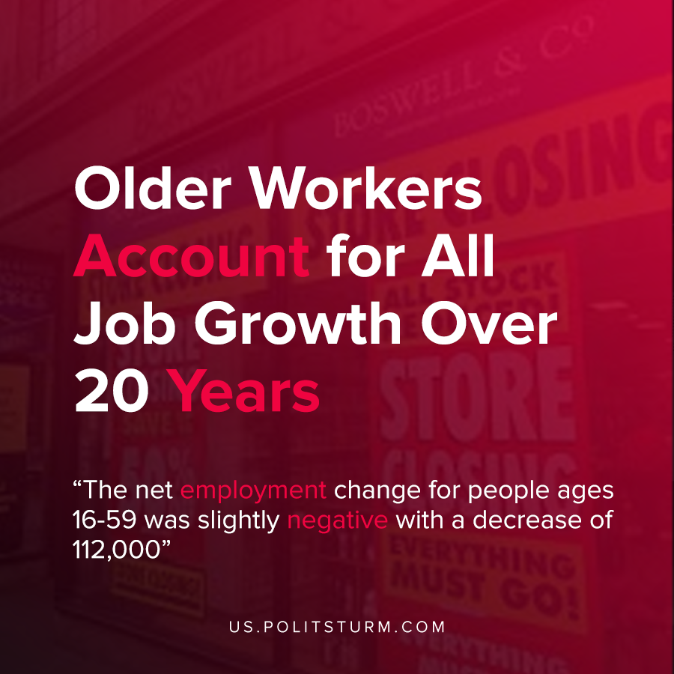

Original article
2021-02-03
1 min read

According to the St. Louis Federal Reserve economist and assistant VP William Emmons, the total U.S. employment growth over the last 20 years went to increased employment for people ages 60 or older. The net employment change for people ages 16-59 was slightly negative with a decrease of 112,000 or -1%.
Despite the younger group (16-59) being 3.8 times larger in population than the older group of workers, most of the employment growth over the past two decades went towards older workers.
At the same time, the median age of a typical U.S. worker has increased, up from 39 in 1999 to 41.9 in 2019.
To compound the difficulties faced by older workers, nearly half of Americans derive the majority of their income from Social Security. As the benefits provided by Social Security are insufficient to cover expenses and many lack pensions or private savings, older workers may have to stay in the labor market into their retirement years.
The capitalist economic system has not created employment growth for the population, but keeps employment at a level to maintain maximum profitability. Rather than providing stable employment and pensions for the elderly, the capitalist system ruthlessly exploits both the young and old. Only the replacement of the capitalist system with a planned economic system run in the interests of the working class can end this absurd arrangement.
Source: 1 , 2 , 3

Original article

