OANN Far-Right News Receives 90% of Revenue from AT&amp;T
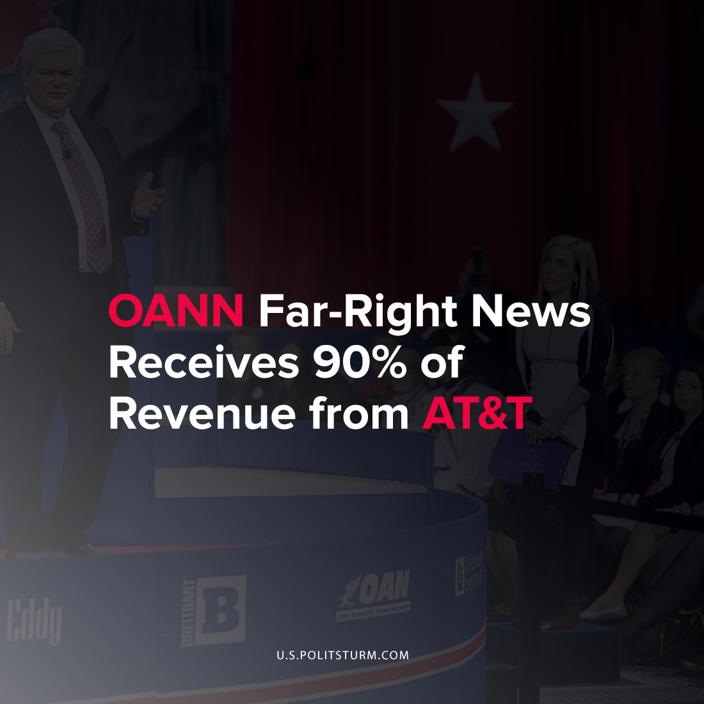

Original article
2021-10-07
1 min read

According to investigative reporting by Reuters, the far-right news network One American News Network (OAN) received significant financial and organizational backing from telecommunications giant AT&T. Testimony by founder Robert Herring Sr testified that the inspiration to create the far-right propaganda network came from AT&T executives.
“They told us they wanted a conservative network…They only had one, which was Fox News, and they had seven others on the other [leftwing] side. When they said that, I jumped to it and built one.”, said Herring in a 2019 deposition.
With respect to the funding of the organization, 90% of OAN’s revenue came from a contract with television-platforms that are sponsored by AT&T. A company accountant testified under oath that the company would have no value without the contract with AT&T.
It is apparent that despite claiming to be an “independent media company” the company receives substantial corporate backing to disseminate reactionary capitalist propaganda. It is in the interest of the ruling class of oligarchs to redirect the discontent of the workers who lack class consciousness in a reactionary manner. It is imperative that workers understand Marxist-Leninist theory and see through the charades of the capitalist class who will use any opportunity to preserve their class dictatorship.
Source: 1 2

Original article

