NVIDIA Partners with Palantir Amid Growing Militarisation
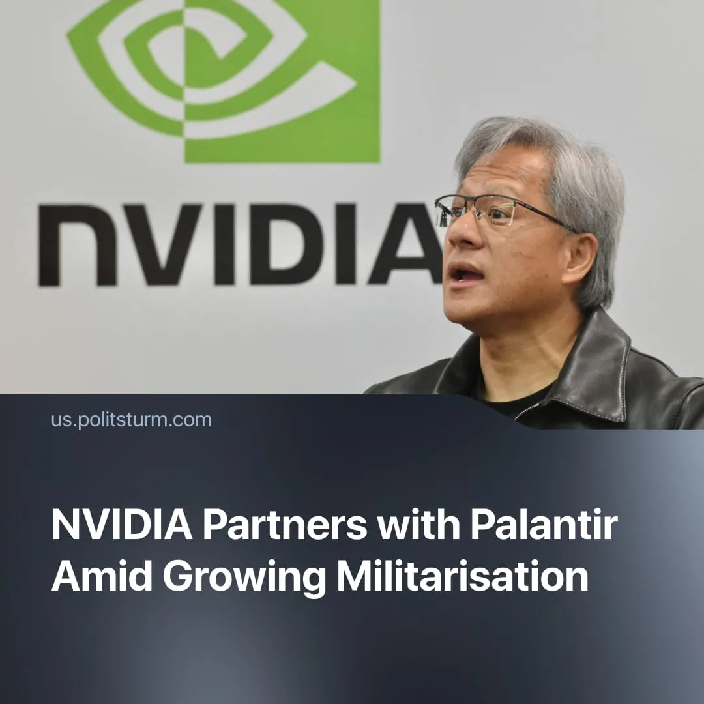

Original article
2025-11-24
2 min read

NVIDIA partners with Palantir as surveillance and military markets expand rapidly.
Details. The technological giant NVIDIA, known for its GPUs (Graphics Processing Units) and AI-focused processors, announced in late October a partnership with the controversial data analytics company Palantir. The collaboration aims to expand AI applications across sectors such as healthcare, finance, and defence.
► NVIDIA will provide Palantir with its computing power, developed AI models, and system tools. Palantir will supply its data-processing platforms, enabling the combined system to allocate resources efficiently and operate on specialised tasks.
► The partnership aims to combine NVIDIA’s powerful AI computing with Palantir’s data-processing platforms to create fast, automated decision tools. These would process huge amounts of information in real time and help organisations – including government agencies and the military – coordinate complex operations more efficiently.
Context. Both firms are expanding rapidly as AI becomes a major profit centre. NVIDIA’s revenue exploded by 114% in 2024 due to record GPU demand. In 2025, Palantir reported its first $1 billion revenue quarter with 48% yearly growth, driven by a surge in government and commercial contracts.
► NVIDIA has developed its GPU-based computing since 2006, expanding beyond graphics into AI and machine learning. Today, its GPUs power over 75% of the world’s top supercomputers, giving the company a dominant position in AI training.
► Palantir is deeply integrated into the US Army under a 10-year agreement, providing software to link databases and automate analysis using AI. Palantir has worked with New York’s police, US Defence Dept, CIA and FBI, UK Ministry of Defence and various hedge funds. and even partnered with US Immigration and Customs Enforcement (ICE).
► Palantir has deep ties with US immigration enforcement, supplying ICE with data analytics tools that aid in tracking migrants. It also has a strategic partnership with the Israeli Ministry of Defence, providing AI‑enabled platforms used for “war‑related missions.”
Important to Know. Such a partnership is no surprise – capital flows to what is most profitable – NVIDIA and Palantir are seizing government contracts as states push for new technologies for war and intelligence gathering.
► Demand for military equipment has surged as state spending escalates – the US is pushing military spending past $1 trillion; the EU is mobilising €800 billion through its Readiness 2030 plan; and China is also expanding its defence budget to around $245 billion in 2025.
► Morals are secondary to profit and the maintenance of the rule of capital. Even figures like Telegram founder Pavel Durov, who warns of the growing surveillance and champions “individual freedom”, operate from the UAE, where trade unions are banned and modern slavery is common.

Original article

