Number of World Billionaires Increases to 2,755
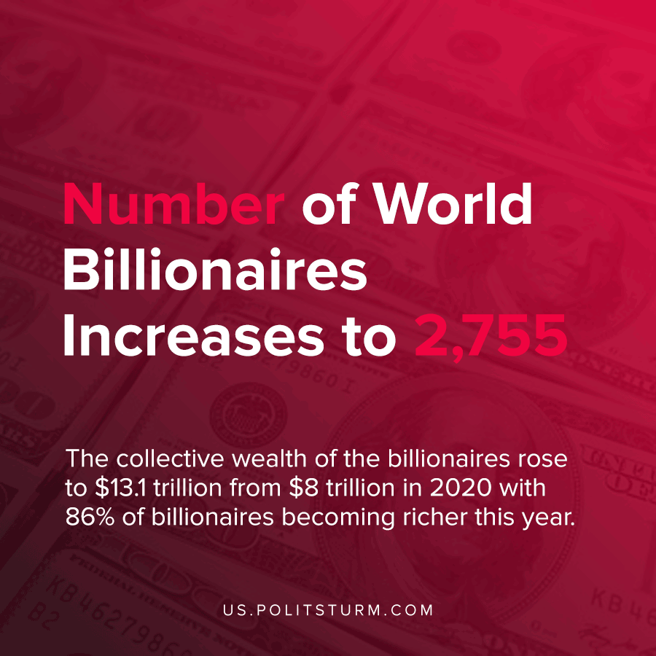

Original article
2021-04-15
1 min read

Forbes released its data surrounding billionaires in 2021 whose wealth exploded amidst the pandemic. The number of billionaires increased by 660 over the past year to 2,755. The U.S. has the most billionaires at 770 followed by China at 698 (including Hong Kong and Macao).
The collective wealth of the billionaires rose to $13.1 trillion from $8 trillion in 2020 with 86% of billionaires being richer this year.
Jeff Bezos is the richest person in the world and he is followed by Elon Musk.
Through their ownership of the means of production, and by extension the ownership over stocks and private assets, the wealthy extract surplus value by exploiting workers in production. As such, the astronomical spoils of the rich represent the massive theft of value from the global working class that exists under the capitalist mode of production.
Source: 1

Original article

