North Carolina Company Fires Employees For Not Participating in Prayer Sessions
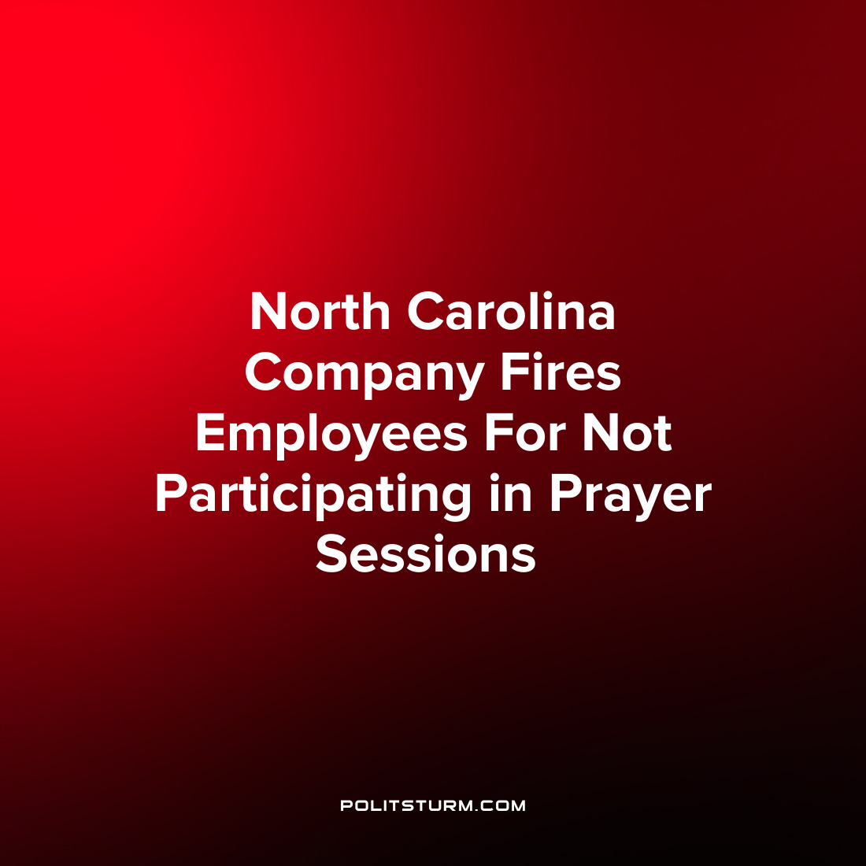

Original article
2022-06-29
1 min read

A North Carolina-based company called Aurora Renovations and Developments, LLC is accused of firing employees and taking retaliatory actions against workers who did not participate in a group prayer session.
According to the lawsuit filed against the company, Aurora conducted daily employer-led prayer meetings. These meetings were led by the company owner and included “Bible readings, Christian devotionals, and solicitation of prayer requests from employees”.
When an atheistic construction worker asked to be excused from the prayer meetings they had their pay cut and were subsequently fired. Several months later another worker was fired for not attending the religious meetings as they conflicted with their personal beliefs.
“Employers who sponsor prayer meetings in the workplace have a legal obligation to accommodate employees whose personal religious or spiritual views conflict with the company’s practice”, said the regional attorney for the U.S. Equal Employment Opportunity Commission Melinda Dugas.
Notice how the attorney does not have any issue with the conduct of a prayer meeting within the workplace, but rather the lack of accommodation to the workers with conflicting beliefs. Under the capitalist economic system there is a clear alliance between the reactionary religious forces and the capitalist class who wish to maintain their class dominance and exploitation. Relying on idealistic rhetoric and the belief in the supernatural and divine, non-material forces, the capitalist class and its beneficiaries wish to preserve their class rule. Only Marxist-Leninist theory exposes the class dynamics and the insidious role that religion can play in maintaining the existing exploitative class structure of capitalism.
Source: 1

Original article

