North Carolina Chick-Fil-A Franchisee Pays Workers with Meals
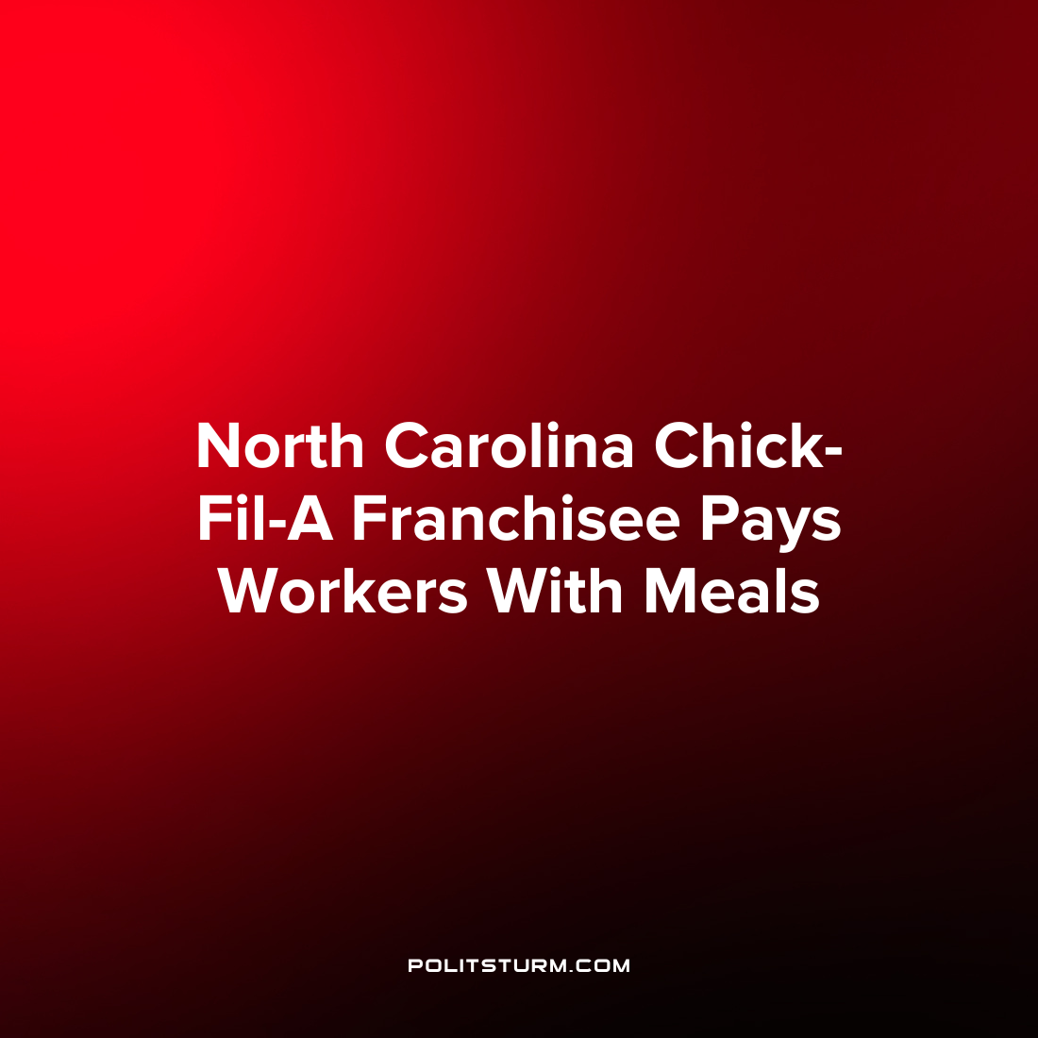

Original article
2023-01-15
1 min read

A North Carolina Chick-Fil-A Franchisee was fined $6,000 by the U.S. Department of Labor after it was found that minors were operating dangerous machinery and being paid with meal vouchers.
Investigators found that three workers under the age of 18 were operating a trash compactor which is a violation of federal child labor laws as minors cannot perform hazardous jobs. Also, certain workers who directed traffic at the restaurant were being paid in-kind with meal vouchers rather than wages, a violation of minimum wage laws.
“Child labor laws ensure that when young people work, the work does not jeopardize their health, well-being or educational opportunities. In addition, employers are responsible to pay workers for all of the hours worked and the payment must be made in cash or legal tender.”, said Wage and Hour Division District Director Richard Blaylock in a briefing.
In an effort to maximize their private profits, capitalists have no qualms about putting workers, even minors, in hazardous conditions. In addition, paying workers with meals allows capitalists to circumvent paying wages and further bolsters their private profits. The entire capitalist system is predicated upon the exploitation of the working class, and it is not uncommon for capitalists to exploit workers even beyond the boundaries allowed by their own legislature and judiciary. As we can see the fines for doing so are minimal.
Source: 1

Original article

