No Breakthrough Achieved in Direct Russia-Ukraine Peace Talks
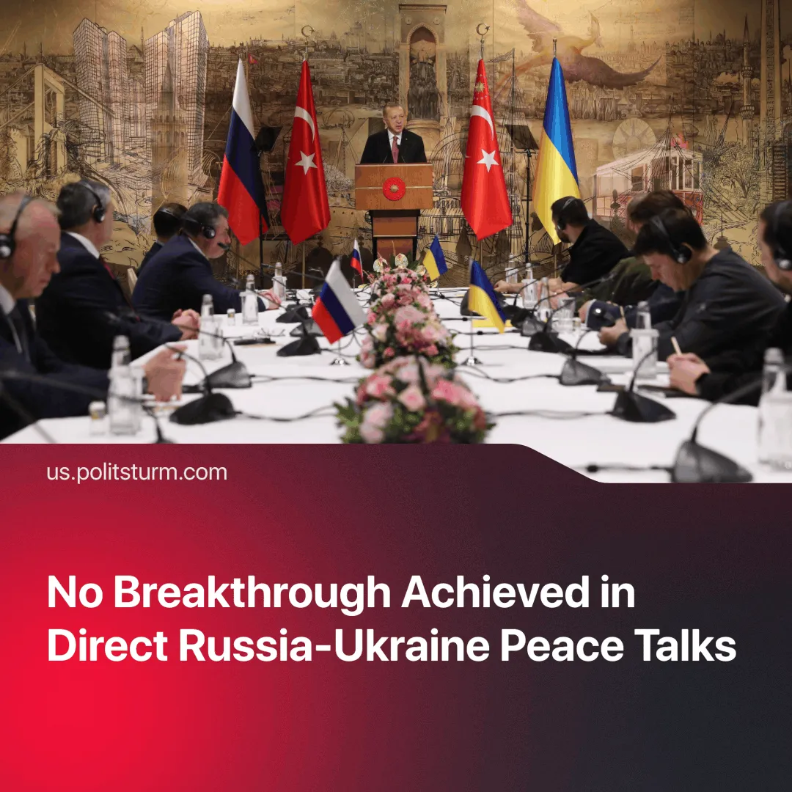

Original article
2025-05-23
1 min read

The first direct negotiations in over three years failed to yield a ceasefire or peace agreement. In contrast, a century ago, the Bolsheviks reached peace within just three months.
Details. The talk in Istanbul aimed to explore steps toward de-escalation but failed to produce concrete outcomes.
► The two delegations discussed a possible ceasefire. Besides the prisoner exchange agreement, the result was limited to vague suggestions of future negotiation rounds without any timelines or binding commitments.
► Russia confirmed its determination to ensure full control of four regions and threatened to continue to expand these territorial claims if the controlled regions were not officially transferred.
Context. Throughout the “Special Military Operation (SMO)”, Moscow and Kyiv have maintained intermittent diplomatic channels, both public and private. This was confirmed by Ukrainian MP Alexei Goncharenko, who stated talks had happened “in 2022. And in 2023. And even in 2024”.
► Talks of negotiations had sharply intensified since Trump came to power, as he began actively promoting the need for a swift end to the clashes. However, neither side is making concessions.
Important to Know. Why are the parties in no hurry to negotiate? The conflict creates a ‘siege mentality’ that benefits both sides. It diverts attention from internal crises and helps justify increased government control. has persisted for over three years.
► This pattern of closed-door diplomacy — where decisions are often made behind closed doors and elites deceive both each other and the public – is typical of imperialism. For example, the Iran-Iraq War lasted eight years. Despite repeated negotiation attempts by the UN, both sides refused to cease fire. Iran eventually agreed to a UN ceasefire resolution not because of international pressure, but because of its own war fatigue.
► In sharp contrast, the Bolsheviks took a clear and consistent approach. One of the main slogans of the October Revolution was the establishment of peace between nations. Just one month after the revolution, in December 1917, they successfully signed a ceasefire agreement with the German Empire. Three months later, they signed the Treaty of Brest-Litovsk, swiftly pulling the young Soviet Republic out of the most devastating war of that era.

Original article

