NLRB Rules Against Starbucks in Union Busting Trial
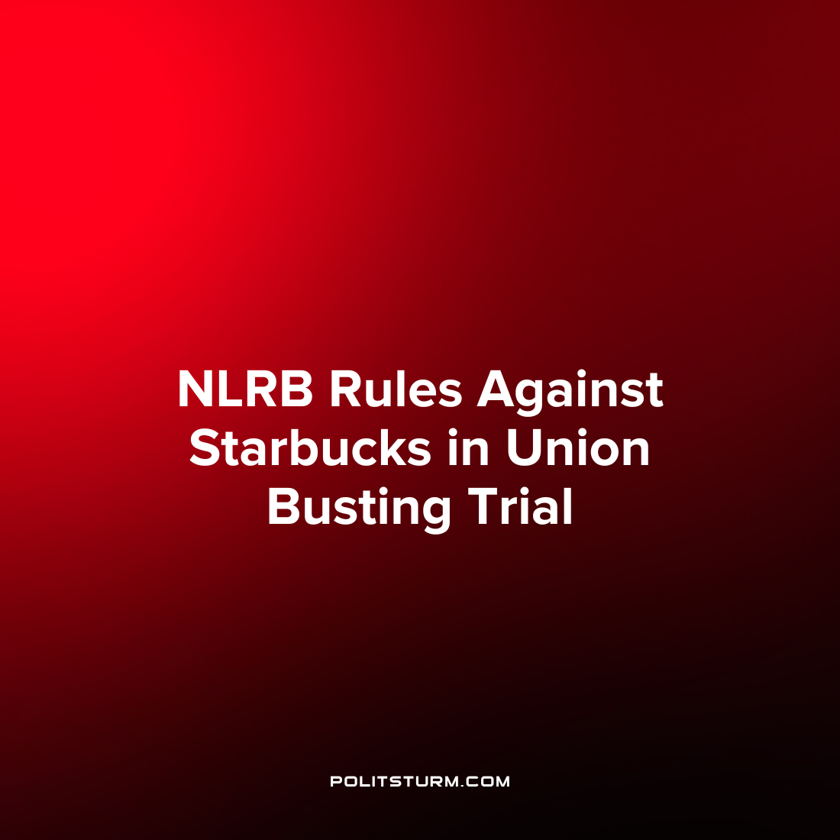

Original article
2023-03-10
1 min read

Workers at a Buffalo, New York Starbucks filed a claim against the company after allegations of retaliation surfaced once workers started organizing for unionization. National Labor Relations Board judge Michael Rosas issued a decision finding that Starbucks had violated Federal labor laws.
As part of the ruling, Starbucks was ordered to re-open the Buffalo location which was closed in retaliation for union organizing. In addition, several workers who were fired for union activities are being reinstated. Workers will also be receiving back pay for consequential damages as a result of Starbucks retaliatory acts.
“Having to reinstate all of these workers, reopen the first Starbucks location closed in the name of union-busting, and most importantly, post notices in every single store across the country for the duration of the Starbucks organizing campaign is such a massive win for us, and for the labor movement as a whole. After waiting through months of Starbucks’ stalling tactics, this will reinvigorate and re-energize the momentum of this movement, said barista Michael Sanabria.
While it is an enormous victory for the Starbucks workers who fought for their rights under the existing conditions, there is much more to be done. It is not sufficient for the labor movement to simply bargain with the capitalists and ensure ‘fair’ conditions under capitalism, but to ultimately end the system of capitalist wage slavery and oppression. The ruling is simply a slap on the wrist to Starbucks for its flagrant union-busting, but in the end the courts and legal system will serve the interests of the capitalists and the continued class rule.
Source: 1

Original article

