NLRB Proposed Ruling Threatens Student Workers Right to Unionize
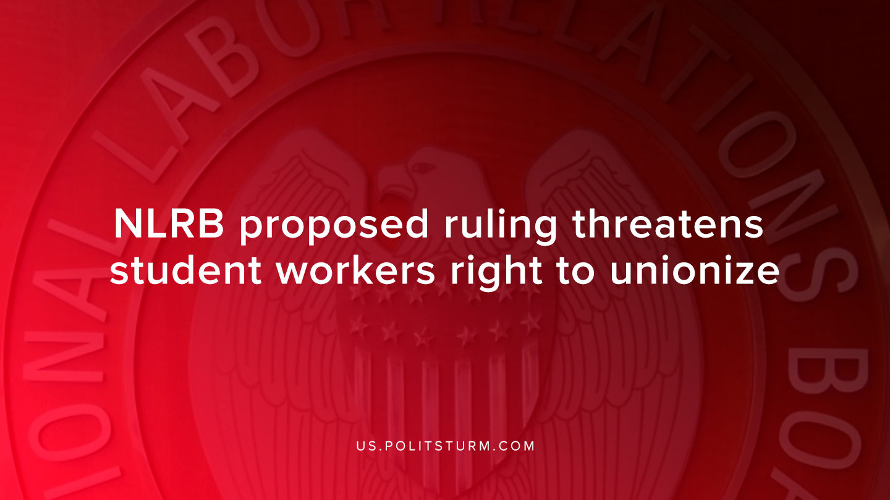

Original article
2019-09-26
1 min read

The National Labor Relation Board announced on Friday, September 20th that it will be revisiting a rule regarding student workers. Section 2(3) of the National Labor Relations Act covered undergraduate and graduate students who work for financial compensation as employees.
The argument put forth by the Board argues that the relationship between students to their school is “predominantly educational, rather than economic”. As a result, the Board is hoping to remove the organizational rights of students who are currently classified as employees.
The National Labor Relations Act allows for employees to procure “collective bargaining and by protecting the exercise by workers of full freedom of association”.
Students won the right to be classified as employees in 2016 as New York University covered both externally-funded graduate research assistants and undergraduate student assistants as employees for the first time. Now the National Labor Relations Board under the Trump administration is working to undermine the ruling by reversing it.
While the National Labor Relations Board claims to mediate the contradictory interests of capitalists and workers, it serves the interests of the capitalists. As a result, the Board is moving to curtail the right to “self-organization, to form, join, or assist labor organizations, to bargain collectively through representatives of their own choosing, and to engage in other concerted activities for the purpose of collective bargaining or other mutual aid or protection…”.
By removing the classification of these workers as employees, capitalists hope to eliminate the ability of workers to unionize and by extension protect the profits of the capitalist class. This ruling is just another example that even the institutions of government that are nominally for the interests of labor, stand with the capitalists against the workers.
Sources: 1 ,2 ,3

Original article

