Nine New Vaccine Billionaires During Pandemic
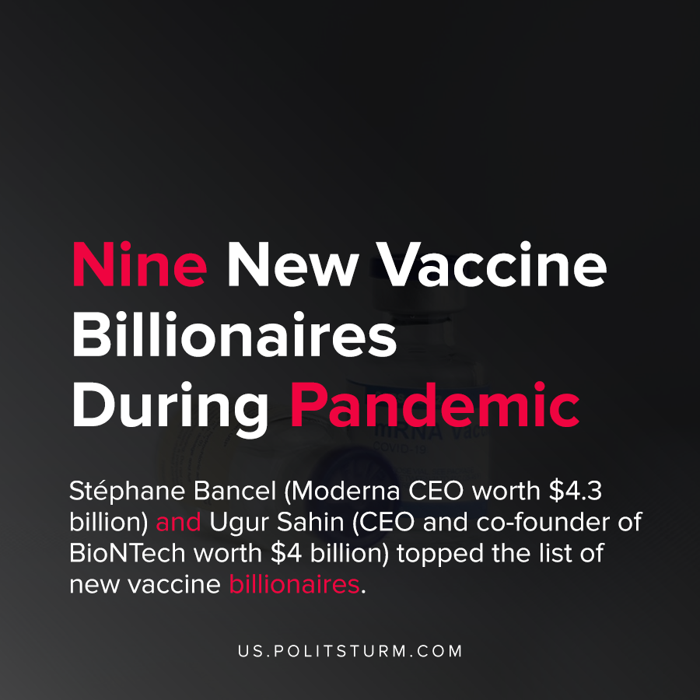

Original article
2021-05-21
1 min read

There have been at least nine new billionaires created during the pandemic from the massive profits in the pharmaceutical industry.
The combined wealth of these billionaires is $19.3 billion, while the virus continues to devastate countries like India and Nepal where a small fraction of the population are vaccinated. Oxfam’s Health Policy Manager Anna Marriott said,

“What a testament to our collective failure to control this cruel disease that we quickly create new vaccine billionaires but totally fail to vaccinate the billions who desperately need to feel safe.”
The 9 new vaccine billionaires, in order of their net worth are:
- Stéphane Bancel Moderna’s CEO (worth $4.3 billion)
- Ugur Sahin, CEO and co- founder of BioNTech (worth $4 billion)
- Timothy Springer – immunologist and founding investor of Moderna (worth $2.2bn)
- Noubar Afeyan- Moderna’s Chairman (worth $1.9 billion)
- Juan Lopez-Belmonte–Chairman of ROVI, a company with a deal to manufacture and package the Moderna vaccine (worth $1.8 billion)
- Robert Langer- a scientist and founding investor in Moderna (worth $1.6 billion)
- Zhu Tao co-founder and chief scientific officer at CanSino Biologics (worth $1.3 billion)
- Qiu Dongxu, co-founder and senior vice president at CanSino Biologics (worth $1.2)
- Mao Huinhoa, also co-founder and senior vice president at CanSino Biologics (worth $1billion)
Due to the private ownership of the means of production, investors and chief executives were able to amass monopoly profits from the production and sale of vaccines. While the virus has killed hundreds of thousands of Americans and millions around the globe, the investors privately enrich themselves.

Original article

