New York Judge Block Minimum Pay Standards for Food Delivery Workers
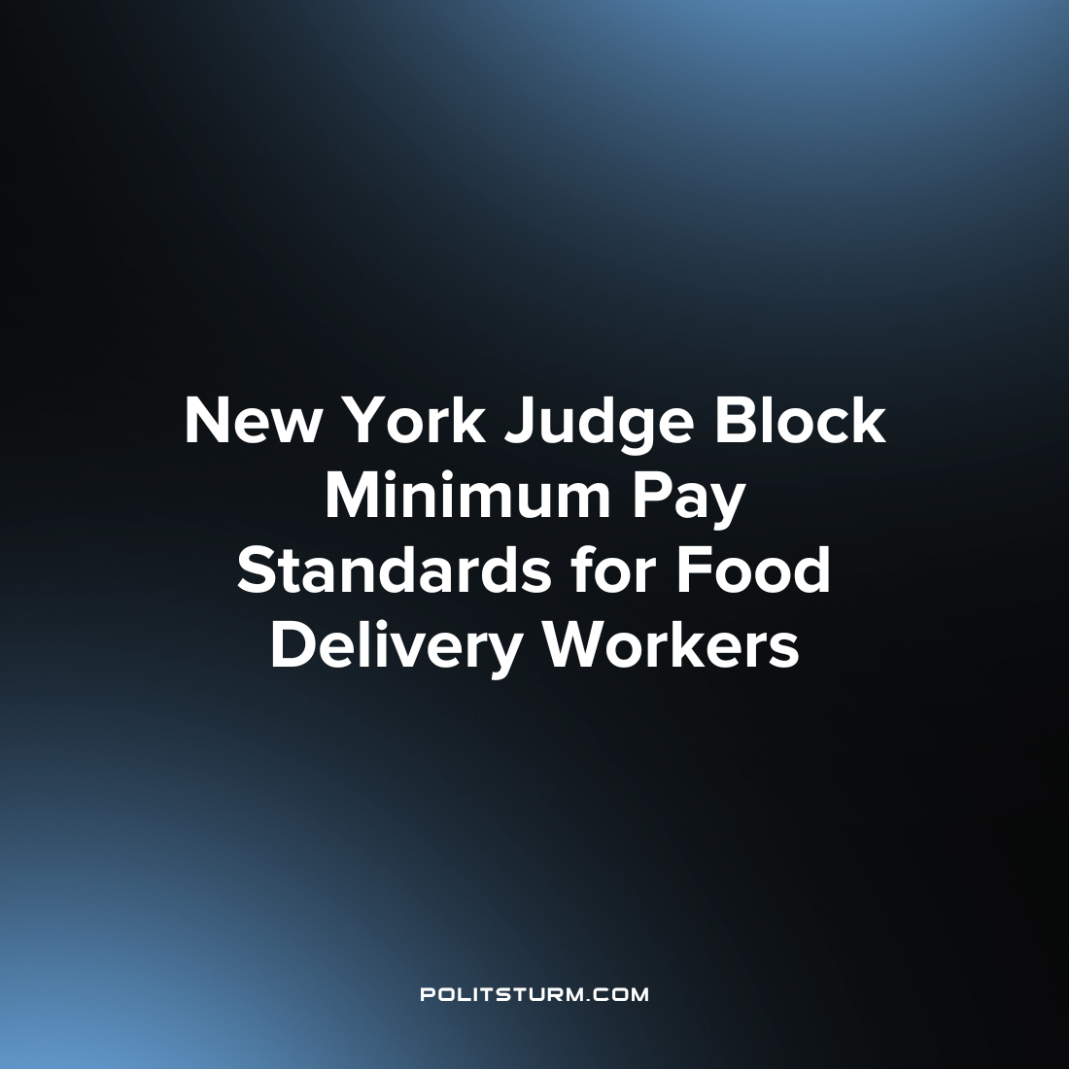

Original article
2023-07-22
1 min read

Uber, DoorDash, and other app-based food delivery companies filed lawsuits seeking to overturn a new law in New York City that sets minimum wages for delivery workers. The companies argue that the law, which requires them to pay delivery workers at least $17.96 per hour, is based on a misunderstanding of the industry and will impose unsustainable record-keeping requirements. They claim that the law will shrink service areas and raise fees for consumers and restaurants. The companies are seeking to have the law permanently struck down and implementation blocked. Proponents of the law argue that it will ensure fair pay for delivery workers who have previously earned less than the city’s minimum wage.
Prior to its introduction, the average wage for a delivery driver in New York City was around $11 per hour after expenses, which fell below the city’s own minimum wage of $15. The law has been welcomed by worker advocates who argue that it will transform the lives of many delivery workers and provide much-needed economic stability.
However, a judge has ruled in favor of the food delivery companies and has blocked the implementation of the minimum wage law. Unsurprisingly. The delivery companies were pleased with the judge’s ruling.
“We are pleased with the judge’s decision today to delay implementation of a rule that, if allowed to stand, will have serious adverse consequences for delivery partners, consumers and independent businesses”, said Grubhub in a statement about the decision.
This is just another example of the judiciary playing their role in capitalist society, namely serving the interests of the oligarchs against the interests of the masses. Delivery companies make massive profits off a pool of labor which they can exploit beyond the typical minimum wage requirements and the judge has, at least temporarily, restricted the implementation of minimum wage requirements. Under capitalism, the judiciary serves to protect the propertied interests of the ruling class, namely the capitalists, who grow their fortunes off the exploitation and immiseration of the workers.
Source: 1 2

Original article

