New UK PM to Borrow Billions to Cut Energy Bills
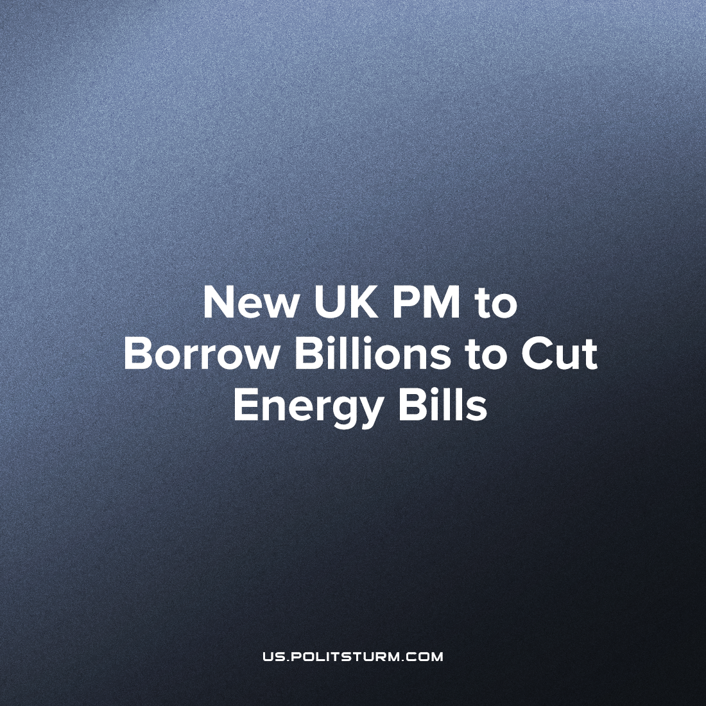

Original article
2022-09-14
3 min read

New Prime Minister of the United Kingdom, Liz Truss, has pledged to solve the British cost-of-living crisis that currently grips the country. This year inflation has surpassed 10% and the price of many essential or basic goods and services has skyrocketed even beyond this and are now unaffordable for much of the British population.
The chart below outlines some of these price increases.
Error loading image
In monetary terms, an average household’s yearly energy bills will have increased from £1,971 to £3,549. Considering the mean average UK salary is £31,447 (the median salary is £25,971 – the mean average is much larger as it is increased by the top percentile of salaries), the situation is made clear. The average worker’s entire salary is not sufficient to cover energy bills, food, transportation, water, rent and other necessities. And while the predicament of the average British worker is frightful, the fate of the poorer or unemployed workers is a downright nightmare.
Error loading image
The British government’s solution to this crisis was first to offer a maximum pay out of about £2,640 to some of the poorest households that qualify, to make small cuts to certain taxes for the lowest income brackets and to raise the minimum wage to £9.50 per hour (£19,760 per year for a 40 hour week). It is important to note that very few households are eligible for the maximum pay out, as they would need to have a person with a disability, a pensioner and all workers need to be on the lowest income bracket. Considering energy bills alone, this is still woefully inadequate for the average working-class household (who don’t even qualify for the additional support), let alone the poorest households.
Now the British government, under the new Prime Minister Liz Truss, has announced plans to borrow over £100 billion under the pretext of easing the energy bills. This large sum will be given to the private energy corporations, in order to subsidise the energy bills for households. This might seem like a step in the right direction to the untrained eye, however these same energy companies are projected to make record profits of £170 billion over the next two years. The British state is increasing the national debt, not to ensure the survival of its people, but to ensure the profits of its richest capitalists.
As Marx said (in Capital Vol, 1 Chapter 31), “The only part of the so-called national wealth that actually enters into the collective possessions of modern peoples is their national debt. Hence, as a necessary consequence, the modern doctrine that a nation becomes the richer the more deeply it is in debt.” These words ring more true now than ever. The national debt is increased to cover the costs of the energy barons, and decreased by the blood, sweat and tears of the working class; the wealth of the capitalists creates the poverty of the workers.
The solution, as more and more workers in Britain are realising, is not to take this impoverishment lying down, not to trust in the government’s ability and goodwill to handle the crisis, not to accept the calls from the Bank of England to refrain asking for wage increases, but to fight – independently – for their rights and resist immiseration. And to eventually realise that a better world is possible. Due to the increasing efficiency of modern production, it requires less and less labour to create goods and services. Yet the only reason and obstacle that this does not translate to one needing to work less and less in order to afford said goods and services, and that instead these basic goods and services are rendered more and more expensive, is the capitalist system. This was proven in reality, for example, in the Soviet Union, after the Second World War, where the prices for basic goods and services (especially staple foods) were reduced each year.
Source: 1 2 3 4 5 6 7

Original article

