New Study Shows Deaths from Capitalism in the UK
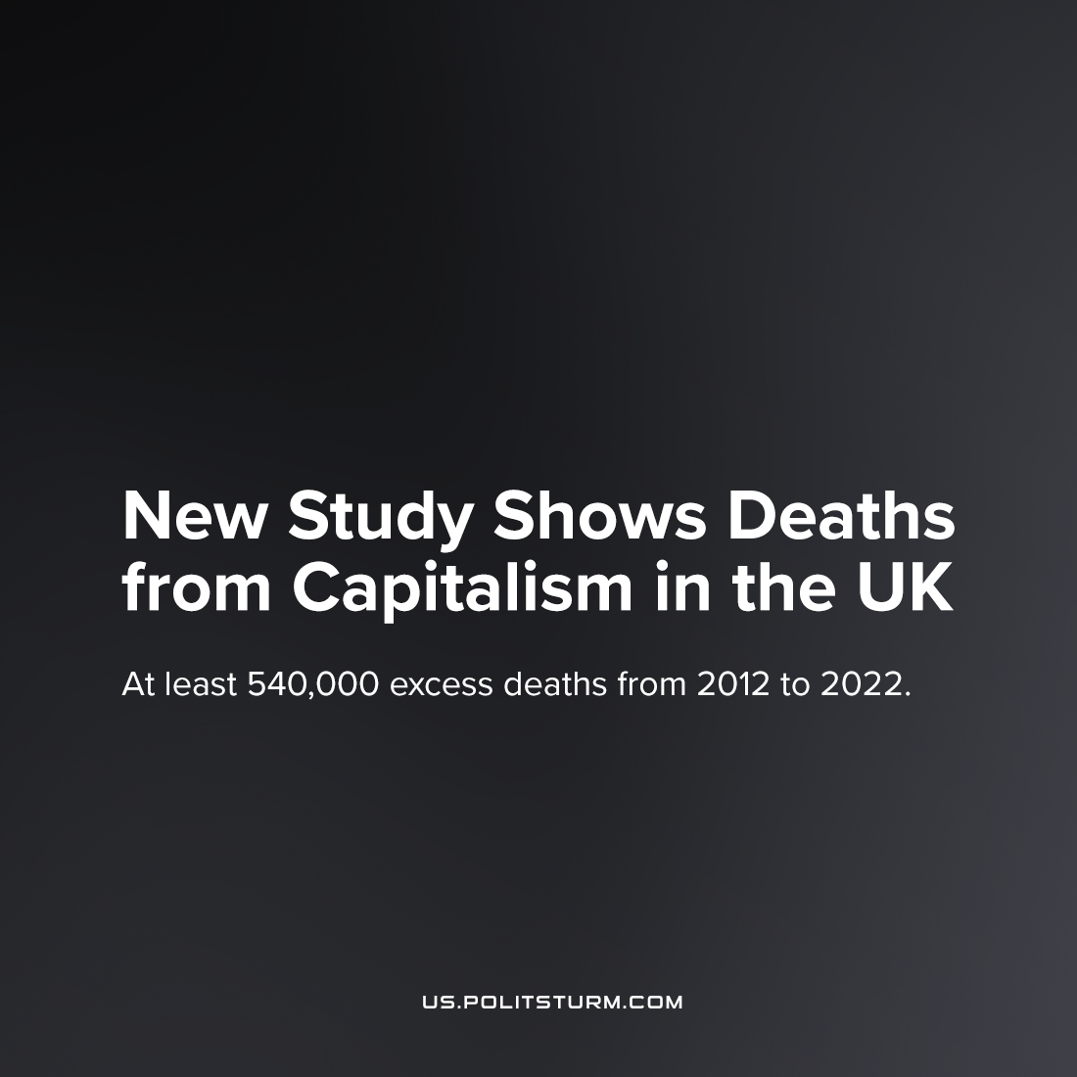

Original article
2022-10-10
4 min read

Recently, a study was published in the Journal of Epidemiology and Community Health outlining excess mortality in the United Kingdom over the past ten years. The study revealed that between 2012 and 2019 over 335,000 more people died than was projected. Expected deaths were defined by following the same mortality trend from 1981 to 2011. It should be noted that this trend does not solely include natural death, but contains its own share of untimely, unnatural deaths. But three hundred thousand deaths in ten years are just the tip of the iceberg of the absolute numbers of excess deaths in the UK over this period.
The time period the study looks at predates the COVID-19 pandemic, which has claimed more than 200,000 lives (according to national data), due to the UK government’s criminal handling of the crisis, as well as overlooking the record-breaking heatwave earlier this year which had caused 3,000 excess deaths, also caused by uninhibited capitalist production via its effects on global climate. Overall, the total excess mortality over the past 10 years is really closer to 540,000 at the very least, and this is only a conservative view.
The study uses national data (as opposed to extrapolation from smaller samples) as well as the fact that mortality is an objective and robust indicator, therefore the results should be viewed as sufficiently scientifically rigorous. The time period for the data used starts in 2012 as that was shortly after the institution of new “austerity” policies by the government, particularly the cuts to social security and vital services, which are seen as the root cause of this spike in deaths. The study highlights the approximate loss of social security income due to cuts for different groups — the highest of which being single parents who have lost 25% of their entire annual income. It goes on to underline how women in general have lost more to cuts than men, and minority ethnic Britons lost more compared to native Britons. While the recipients of these hamstrung services are predominantly women (i.e., single parents and single pensioners), the greatest increase in mortality was among men. This demonstrates that while sex-based and racial oppression are objective phenomena to be implacably struggled against, what unites these various groups, who together bear the tragedy of these deaths, is their class. The increase in excess mortality was highest amongst the households with the lowest incomes as well as within the most deprived regions. To deny the primacy of class and divorce the battle for women’s liberation, and the fight against racism and other dark prejudices from the struggle against capital is to hand these movements over to the bourgeoisie who will inevitably use them to divide the working class for their own benefit.
While the “austerity” policies of the UK government have clearly led to increased immiseration amongst the working class of Great Britain, this is of no concern to the ruling class in British society. Happily, they sacrifice millions at home and unspeakable numbers abroad to fuel the sputtering engines of their moribund system. As Britain’s position and profit margin within the international imperialist hierarchy slip, British capital must intensify exploitation at home in order to extract greater profit – necessitating “austerity” policies by the British government and the curtailment of the “welfare state” – even knowing the cost it will have on the strength and health of the British people. To put an end to the rising tide of death, and without simply exporting it to other countries, we must bring an end to the capitalist system ruling the country and the world.
Engels’ words, which ring so truly today, can explain the situation further:

“When one individual inflicts bodily injury upon another such that death results, we call the deed manslaughter; when the assailant knew in advance that the injury would be fatal, we call his deed murder. But when society [Engels’s footnote: When as here and elsewhere I speak of society as a responsible whole, having rights and duties, I mean, of course, the ruling power of society, the class which at present holds social and political control, and bears, therefore, the responsibility for the condition of those to whom it grants no share in such control] places hundreds of proletarians in such a position that they inevitably meet a too early and an unnatural death, one which is quite as much a death by violence as that by the sword or bullet; when it deprives thousands of the necessaries of life, places them under conditions in which they cannot live – forces them, through the strong arm of the law, to remain in such conditions until that death ensues which is the inevitable consequence – knows that these thousands of victims must perish, and yet permits these conditions to remain, its deed is murder just as surely as the deed of the single individual; disguised, malicious murder, murder against which none can defend himself, which does not seem what it is, because no man sees the murderer, because the death of the victim seems a natural one, since the offence is more one of omission than of commission. But murder it remains. I have now to prove that society in England daily and hourly commits what the working-men’s organs, with perfect correctness, characterise as social murder, that it has placed the workers under conditions in which they can neither retain health nor live long; that it undermines the vital force of these workers gradually, little by little, and so hurries them to the grave before their time.”
Sources: 1, 2, 3, 4

Original article

