New Protests in the South-West of Kazakhstan
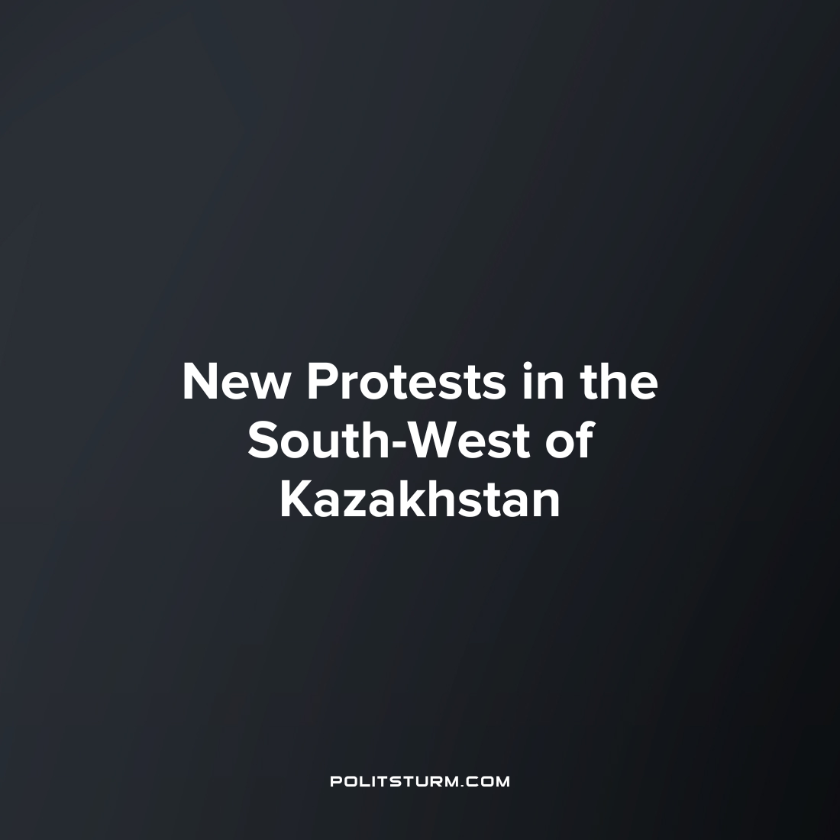

Original article
2023-05-29
2 min read

In Zhanaozen, about two thousand people protested the arrest of oil workers attending an unauthorized rally in Astana.
Error loading image
The head of the Zhanaozen administration urged the protesters to calm down and not to succumb to provocation:
"In the holy month of Ramadan, I urge everyone to calm down. Not knowing the essence of the issue, I ask you not to succumb to emotions and calls of provocateurs, not to commit any illegal actions."
Earlier, according to the Astana Police Department, more than 100 oil workers from Zhanaozen were detained. On April 11th, there were strike actions in the surrounding regions, affecting a number of companies such Ozenmunaigas JSC, Ozenmunaiservice LLP, and Burgylau LLP.
Workers of an oilfield service contracting company came to protest against the loss of jobs due to the organization's loss of drilling tender and the dissolution of the positions. A rally was held over-night in front of the office of the national oil and gas company "KazMunayGas".
The workers demanded employment. In response, the company refused and offered employment through a contracting organization. The workers rejected the offer and continued the protest.
The police subsequently dispersed the protesters. The press service of the department comments:
"Since yesterday, a group of employees of an oil industry service company organized an unauthorized rally in the capital… In connection with the violation by the protesters of the law "On Peaceful Assemblies"... a number of organizers and active participants of the action were taken to the police."
Zhanaozen represents a deep memory of the Kazakh working class, where in 2011 it was the site of the "Zhanaozen massacre" in which many protestors including striking oil workers were shot to death, inciting a national wave of protest.
As monopolization increases its ownership of the Kazakh oil fields, these conditions will only worsen as international capital increases its willingness to bring in non-local labor and further undermine the precarious position of Kazakhstan's oil workers. This situation is a characteristic feature of capitalism, which cannot be eliminated within the framework of this socio-economic system. The capitalist economy has left these workers without earnings. For the sake of preserving and increasing profits, capitalists do not care about the lives of ordinary workers, and they can easily reduce them and replace them with cheaper labor from among the thousands of unemployed who agree to work on any conditions.
In such a situation, what can the workers do? To unite in collectives, to act as a united front for their common interests and to study Marxist-Leninist theory. Only under the leadership of the Communist Party is it possible to change the existing economic system and provide workers with a decent life.
Source: EADaily - "Mass protests broke out in the south-west of Kazakhstan" on April 11, 2023.

Original article

