New ICE Policy Targets International Students
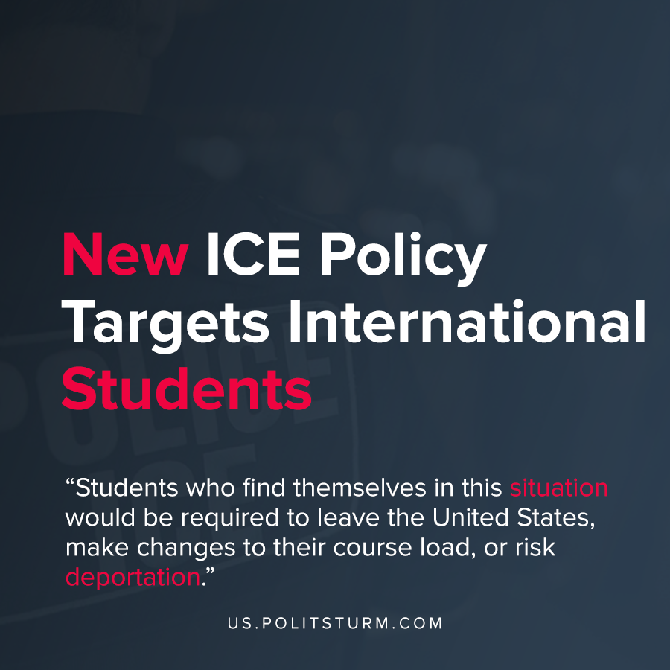

Original article
2020-07-08
1 min read

A new memo released by the U.S. Immigration and Customs Enforcement (ICE) would prohibit immigrants taking online-only classes from remaining in the United States.
“Nonimmigrant F-1 and M-1 students attending schools operating entirely online may not take a full online course load and remain in the United States. The U.S. Department of State will not issue visas to students enrolled in schools and/or programs that are fully online for the fall semester nor will U.S. Customs and Border Protection permit these students to enter the United States”, according to the memo.
Students who find themselves in this situation would be required to leave the United States, make changes to their course load, or risk deportation.
The move comes in light of the Trump administration executive order that barred entry of immigrants to the United States under the guise of protecting “already disadvantaged and unemployed Americans from the threat of competition”.
The Trump administration and the increased immigration enforcement appeals to the nationalist, chauvinistic elements that have dominated the Trump administration’s policies and actions throughout his presidency. Not only is the Trump administration discriminating against the immigrants within the United States, now non-immigrants who pay for education within the United States are targeted based on policies they have no control over.
The Trump administration and the increased enforcement by immigration authorities is a tool to undermine the unity of the working class. It also serves to promote a false unity between the oligarchs represented by Trump, and the working masses in the United States under the banner of a single national entity. However, to the class conscious worker it is clear that Trump and the entire capitalist system is the root cause for the instability and fracturing of American society, not immigrants and students from foreign countries.
Sources: 1 , 2 , 3

Original article

