New Hampshire Passes “Anti-Woke” Education Bill
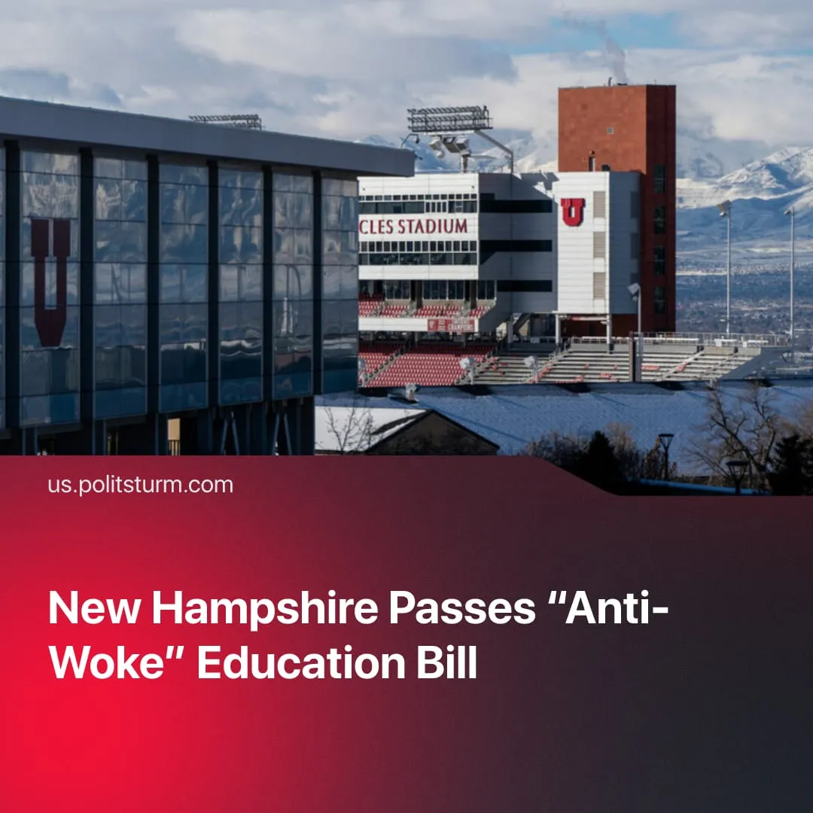

Original article
2026-03-05
1 min read

New Hampshire has passed an “anti-woke” education bill, invoking the name of Charlie Kirk to explicitly outlaw class-based analysis in education.
Details. The New Hampshire state legislature passed House Bill 1792 – the “CHARLIE” Act – backed by Republican legislators and conservative organisations. The bill advances an “anti-woke” education agenda and will be implemented through changes to public school curricula, teacher training, and state oversight.
► Section 3 of the bill bans education promoting “dialectical world-views” or “critical consciousness,” and prohibits “using dialectical analysis to frame history or current events as class-based conflicts.”
► These measures are justified through “anti-woke” rhetoric and chauvinist framing, with supporters claiming the bill protects students from radical indoctrination. Nationalist and pro-capitalist ideas are actively promoted as the acceptable and ‘neutral’ framework of education.
Context. In the US, this marks a further expansion of anti-communism, building on measures under Donald Trump such as the criminalisation of “antifascism” and the launch of state-backed “Anti-Communism Week.” This direction is bipartisan, reflected in a congressional vote condemning the “horrors of socialism,” backed by both Republicans and Democrats.
► Similar trends are accelerating internationally, including bans on communist organisations and expanded state surveillance – such as the UK government awarding major contracts to Palantir, whose UK head is the grandson of Oswald Mosley, leader of the British Union of Fascists.
► The bill is named after Charlie Kirk, a far-right commentator who was publicly assassinated, continuing the Trump administration’s use of his image as a nationalist symbol and rallying point for reactionary policies.
Important to Know. Marxism was never really taught in US schools. The “CHARLIE” bill targets an invented threat, echoing longstanding right-wing conspiracy narratives used to justify further repression.
► Right-wing commentators claim that “cultural Marxism” has infiltrated education and culture to undermine American values. In reality, Marxism is already actively suppressed – academics who apply it seriously face institutional barriers in hiring, funding, and publication.
► This conspiracy mirrors the Nazi notion of “cultural Bolshevism” – that socialist and progressive ideas were part of a deliberate plot to weaken the nation – historically used to justify censorship, ideological purges, and the repression of dissenting thought.

Original article

