Nearly 80% of American Workers Live Paycheck to Paycheck
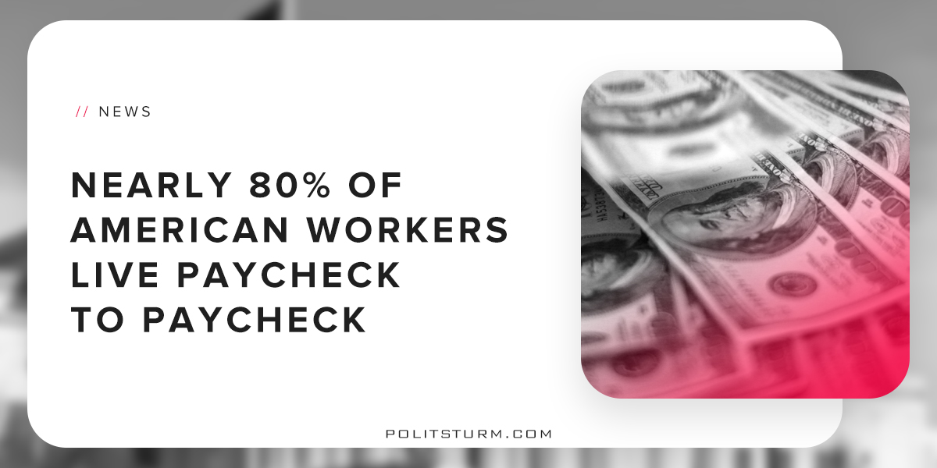

Original article
2018-08-17
2 min read

78% of workers are living paycheck to paycheck, according to a report by CareerBuilder. Most Americans also acknowledged that they are in debt and that they likely will always be indebted. Even the 10% of workers earning more than $100,000, who are among the best-paid workers, are struggling to make ends meet.
The study blames the fact that worker incomes have not kept pace with cost of living increases. As the stock market has hit record highs the contrast between the “1%”, or capitalist class, and the working class has become more stark and transparent.
The working class is only able to survive by selling their ability to work in exchange for a wage. Although productivity has risen, the gains have not translated into higher wages for American workers but into higher profits for investors and executives. Unions are weaker than they have been at any point in recent history, while at the same time profits are astronomical. These are two sides of the same coin due to the class differences between workers and capitalists.
Industrial production has largely shifted out of the United States, decimating the “rust belt” as highly paid industrial work moves out of the country in search of lower wages. The United States has lost almost 1 million manufacturing jobs since the official start of the 2008 recession, even according to its own statistics. There are fewer well-paid jobs in the country and as a result workers are struggling to make ends meet.
The capitalist class, in contrast, have been the chief beneficiaries of the booming stock market and stagnant wages. By buying shares of stocks and other securities on the market, the shareholders are able to appropriate a portion of the profit produced by the working class. The dividends, interest, and capital gains that accrue to these individuals comes from the unpaid labor of working people. The more the bourgeois class can suppress wage growth, the more money they make.
The diametrically opposed interests of the working class and the oligarchs forms the basis for class struggle and conflict. The government represents the interest of the dominant, oppressor class which explains why so little has been done to help the plight of those living paycheck to paycheck. As long as the government represents the interests of the billionaires and wealthy we will continue to see these mediocre results.
https://www.cnbc.com/2017/08/24/most-americans-live-paycheck-to-paycheck.html
https://fred.stlouisfed.org/series/MANEMP

Original article

