Near-Poor Pay More Receive Less Medical Care
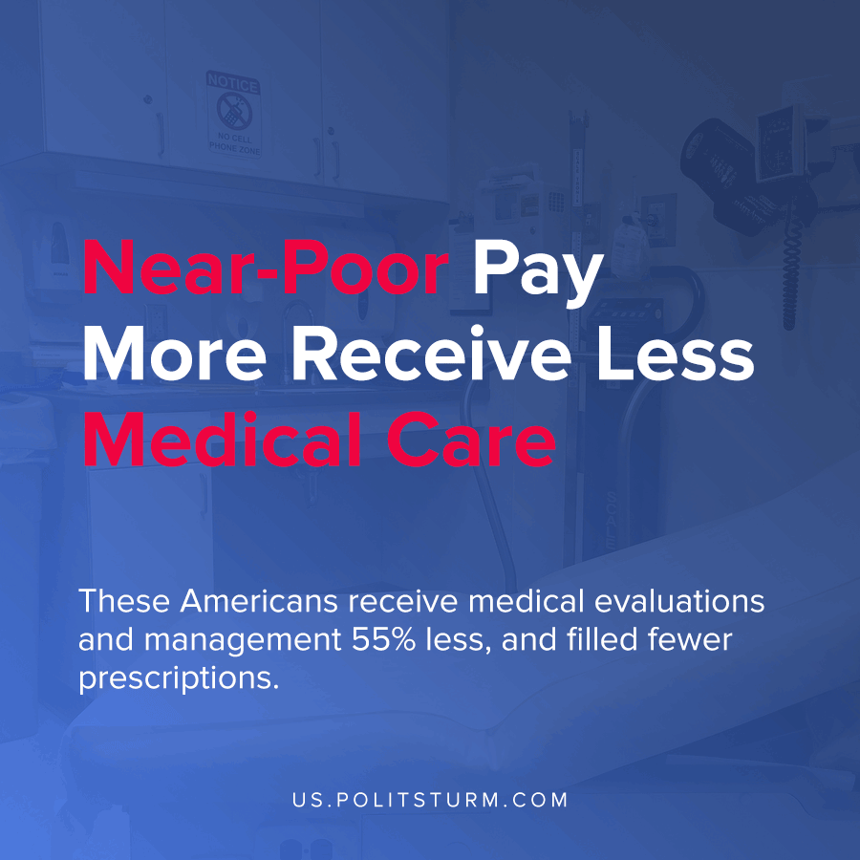

Original article
2021-04-07
1 min read

According to new research featured in the peer-reviewed journal Health Affairs, Americans near the poverty line end up paying a large percent of their incomes on medical expenses. For those who do not have supplemental insurance from Medicaid, insurance provided by an employer or a Medigap plan, an additional $2,288 is spent in out-of-pocket spending over the period of two years.
These individuals who pay a substantial amount in out-of-pocket costs for being just above the poverty level which would qualify for government assistance also receive less medical care. These Americans receive medical evaluations and management 55% less, and filled fewer prescriptions.

“Expanding eligibility for Medicaid supplemental coverage and increasing take-up of Part D subsidies would lessen cost-related barriers to health care among near-poor Medicare beneficiaries.”, the authors conclude.
Those who are unable to afford out-of-pocket costs through the market forgo care and treatment while paying large proportions of their income on limited care. A system with high-costs, poor outcomes, and insufficient health coverage exists because it is profitable for the capitalist class who privately benefit from this arrangement.
Source:1

Original article

