NATO Raises Military Spending to ‘Cold War Levels’ for War Preparations
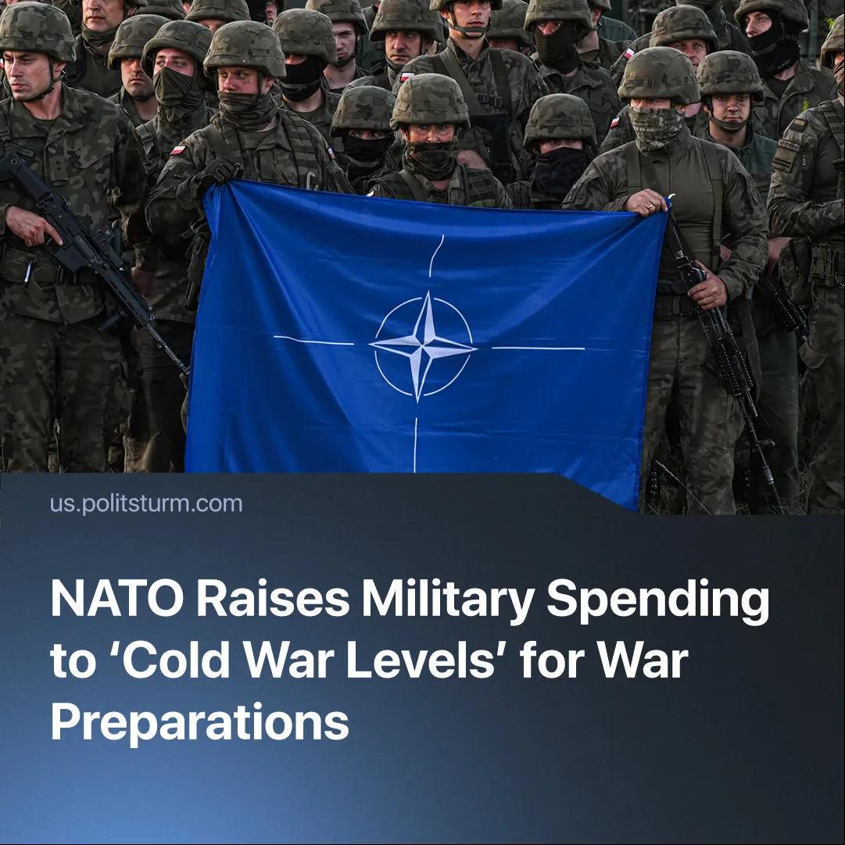

Original article
2025-07-02
2 min read

European NATO nations have agreed to drastically increase military spending, as imperialist blocs consolidate and prepare for the redivision of the world through a third imperialist war.
Details. Leaders of the European member states joined US President Trump at the 2025 NATO summit. They agreed to substantially raise military spending and reaffirmed their alliance.
► NATO member states pledged to invest 5% of GDP in ‘defence’, a major increase from the previous target of a minimum 2% of GDP.
► The new plan requires allies to submit annual progress reports and to meet capability targets. 3.5% of the new 5% target would be spent directly on the core military budget, whilst another 1.5% would be invested to build out the supporting military-industrial infrastructure.
► Trump called the meeting a “big win” for the West. He has finally won European cooperation in his long-running campaign to stop their “freeloading” off of American protection.
Context. Russia currently produces multiple times more tanks and munitions than NATO states. To match other imperialist powers’ production numbers, NATO states are continuing to mobilise a ‘war economy’, investing in their ‘defence-industrial base’, as we have previously covered.
► European states have become increasingly aware of their overreliance on the US ally for continental defence: the EU’s recent Readiness 2030 plan follows calls from French President Macron and German Chancellor Merz for stronger European armies.
► The ‘special military operation’ in Ukraine and Israel’s war in Gaza drag on. Momentary outbreaks of conflict are becoming more common, such as Israel vs. Iran and India vs. Pakistan. The US hegemon is now also acting with a more hawkish foreign policy, and is trying to bring its “partners” closer, which reveals Trump’s ‘isolationist peacemaking’ as a deception.
Important to Know. Trump’s approach — offloading the cost of fighting Russia onto European states — gives the US short-term gains and arms profits. But in the long run, militarisation could undermine US control over Europe by making the EU less dependent on American protection.
► A Secretary-General of NATO once said the purpose of the alliance is “to keep the Russians out, the Americans in, and the Germans down.” The long-term trend now appears to be the dissolution of this formula. The Americans are also being pushed out of Europe, and the Germans are rising up (alongside the French). Through measures such as independent military forces and advancing the Euro as a global reserve currency alternative to the US Dollar, the EU capital bloc ever more confidently asserts its sovereignty against US control.
► Trump’s tariffs have deepened the long-existing wedge between US and EU imperialism, their inherently unstable ‘partnership’ having shown increasing cracks since the end of the Cold War. However, as the outcome of this NATO summit shows, the present instability and common threats have driven the two blocs to continue cooperation for now.

Original article

