NATO Claims “Not Ready” For War Despite Record Military Budgets
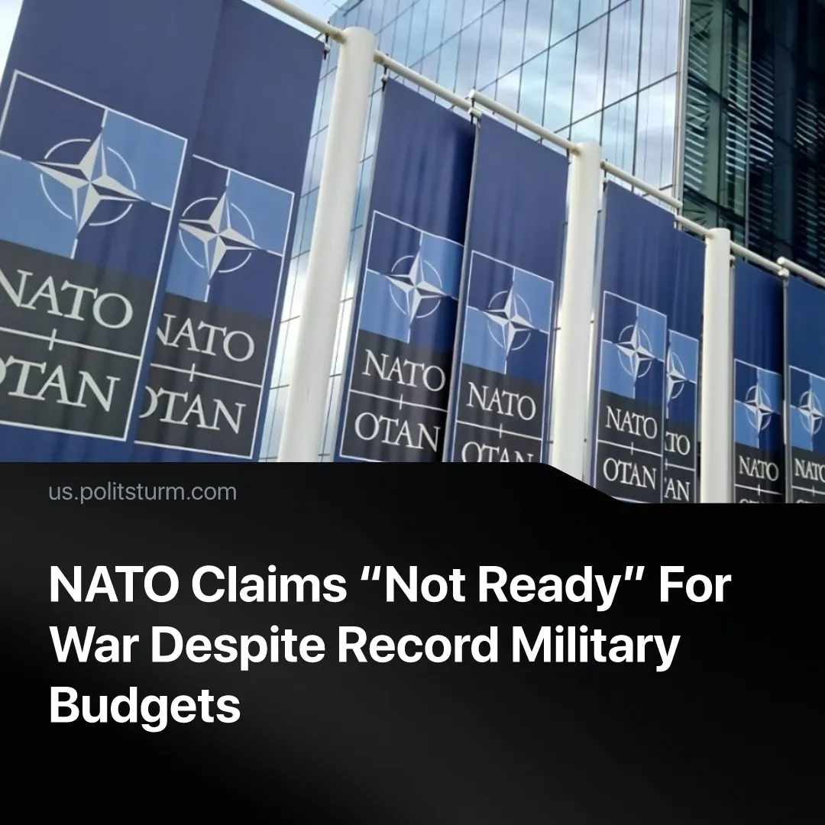

Original article
2026-09-24
2 min read

US and NATO generals are demanding more military production over alleged Russian-Chinese attack, although the Western bloc is already more militarized and is developing its own war plans against rivals.
Details. In an interview with The Atlantic last month, the Director of the NATO Defense College’s Research Division, Florence Gaub, was asked about the scenario of a coordinated Russian-Chinese attack. The official claimed NATO is too weak and unprepared for such a conflict.
Quote: “Let’s just say this is the scenario we’re currently not ready for”.
► Gaub suggested that NATO is “keenly aware” of its lacking readiness for war, echoing previous statements from Western officials. Last year, US Supreme Allied Commander Europe General Grynkewich publicly demanded more arms production in order to meet the threat of a simultaneous attack by Russia and China.
Quote: “Each of these threats that are out there cannot be viewed, in my estimation, as discrete challenges. We’ve got to think about how all of them are aligning. [...] That, to me, means that both of these things could happen together. [...] We’re going to need every bit of kit and equipment and munitions that we can in order to beat that”.
► This followed NATO Secretary-General Mark Rutte’s 2025 warning that Russia and China plan to invade Europe and Taiwan simultaneously, with the supposed aim of overwhelming Western forces. Since then, this narrative of being encircled in a two-front war, and of a readiness gap, has been propagandised to justify further NATO militarisation.
► In recent weeks, US and European intelligence issued warnings claiming that Russia plans to attack NATO within months. Meanwhile, US defense officials warned of “beyond critical” shortages of European armaments, as further budget increases are proclaimed the solution.
In reality, the US Pentagon will receive its largest budget in history, spending more than Russia and China. Even adjusted for PPP, America’s planned increase to a $1.5 trillion military budget exceeds the combined $1 trillion spent by Russia and China last year.
► European NATO countries outnumber Russia militarily – even without US support: 1.47 million active duty troops and 7,000 tanks compared to 1.26 million soldiers and 5,000 tanks. Similarly, the US Navy alone continues to outweigh the Chinese fleet nearly 5:3.
► American arms production is already surging. During the Iran war, US President Trump has ordered the military-industrial complex to quadruple production of munitions. Arms monopolies continue to receive highly profitable contracts to expand militarization.
► The US Pentagon itself drafted new war plans targeting Russia and China, strategizing the use of tactical nuclear weapons against them. In 2026, all imperialist powers continue to militarize and prepare war plans against each other, because each financial capital inherently needs to expand.
Context. Historically, imperialists used similar hysteria over “encirclement” and “unpreparedness for war” to justify arms races. In 1906, German Chancellor Bülow condemned the Triple Entente of rivals Russia, France and Britain which he claimed were surrounding Germany.
Quote: “A policy aiming at the encirclement of Germany and seeking to form a ring of Powers in order to isolate and paralyze it would be disastrous to the peace of Europe. [...] Pressure provokes counter-pressure”.
► In the following years leading up to 1914, Germany’s General Staff used this “encirclement” narrative to push for a massive defense spending increase, claiming the army wasn’t ready to fend off a simultaneous attack by France and Russia, and thus needed more weapons.
► Despite both sides of World War I claiming they weren’t responsible for aggression, the rival imperialist powers all drafted offensive war plans against one another beforehand. For example, Germany had developed the Schlieffen Plan against France, while France devised its own invasion – Plan XVII – against Germany.

Original article

