NATO Chief Urges World War Preparation
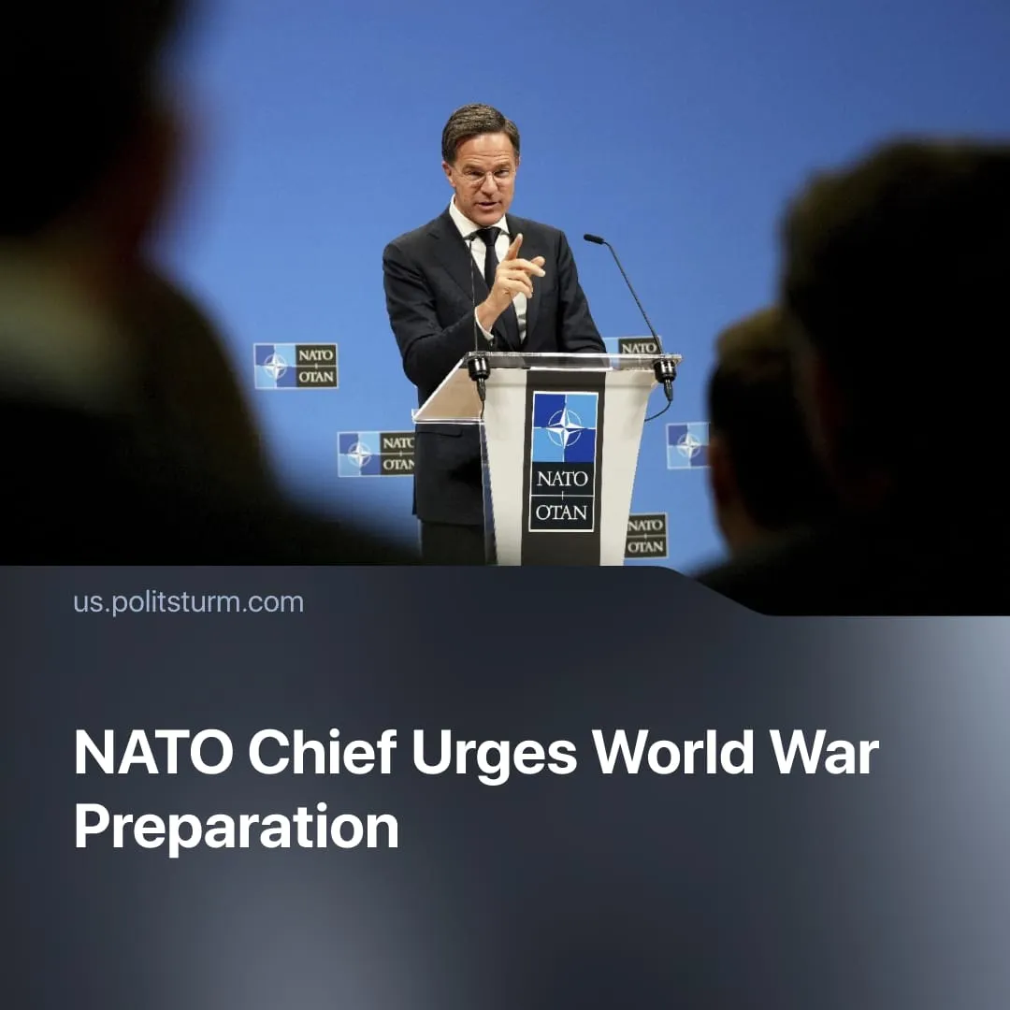

Original article
2025-12-18
1 min read

World War Preparation urged by NATO Chief, echoing similar statements from European and US leaders
Details. NATO Secretary General Mark Rutte gave a speech on 11 December at a NATO keynote event held in Berlin, Germany.
► In the speech, Rutte addressed the public, stating an immediate imperative to be “prepared for the scale of war our grandparents or great-grandparents endured.”
► He praised Germany for “fundamentally shifting its approach to defence,” and the allies for strengthening NATO, following the latest Hague Summit, where they “agreed to 5% of GDP annually on defence by 2035.”
Context. Rutte continues the trend of Western leaders spreading military hysteria. Ministers, chiefs of staff, and other leading political figures have continuously emphasised the supposed need to prepare for war.
► EU leaders have recently been quoted calling the current period a “pre-war phase,” warning that Europe may have already experienced its “last summer of peace.” In the UK, the Air Chief recently stated that the nation’s “sons and daughters” need to be ready to fight.
► This intensifying fearmongering is not limited to Europe. In the US, the Department of Defence was recently renamed the “Department of War.” The current US Secretary of War, Pete Hegseth, admitted that preparations are being made “for war, not for defence.”
► This hysteria is used to justify massive war spending, expected to reach €392 billion in 2025, and to prepare the working class for “sacrifices” – meaning further social spending cuts, increased taxes, and ultimately conscription – as seen in recent efforts in France and Germany.

Original article

