Nationwide Teachers’ Strike in Portugal
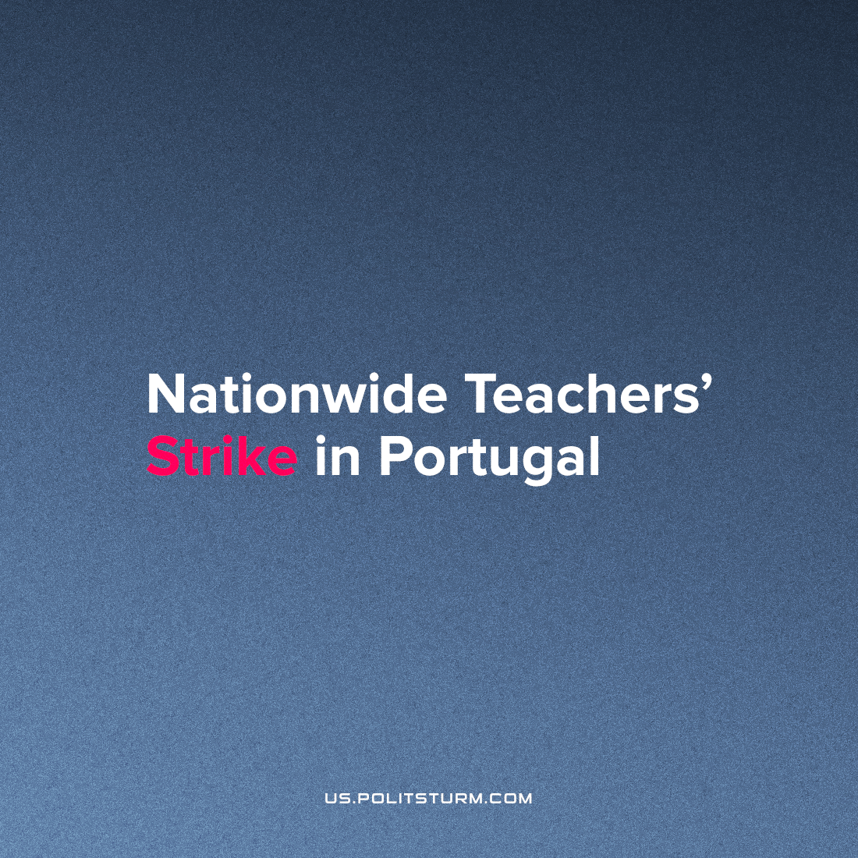

Original article
2022-11-12
1 min read

On November 2, a nationwide teachers’ strike took place throughout Portugal. According to reports, about 90% of the country’s teachers did not come to work in protest against insufficient government investment in the education sector.
“The levels of adhesion are very close to those of the previous strike, that is, in the order of 90%. There are many schools closed from north to south of the country, and others are open, but classes are not being held due to a lack of teachers,” said FNE Secretary General Joao Diaz da Silva.
The reason for the strike was the publication of the Portuguese state budget for 2023. The budget for the new year provides for the allocation of about 7 billion euros for primary and secondary education. According to representatives of the trade unions, however, this amount is not enough to solve the significant problems in the education sector of the country.
In addition to calls for increased funding, teachers are demanding more job stability and incentives to attract young staff. They explained that the lack of funds for education hinders the improvement of the conditions in schools and, subsequently, discourages many young people from choosing to become a teacher.
The strike was the result of a collaborative organization of 7 unions, including the National Federation of Teachers (Fenprof), the National Federation of Education (FNE) and the National Democratic Union of Teachers (SINDEP). Trade union representatives expressed confidence that a nationwide teachers’ strike would force the Portuguese Ministry of Education back to the negotiating table.
On the one hand, wage earners can indeed achieve incremental improvements in life and work through strikes and other organized activities. On the other hand, protests alone cannot force bourgeois governments to provide all citizens with quality education and good working conditions. This requires fundamental changes in the system and, ultimately, the establishment of socialism.
Sources: 1, 2, 3

Original article

