Nationalism And Its Class Meaning


Original article
2019-03-31
12 min read

Nationalism as an ideology developed simultaneously with capitalism. The feudal fragmentation, its innumerable duties, barrage of barriers, extortion, and parochial anarchy prevented the development of the market and created considerable difficulties for trade and production. Therefore, one of the primary economic tasks of emerging capitalism was the struggle for a single market, for a single national state capable of ensuring the stability of this market.
In the ideological sphere, this struggle manifested itself in different ways: in the form of the Reformation, replacing the single Catholic Church with a number of national churches, or within the framework of strengthening liberalism, which proclaimed the thesis of national sovereignty and national will, which lie at the heart of the state.
With the economic and political strengthening of the bourgeoisie now rushing to power, nationalism permeated amongst the broad masses, destroying the outdated worldview of the Middle Ages and undermining the obsolete feudal order. Nationalism became one of the pillars of the bourgeois revolutionary movements of the XVII-XVIII centuries, pushing the masses on the path of economic renewal, often coinciding with the process of national liberation, as in America and the Netherlands.
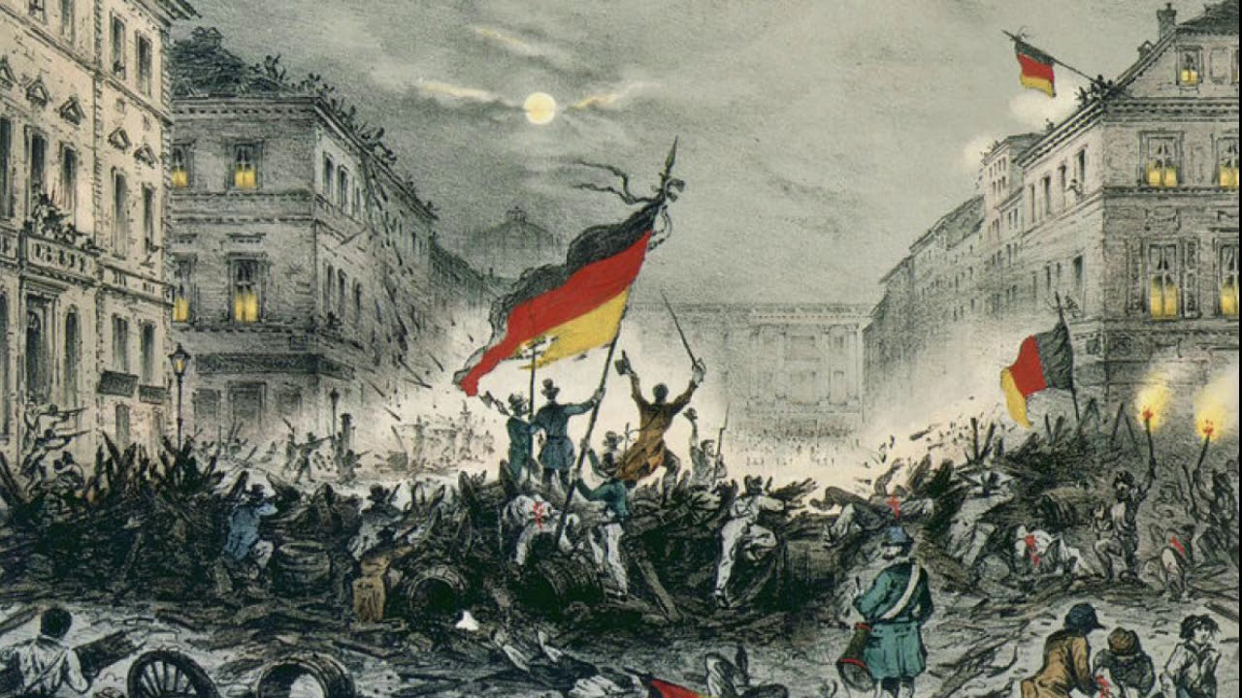
In the 19th century, German nationalists wanted to form a unified democratic republic.
Having played its positive role in history, bourgeois nationalism, like the bourgeoisie itself, acquired reactionary traits, as the political positions of the proletariat, created by capitalism, began to strengthen. The proletariat – first spontaneously, and then quite consciously began the struggle against capitalist oppression, threatening to overthrow the existing economic system and replace it with socialism.
Nevertheless, in the struggle for socialism, the proletariat had to realize its class unity, class goals in common to all workers, belonging to various nationalities. And here nationalism came in handy to the bourgeoisie as an instrument that, firstly, destroys proletarian unity, dividing workers into national limits, and secondly, proclaims a kind of «class peace» between oppressors and oppressed of the same nationality. In the era of proletarian revolutions, nationalism became one of the main methods of the ideological struggle of the bourgeoisie against the working class, used with great ingenuity — both directly and imperceptibly.
It was hard for the bourgeoisie to resist the influence of socialist ideas that spread in the widest masses of workers and peasants in Europe and Russia.
The united social-democratic party of the Austro-Hungarian Empire collapsed into a number of independent national parties warring with each other because of the national question. This also happened to the Russian parties of socialist revolutionaries, Mensheviks and other «national» revolutionary-democratic organizations (Armenian Dashnaktsutyun, Ukrainian PSR and SDP, Belarusian Socialist Gromada, etc.). Once in power in the wake of the collapse of tsarism, they proclaimed a completely bourgeois «national course», accompanied by ethnic massacres.
However, even the victory of socialism in Russia did not go without attempts by the bourgeoisie and its supporters to undermine proletarian unity.
Subsequently, even reactionaries of Europe, facing the proletarian revolution in their countries, sought to curb and deceive the working masses tired of capitalist hell, pursuing a line of “socialism” with a national bent, hiding fascism.

Petty bourgeois nationalism
Besides directly bourgeois, clearly reactionary nationalism, it has another, less odious form — petty-bourgeois nationalism. This ideology, expressing interests of small and average bourgeoisie of cities and villages, differs from bourgeois nationalism by some of its essential features. First, the absence of frank expansionism and great power ideas, since, by virtue of its position, the petty bourgeoisie does not set the task of conquering other nations. This results in a certain democracy of petty-bourgeois nationalism, which formally proclaims both the equality of nations and nationwide equality.
It seems that petty-bourgeois nationalism is more “progressive” than bourgeois. However, the first appears only as an undeveloped form of the second. Both the formal absence of chauvinism and even the proclamation of «internationalism» is compensated by national egoism and the rejection of restrictions – even temporary – national interests in the name of the working people class interests. That is, petty-bourgeois nationalism more subtly, but no less consistently, performs exactly the same class tasks of preserving capitalism from proletarian struggle as bourgeois nationalism does. At the same time, the logic of its internal development inevitably and always leads to the transition of petty bourgeois, relatively «progressive» nationalism into an overtly reactionary bourgeois nationalism.
Russian populism (narodnichestvo) appears to be a model of such petty-bourgeois thought: it carried the progressive ideas of democracy and freedom to the masses in its time, but with the advent of the socialist revolution, it degenerated into a bourgeois movement that sought to slow down the development of the proletarian revolutionary movement.
This category also includes the Jewish Bund and Poale Zion, the Welsh Plaid Cymru, the Irish Sinn Fein, the numerous (mostly «left») parties and organizations of the Basques, Catalans, Galicians, Corsicans, Sardinians, etc. History shows that relative progressiveness of such movements is completely offset by the tendency to opportunism and collusion with the bourgeoisie, adventurism, the oblivion of the working people’s class interests, and as a result, despite all the social democratic slogans — the principled anti-revolutionary stance in defense of the capitalist system.
Rozhava, a Syrian part of Kurdistan, could be a modern illustration of petty-bourgeois nationalism. The achievements of Kurdish petty-bourgeois nationalists in the democratization of Kurdish society under the flag of some kind of “national revolution” do not annul any support for the Syrian working people who are socially close to them. Obeying a limited nationalist line, the Kurds indifferently looked at how Syria was becoming a frank colony, overrun by imperialists of all stripes and where the existence of an independent Kurdish state, ensuring the true liberation of the Kurdish people is out of the question. In the end, the Kurdish workers themselves will lose the most, shedding blood for the sake of the national project, which in the context of the inter-imperialist struggle in the Middle East has turned into a tool for the struggle of some interventionists against others.
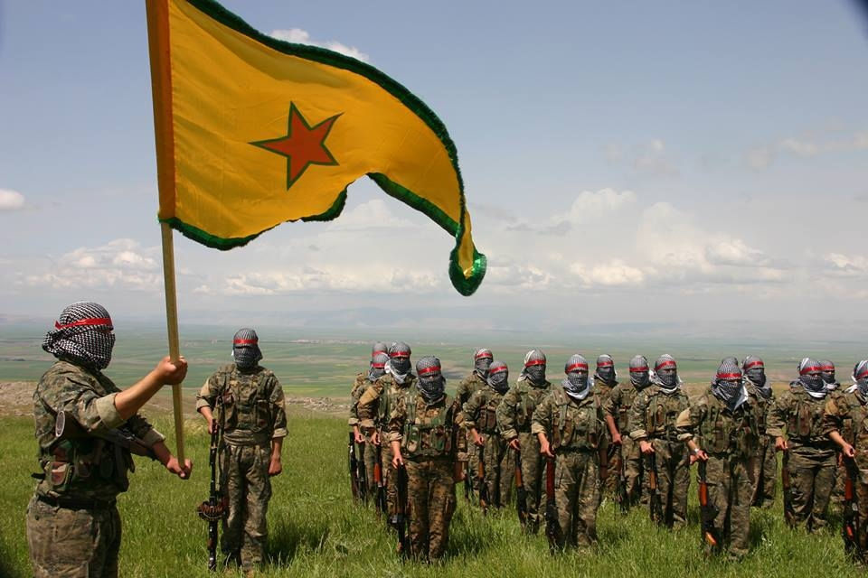
There is no doubt that over time, petty-bourgeois nationalism will inevitably grow into ordinary bourgeois chauvinism, and the «democratic federal autonomy of Rojava» will become completely dependent on imperialism, torn by ethnic contradictions bourgeois republic with a touch of despotism, which has long happened to the Iraqi Kurdistan.

Nationalism of the oppressed nations
In the colonial countries of Asia, Africa and Latin America in the 19th and 20th centuries, nationalism expressed the aspirations of the widest masses of the city and village, demanding liberation from imperialistic oppression, the destruction of the remnants of feudalism, democratization and economic development. Therefore, at this stage bourgeois nationalism was democratic and progressive; economically, as it promoted the maturation of conditions, conducive to the further development of the class struggle of the proletariat, the maturation of capitalism.
In the second half of the 20th century, when the old colonial system was collapsing, nationalism, which merged not only with anti-feudalism, but also with anti-imperialism, became the banner of the peoples of Asia and Africa in struggle, also having a significant impact on Latin America, where the process of founding nations was not yet complete.
However, this does not mean that nationalism was becoming a progressive phenomenon. Having played the role in the struggle for national liberation and economic renewal, it transformed into a factor slowing down further social development, since the class interests of the national bourgeoisie, which had become firmly established after independence, inevitably came into conflict with the workers class interests.
Seeking to prevent the growth of the proletariat consciousness and the revolutionary movement while fearing to speak openly against the working class, the national bourgeoisie of the liberated countries began to use slogans of «exclusivity», fooling the working masses with projects of the original «non-capitalist development» or «third way». The Libyan «Jamahiriya», the Argentine «national socialism», the Indonesian «nasakom», the Tanzanian «ujamaa», the Guyana «cooperative socialism» and other variants of the «original» «national socialism» in fact hindered and impeded the development of the revolutionary movement towards true socialism.
It is no wonder that, being in their essence limited models of state capitalism with socialist elements, with the help of which the bourgeoisie, in an era of revolutionary upsurge, tried to defend their domination from the upsurge of the proletariat, all these «national socialisms» were falling under their own contradictions. Somewhere (Indonesia, Argentina, Peru, etc.) the reactionary bourgeoisie connected with imperialism forced this process, carrying out a violent reversal towards «classical» capitalism, and somewhere (Syria, Iraq, Libya, etc.) the path stretched in time, accompanied by the disintegration of the political elite, the collapse of mixed economic systems, the grovelling in front of the imperialism, the attack on the working people rights.
That is, the nationalism of the oppressed peoples, despite all its «revolutionism», eventually showed its true essence as an instrument of the bourgeoisie in the ideological struggle against the working class and the communist movement, and therefore at the present stage has lost most of its progressive features.
Why? Firstly, because capitalism has now become established throughout the world, and, accordingly, a clear separation into antagonistic classes has been made — the proletariat and the bourgeoisie, where the bourgeoisie is a brake on social development. It is not faced with the tasks of destroying feudal remnants or the maximum development of production — those avant-garde tasks for the fulfilment of which nationalism previously mobilized the masses. On the contrary, the bourgeoisie of the oppressed peoples sometimes even fostered the most reactionary traditions and customs, presenting them as manifestations of the «national spirit». And the fact that in the conditions of chronic capitalist overproduction there can be no question of any liberated nation states industrial development this is not even worth mentioning.
Secondly, without being able to offer the masses anything new, the oppressed nations bourgeoisie finds the main support in their «liberation struggle» in the face of imperialism, turning either into a pawn in the inter-imperialist game, or in a politically and economically dependent agent of a «great power». This can be clearly seen in contemporary examples of the «struggle for national liberation» of Kosovars, Tibetans, Sikhs in India, Karen and Shan in Burma, Abkhazians and Ossetians in Georgia, Uyghurs in China, Balochi in Iran, etc. where the oppressed movements political leadership is completely dependent on the imperialists. There is no need to mention the destruction of the USSR, Yugoslavia or Czechoslovakia, where the bourgeois nationalism of the «oppressed» played a leading role in the reversion to capitalism: the reactionary role of various «national liberators» is evident.
Finally, thirdly, national liberation for the sake of national liberation is today a reactionary idea only because the national state is not a defense against national oppression by imperialism, which, expanding the orbit of its influence, today exploits and oppresses even those nations that never faced national oppression.

Internationalism
Capitalism and imperialism inevitably give rise to national oppression, which gives rise to the bourgeoisie forcing nationalist “liberation” sentiments. This means that the guarantee of genuine national liberation is not nationalist rhetoric, not petty-bourgeois national reformism, but a socialist revolution led by the working class, which will end the national oppression where it takes place. But not in order to replace the foreign oppressors with the «native» oppressors, national ones, but in order to ensure development and prosperity, both cultural and economic, of all nations without exception in the framework of the new economic system.
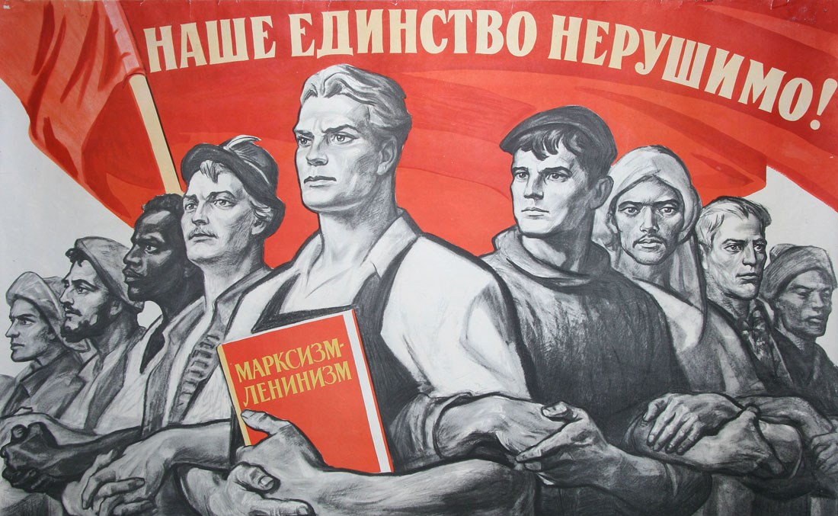
“Our unity is indestructible!”
This is the basis of proletarian internationalism. On the one hand, it opposes bourgeois and petty-bourgeois nationalism, which seeks to strengthen the partitions between the working people, to break up a single proletarian camp for the sake of capitalism. On the other hand, proletarian internationalism categorically rejects bourgeois cosmopolitanism, which denies the necessity of national states, national cultures, and national languages. Cosmopolitanism, expressing the interests of imperialism with its abstract “universal values”, ideologically justifies the forced assimilation, the complete enslavement of the working people by the world capitalist market, which knows no «national» barriers.
Workers of different countries, different nationalities, races, cultures are in the equal position of people forced to live, selling their labour to the owner of capital, whose goal — maximizing profit from the labour of workers — also does not depend on nationality, religion or language. Consequently, the workers of all nationalities have the same enemies, united in their business of exploiting the working people. Therefore, the workers must work together on a global scale to fight this anti-proletarian world unity of the bourgeoisie.

Original article

