National Labor Relations Board Proposes Ruling to Hurt Workers
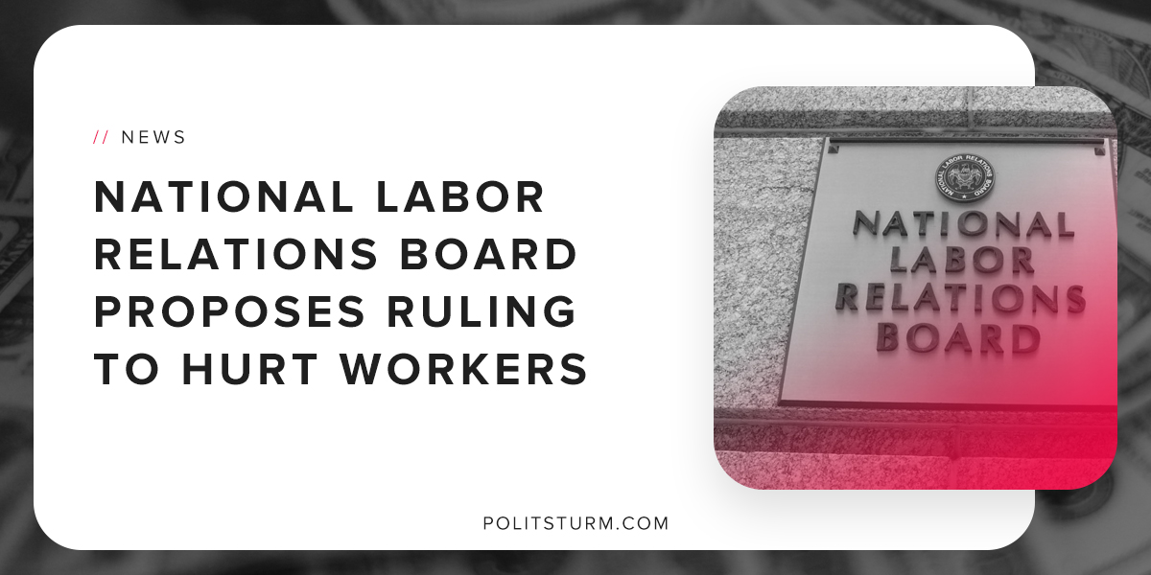

Original article
2018-09-21
1 min read

The National Labor Relations Board is proposing a change to it’s “Joint-Employer Standard” in an effort to further undermine union organizing in this country. This decision will have a major impact on how corporations with franchise operations collectively bargain with their employees.
For example, a fast-food corporation can have franchises all over the country in which a smaller capitalist is in direct control of business operations. The franchise owner directly hires labor and oversees production whereas the larger corporate fast-food chain is only indirectly involved in the production process.
This ruling states that “indirect influence and contractual reservations of authority would would no longer be sufficient to establish a joint-employer relationship.” This interpretation means that only the franchise owner would be considered the employer, not the larger corporate entity.
This ruling, if implemented, would make it harder for employees of franchises all across the country to form unions and collectively bargain with big corporations because they are no longer considered their employees.
It also, however, lays bare the class nature of the American government. The National Labor Relations Board, despite its name, is defending the interests of the large corporations and shareholders at the expense of the working class.
It should be no surprise that a board designed to mitigate the contradictions between the capitalist class and workers is siding with the corporations. The state is merely the dictatorship of the bourgeoisie and it therefore has no interest in improving the lives of franchise workers across this country.
https://www.nlrb.gov/news-outreach/news-story/board-proposes-rule-change-its-joint-employer-standard

Original article

