National Grid Workers Locked Out Over Contract Negotiation
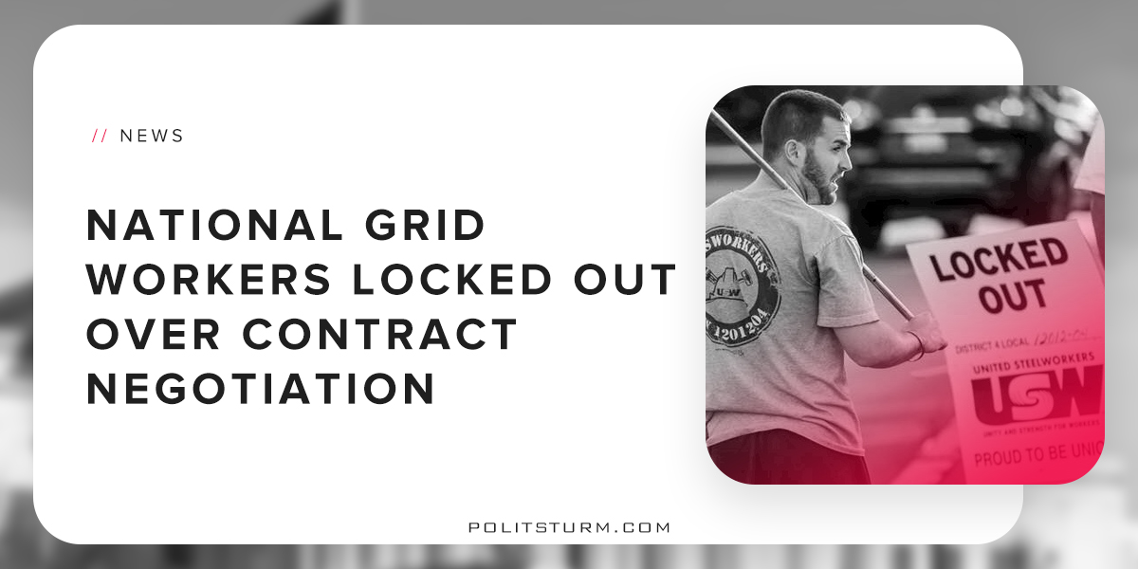

Original article
2018-08-09
1 min read

National Grid, a multinational electricity and gas utility company, has locked out the 1,200 members of the USW Local 12003 and 12012. These workers do the work of maintaining the natural gas lines that run to the homes, schools, and businesses across Massachusetts.
The lockout comes after union members and the corporation failed to come to an agreement over their next contract. National Grid is unwilling to compromise and thus has locked workers out, preventing them from working.
If the contract is approved as National Grid proposes it, the union stated that the changes would be devastating for workers. It would cut wages, benefits, medical coverage, and force new hires into a mediocre retirement plan. New hires would lose medical benefits after the age of 65, and get less sick time and life insurance. The company is trying to divide the workers in an attempt to have older workers sacrifice benefits for the newly hired workers.
The company has locked out employees while negotiations continue, and they have replaced the union employees with less experienced contractors. Working with gas lines can be extremely dangerous, and it is important to have highly trained and experienced professionals to protect public safety. In order to increase the profits of the capitalist class, the company has decided to risk the safety of the public and employ strikebreakers. The National Grid strike represents just one more example of the working class standing in solidarity against the capitalists.
https://www.usw.org/act/campaigns/lockout-at-national-grid/resources/facts-about-the-lockout-at-national-grid

Original article

