Myth of “Inherent Democracy” in the USA Shattered By Trump
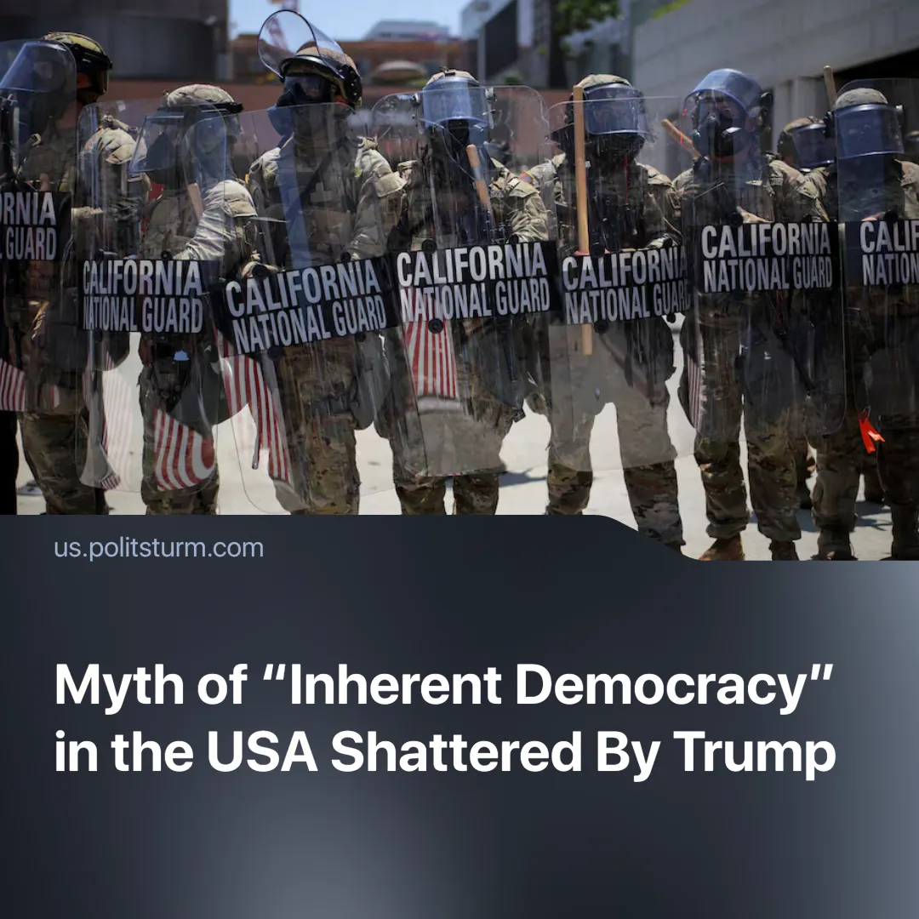

Original article
2025-06-23
2 min read

The new American administration has resorted to increasingly reactionary and repressive methods, shattering the common myth of the U.S. as “the model of democracy”.
Details: The first six months of the new Trump administration have been marked by a number of reactionary actions.
►Trump used military force to suppress protests in Los Angeles and to ensure the success of Immigration and Customs Enforcement (ICE) raids. The military was also used against those who resisted his decisions: against elected officials who resisted ICE raids (subjecting them to prosecution) and judges’ rulings.
►Trump actively used the Supremacy Clause, a principle used to resolve conflicts between federal and state law in favor of the federal government, to push through plans that went against decisions of states and American law in general. For example, 20 states (led by California) are facing the threat of losing transportation grants if they don’t cooperate with Trump’s immigration policy. Another example was the deployment of the California National Guard and Marines to stop protests in Los Angeles without the agreement of the state administration.
Context: As the leader of the capitalist world since the end of WW2, the U.S. has traditionally been portrayed as a democratic state governed by the rule of law. Many capitalist ideologists, such as Ayn Rand, John McCain or Seymour Lipset, claimed the principles of liberal democracy and “freedom” to be a part of American exceptionalism.
►The United States has regularly ranked high in various Western-led, liberal rankings of “freedom and democracy”, such as Freedom House or Democracy Index.
►Meanwhile, liberal ideologists often claim countries like Russia are inherently “authoritarian”. For example, in the rhetoric of The Times or VoxUkraine, Russians are psychologically oriented towards “strong leaders” and tend to tolerate authoritarian rule.
Important to Know: All attempts to reduce the ongoing changes to a struggle between Democrats and Republicans are nothing more than a distraction from the real movement towards open dictatorship. Bipartisan mass surveillance, police militarization and border crackdowns – none of this is new to Americans, but the ruling class has begun to stop hiding these means behind the vale of “democracy”.
►Tightening control over protests, militarization and rising nationalism are the only means of imperialists to maintain their system especially as they prepare for war – a natural result of capitalist competition. These measures, as well as imperialism itself, stem from the need to continue exploitation, secure profits, and multiply them.
►The example of the U.S. demonstrates that even liberal democracies, as forms of the class dictatorship of the bourgeoisie, can and do resort to reactionary and openly terroristic methods when required — fascism is not the opposite of liberal democracy, but grows out of it as the needs of the bourgeoisie change. These methods are rooted in the very logic of the capitalist system.

Original article

