Musk Defies Alameda Shelter Order, Restarts Production
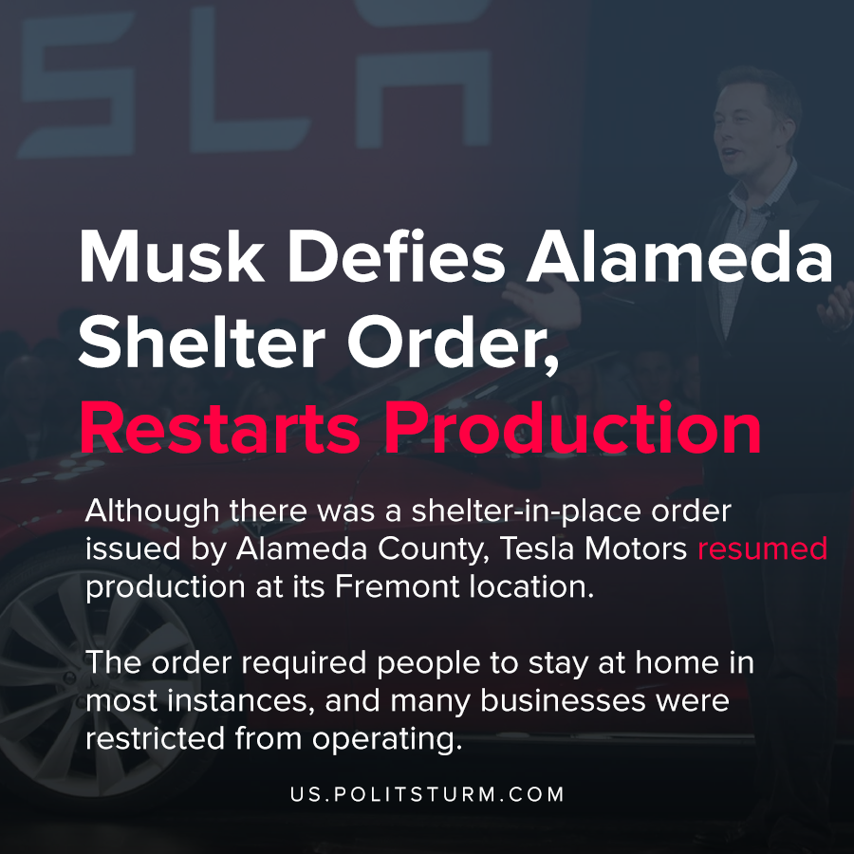

Original article
2020-05-16
1 min read

Although there was a shelter-in-place order issued by Alameda County, Tesla Motors resumed production at its Fremont location. The order required people to stay at home in most instances, and many businesses were restricted from operating. Not complying with the order and resuming production puts the company in violation with California law.
According to Alameda County, the county said the purpose of the order was to control the spread of the coronavirus and limit infections.
CEO of Tesla Motors tweeted, “Tesla is restarting production today against Alameda County rules. I will be on the line with everyone else. If anyone is arrested, I ask that it only be me.”
President Trump came out in support of Musk, stating that California should allow Tesla to resume production “Fast & Safely”.
Musk is demonstrating that his freedom to exploit workers on the production line is more important than the safety of workers at the plant. Driven by the pressures to return profit to investors and the private owners of the means of production and to finance liabilities, there is incentive to resume production. If the workers are not adding value in production, the capitalists cannot sell the products produced by the workers and realize their profit in monetary form.
https://twitter.com/elonmusk/status/1259945593805221891?ref_src=twsrc%5Egoogle%7Ctwcamp%5Eserp%7Ctwgr%5Etweet
https://covid-19.acgov.org/covid19-assets/docs/5-4-20%20Alameda%20County%20SIP%20Order%20FAQ%205.9.20%2011%20AM.pdf
http://www.acphd.org/media/572718/health-officer-order-20-10-shelter-in-place-20200429.pdf
http://www.acphd.org/media/572777/health-officer-order-20-10-shelter-in-place-summary.pdf
https://twitter.com/realDonaldTrump/status/1260203080076931072?ref_src=twsrc%5Egoogle%7Ctwcamp%5Eserp%7Ctwgr%5Etweet

Original article

