Musk Becomes World's First Trillionaire
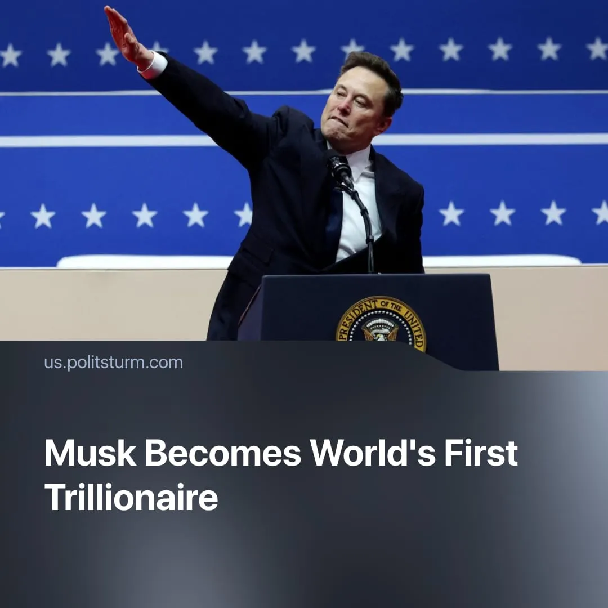

Original article
2026-06-22
2 min read

Elon Musk becomes the first capitalist ever to accumulate $1 trillion, one man’s wealth surpasses the annual GDP of Paris or the US state of Ohio.
Details. Elon Musk has accumulated a net worth of $1.4 trillion – more than the combined wealth of the poorest half of humanity, around 3.8 billion people – and larger than the GDP of 90% of the world's countries. His fortune is growing by $1 million per minute, while the average US worker earns around $62,000 per year.
► The $1 trillion mark was crossed after SpaceX went public on the NASDAQ stock exchange on June 12, raising a record $75 billion in its Initial Public Offering (IPO) at $135 per share, closing its first day at $161. The IPO came after SpaceX absorbed Musk's AI company xAI in February 2026, making the combined company unprofitable – losing $4.94 billion in 2025.
► NASDAQ's index rules – previously designed to keep unprofitable companies out of the retirement funds millions of workers depend on – were loosened in May 2026 to fast-track SpaceX's inclusion, forcing millions of workers' savings and retirement funds to automatically finance a loss-making company.
► His 4.76 billion SpaceX shares are worth around $960 billion, by far his largest source of wealth, followed by an 11% stake in Tesla worth around $168 billion, and a stake in brain-implant company Neuralink worth around $3.42 billion.
Context. Tesla has around 134.000 employees producing 1.65 million cars per year, while SpaceX employs around 22,000 workers building hundreds of rockets and satellites annually. Together, these workers put in millions of hours each week. Musk claims to work 80 hours per week himself, yet earns 375.000 times the average Tesla worker's salary.
► Historically, 1900s US "robber barons" such as Rockefeller and Carnegie accumulated vast fortunes by controlling key industries – oil, steel, and railways. At his peak, Rockefeller controlled 2% of US GDP; Musk now controls 3%. Meanwhile, US workers face record inflation of 4.2%, a +50% rise in gas prices, and stagnating wages as capitalists pocket record profits.
Important to Know. Musk's wealth is a product of state-monopoly capitalism, drawn from the working class as a whole. Capital accumulation naturally leads to concentration and centralisation, paving the way for monopolies to emerge and directly control the capitalist state.
► SpaceX's business is built on Pentagon and NASA contracts funded by workers' taxes — surplus value extracted from the working class and redistributed to the oligarch. Under Trump, Big Tech CEOs have been assigned military offices and AI monopolies like Palantir have secured federal contracts, as the boundary between monopoly capital and the state dissolves entirely.
► This catastrophic concentration of capital in the hands of a single individual is the natural endpoint of capitalist accumulation. Monopoly capitalism socialises production while keeping ownership private, the scale already reached by Musk's enterprises demonstrates that the productive forces have long been ready for public ownership and socialist planning.

Original article

