Musk Backs Far-Right Figure Tommy Robinson
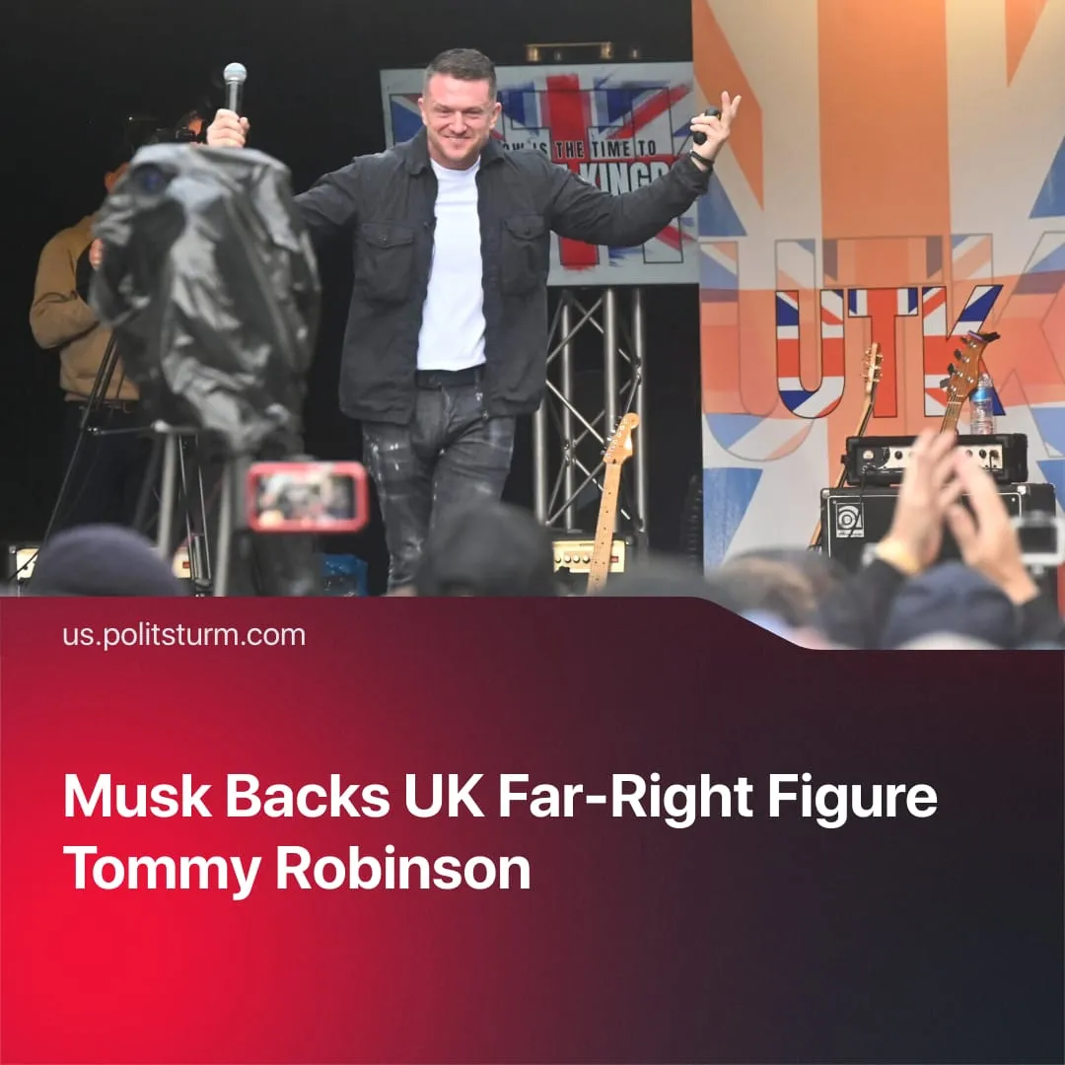

Original article
2025-10-23
1 min read

Elon Musk is funding the legal defence of far-right organiser Tommy Robinson, after recently also calling for the dissolution of UK parliament.
Details. Former leader of the far-right “English Defence League”, Tommy Robinson – whose real name is Stephen Yaxley-Lennon – appeared in court last week over charges arising from a counter-terrorism stop at the border in July 2024.
► The trial centres on Robinson’s refusal to unlock his phone during the stop. Prosecutors claim officers had reason to believe the device contained material relevant to ongoing terrorism inquiries. He maintains that he was protecting confidential journalistic material.
► During his court appearance, Robinson declared: “Thankfully, I haven’t had to beg for donations today because Elon Musk has picked up the legal bill for this absolute state persecution.” Musk has neither confirmed nor denied the claim.
Context. Musk’s reported involvement aligns with his growing record of amplifying and financing far-right and nationalist figures across Europe through his social media platform, X. This trend mirrors the wider resurgence of such movements in Europe, whose influence has expanded markedly in recent years.
► In the UK, Musk has aligned himself with Robinson, after he called Nigel Farage of the far-right Reform UK party “unfit” to lead. Recently, at a major London protest organised by Robinson, Musk appeared via video link, calling for the “dissolution of Parliament” and warning that “whether you choose violence or not, violence is coming to you.”
► Capitalists have always been the financiers of the far-right and fascists. Industrialists such as Alfred Hugenberg, Henry Ford, Fritz Thyssen, and Hjalmar Schacht backed Hitler’s rise in Germany, while Italian industrialists and financiers supported Mussolini, including Giovanni Agnelli of Fiat, industrialist Michele Bianchi, and banking elites who funded the Fascist Party.

Original article

