Monopolies Reap $85 Billion Extra Profit During Crisis
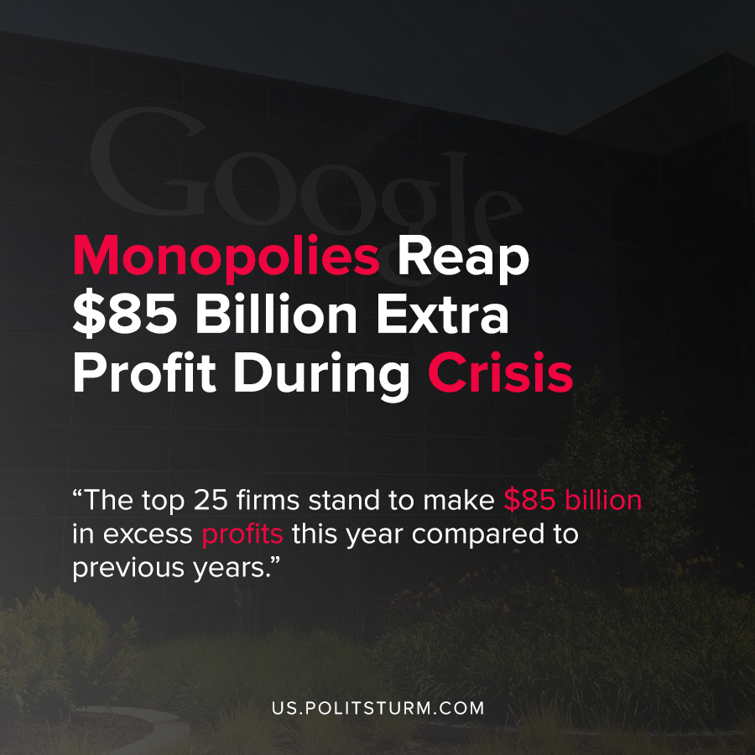

Original article
2020-07-23
1 min read

A new study by Oxfam examined how the profits of the largest U.S. corporations were impacted by the coronavirus pandemic. The study found that the top 25 firms, including Facebook, Microsoft, Johnson & Johnson, Pfizer and Visa, stand to make $85 billion in excess profits this year compared to previous years.
The sectors of the economy that stand to benefit most are technology, pharmaceuticals, utilities, and telecommunications.
Oxfam notes that these super-profits appropriated by the monopolies will be siphoned to corporate shareholders and that 10% of the U.S. population controls 87% of the corporate stock. Oxfam was alarmed that the largest monopolies were actually seeing profit increases, while a large number of smaller firms were experiencing steep declines in corporate profits.
Small U.S. companies experienced a 49% decline in profits during the first quarter, and are expected to have an 85% of profits in the second quarter.
Simultaneously, millions of Americans have been thrown out of work and unemployment has skyrocketed.
The historical tendency of capitalism is towards the consolidation of firms into large monopolies that extract massive profits. Capitalism also is characterized by recurrent crises of overproduction that occur roughly every 10 years. The owners of capital, the shareholders in these corporations, will continue to profit while the workers suffer the brunt of the crisis. The methods proposed by Oxfam, including a tax on excess profits and fighting against “wage theft” are insufficient to resolve capitalism’s contradictions.
Capitalism as a system is predicated upon the theft of value from the proletariat, and the government is run in the interests of the capitalist class who will fight tooth and nail to protect their class interests. For as long as capitalism exists, monopolies in the imperial core will continue to extract profits to their shareholders.

Source: 1

Original article

