Indian Prime Minister Modi's Congressional Opposition Leader is Jailed
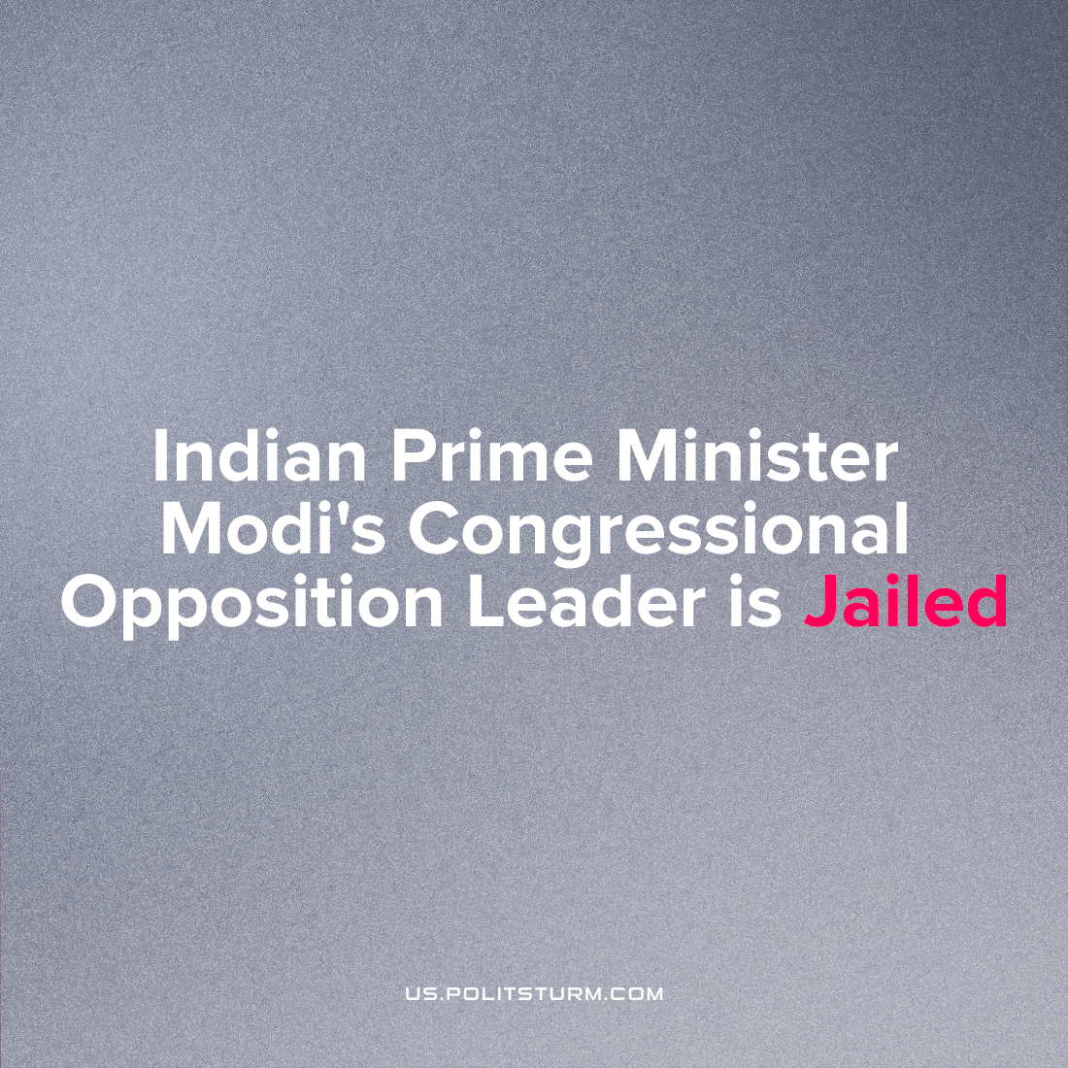

Original article
2023-04-03
3 min read

Rahul Gandhi, the leader of the opposition in the Indian Parliament’s Lower House “Lok Sabha” has been arrested and has been sentenced to two years in jail for defaming the name Modi, thus disqualifying his position in elected office and ejecting him from the parliament. Gandhi was the leader of the Indian National Congress, a bourgeois-liberal party which played a leading role in India's national liberation movement from 1912-47.
Gandhi was arrested on the basis of a single event in London. Firstly, he gave a political lecture at Oxford University, in which he attacked the current government of India, led by Narendra Modi and his policies. It is frowned upon in most cultures to air one’s dirty laundry outside of one’s own home, and especially so in India. Modi’s party (BJP) had filed a defamation case, alleging that Gandhi’s lecture was akin to this; deliberately slandering the Indian nation in the house of its former colonial master.
Secondly, while addressing a gathering, Gandhi had said that the name “Modi” had become synonymous with thievery. This is in light of Narendra Modi initiating mass privatisation measures and the billionaire Nirav Modi committing bank fraud and fleeing the country to escape punishment when this was discovered. However, the surname “Modi” is shared by millions of other Indians, so casteist tensions can be piled up around Gandhi’s statement, and this has become the Modi’s party has included this in the defamation case.
The Surat High Court, a city in Modi's traditionally conservative home state of Gujarat, sentenced Rahul Gandhi to two years imprisonment for; "The deliberate insult of national symbols in public" and "insulting and targeting a specific group of similar people", since it cushions the anxieties of the public about the criminal proceedings of capitalist governance with a veneer of 'bourgeois legality'.
Error loading image
For the first time, "National symbols" were interpreted by the court to include the prime minister himself. Nominally independent, the Indian judges act on their own interests and prejudices in support of BJP nationalism which ultimately uphold the goals of Modi. Lawfare is the current preferred tool of internal bourgeois competition, as we see in many countries in only the past few years.
Following this sentence, the speaker of the parliament disqualified Gandhi as a member of parliament, and he was taken to prison by the Delhi Police to face his sentence. The consolidation of power in India by Modi's BJP is accomplished, and its gains are being defended from bourgeois parliamentarism.
India’s ruling party, the BJP, is hyper-reactionary and subscribes to Hindu supremacist views, succeeding for the past many years in manipulating people’s darkest prejudices to gain a mass following which has seized Indian politics. Vinayak Savarkar, the earliest proponent of the BJP’s ideology “Hindutva” was an admirer of Hitler and Mussolini. Consequently, the process of fascistisation is well underway in India with many looking to Modi as a strong leader to revive the country to the state of “ancient Hindu glory” while committing acts of political violence against non-Hindu groups, particularly Muslims, as well as legitimizing class heirarchy as a "Hindu cultural value" in the form of castes.
There is very little resistance to this state of affairs, either from the media or other political and civil groups, suggesting that the Indian bourgeoisie are fairly united in backing Modi to achieve this goal. The arrest and imprisonment of Rahul Gandhi is another step on the path towards an open terrorist dictatorship of finance capital. Only a working class led by a communist party and conscious of its class position and objective interest can effectively oppose the fascist offensive and forge a new world free of class exploitation and devoid of national, ethnic and religious hatred. This is will be an incredibly challenging task considering the strength of the BJP and the fact that India has many nominally “communist” parties that mislead the people with Dengist reformism on one end and Maoist adventurism on another, however we strive for the formation of such a party. We call for all genuine communists to join Politsturm.

Original article

