Modern Warfare: Capitalist Wars Explained
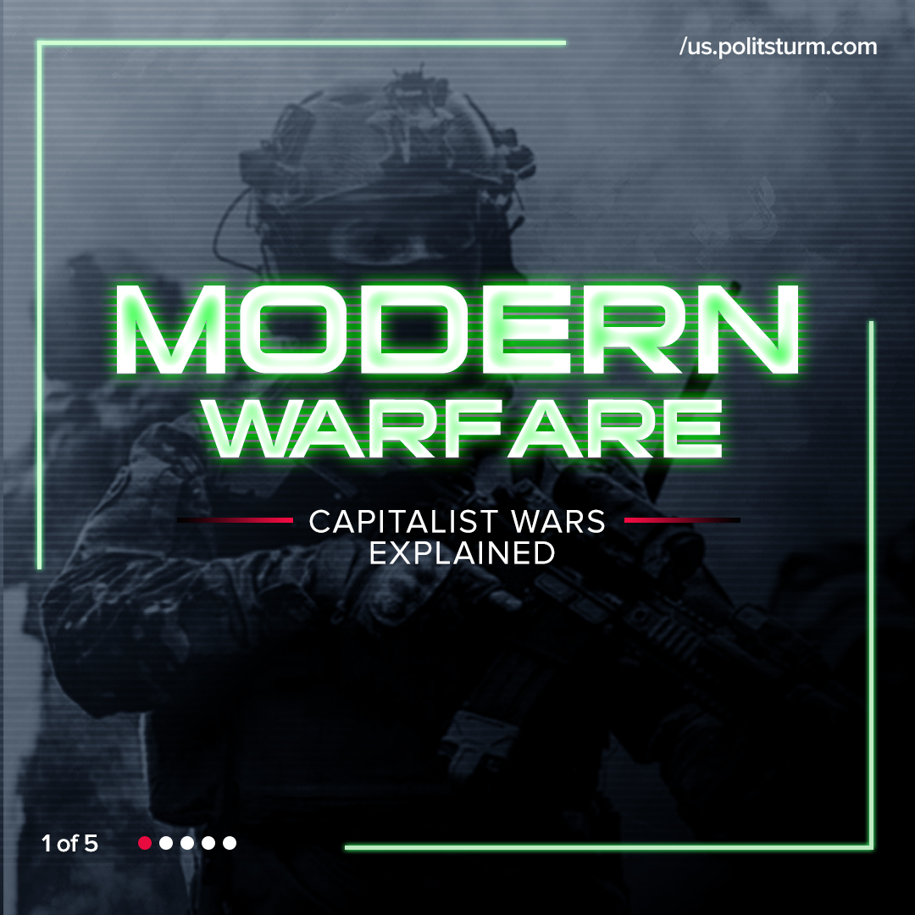

Original article
2022-03-13
1 min read

Error loading image
Error loading image
Error loading image
Error loading image

Original article

