Modern Slavery Rises to 50 Million: A Short Review
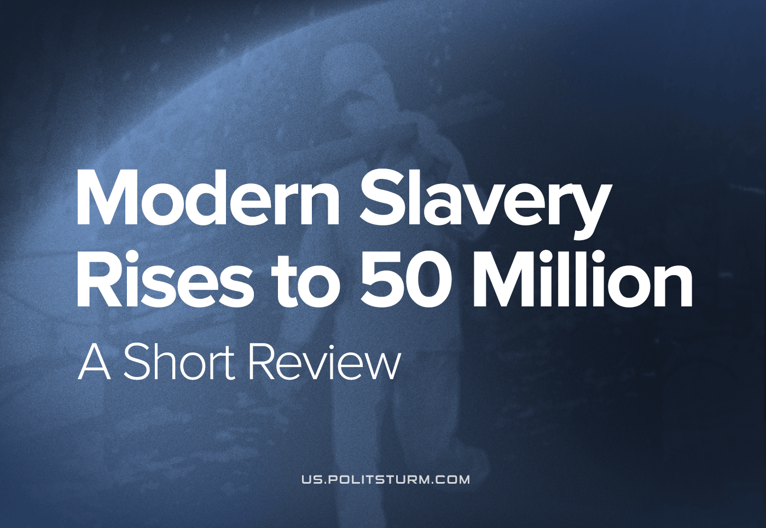

Original article
2022-09-19
4 min read

Since 2016, the number of people living in slavery globally has risen by an estimated nine million to around 50 million in total, according to the International Labour Organisation (ILO) which is part of the United Nations (UN). They regard modern slavery to be either forced labour (27.6 million people) or forced marriage (22 million people).
According to their report, forced labour is not a phenomenon exclusive to the most absolutely poor and wartorn countries – in fact more than half the total forced labour occurs in upper-middle to rich countries. Despite fairly even distribution across all sectors of the economy, the industries where slavery is most prevalent is construction for men and domestic and sexual slavery for women, and it is far more common in private corporations (85% – of which 27% are sex slaves ) than state-owned enterprises (14% – 55% of which involve some form of abuse of compulsory penal labour and 27% of which involve the abuse of conscription). Forced labour is more prevalent amongst migrant workers, than local workers. People in forced labour are often subject to multiple forms of coercion and abuse, including: a withholding of wages, forced confinement, abduction, drugging, physical abuse, sexual abuse, and the deprivation of basic human needs. Many of the worst abuses occur in regions where armed conflict is ongoing. There are an estimated 3.3 million children subject to forced labour.
As per the ILO report, forced marriages also occur across all regions of the world, however more than 60% of forced marriages happen in poorer countries. Over 67% of those who are forced into marriage are women and girls. The majority of those compelling forced marriage are blood relatives, it being the parents of the person forced to marry in 73% of cases. The method of coercion in half of all cases is emotional and verbal abuse (the parents for example would threaten to self-harm, or estrangement), however physical or sexual violence or threats of violence are not uncommon, occurring in 19% of all cases.
This form of marriage stems from the historical subjugation of the female sex, the ancient downfall of the rights of maternal descent and the turn of relations of inheritance to father-right. Engels, in his study “The Origin of the Family, Private Property and the State” states that “The overthrow of mother-right was the world historical defeat of the female sex. The man took command in the home also; the woman was degraded and reduced to servitude, she became the slave of his lust and a mere instrument for the production of children. This degraded position of the woman, especially conspicuous among the Greeks of the heroic and still more of the classical age, has gradually been palliated and glossed over, and sometimes clothed in a milder form; in no sense has it been abolished.”
To this day, women’s forced labour continues in the same occupations. Engels points out that this trend goes back to the very origins of oppression in human societies, in which the word family; “among the Romans .. did not at first even refer to the married pair and their children, but only to the slaves. Famulus means domestic slave, and familia is the total number of slaves belonging to one man. … The term was invented by the Romans to denote a new social organism, whose head ruled over wife and children and a number of slaves, and was invested under Roman paternal power with rights of life and death over them all.”
He continues, quoting Marx: “The modern family contains in germ not only slavery (servitus), but also serfdom, since from the beginning it is related to agricultural services. It contains in miniature all the contradictions which later extend throughout society and its state.”
The UN (and its ILO) is a capitalist institution, and so naturally its solutions to this problem can only manifest in a liberal reform of the most extreme deprivations, and so their report does not include wage slavery, a life of desperate work to the point of death, as a form of slavery. They define forced labour as “all work or service which is exacted from any person under the menace of any penalty and for which the said person has not offered himself voluntarily.” Of the 27.6 million slaves forced into labour mentioned in the report, 99.1% are under the above category and 0.9% are under chattel slavery. The truth is that all labour under capitalism, is forced and exploitative. In either form, the value which we create with our hands is robbed of us, and we are given just enough gruel to survive and work more for the same classes of ruling owners. The workers are deprived ownership of the very means of production they operate and have had the world parcelled off and sold back to them in order to leave them only the option to sell their labour to a capitalist under humiliating conditions. The line between the absolute poverty of the lowest stratum of the working class, and the 27.6 million under forced labour slavery, becomes blurred.
This slavery have been ongoing since the advent of debt and usury in ancient Greece. Engels writes again (Ibid. Ch. 5) that “If the sale of the land did not cover the debt, or if the debt had been contracted without any security, the debtor, in order to meet his creditor’s claims, had to sell his children into slavery abroad. Children sold by their father – such was the first fruit of father-right and monogamy! And if the blood-sucker was still not satisfied, he could sell the debtor himself as a slave. Thus the pleasant dawn of civilization began for the Athenian people.”
The rise in modern slavery is a result of increasing immiseration under the world’s capitalist mode of production, the highest advancement of these ancient forms of private ownership and domination. As capital becomes increasingly concentrated in fewer and fewer hands, as the rate of profit continues to decline and as the communist and labour movements and civil society is repressed, the masses of working people have been driven into destitution.
This destitution enables the most unprincipled and predatory capitalists to take advantage of those who are unable to resist and coerce them to work for nothing or next to nothing under the most horrible cruelty. No reforms can fix this, and in fact we can only resist its increasingly endemic appearance in the current world economic crisis. It is only by supplanting the capitalist mode of production with a communist one that the exploitation of man by man can be ended for forever.
Sources: 1

Original article

