Mobilization in Russia
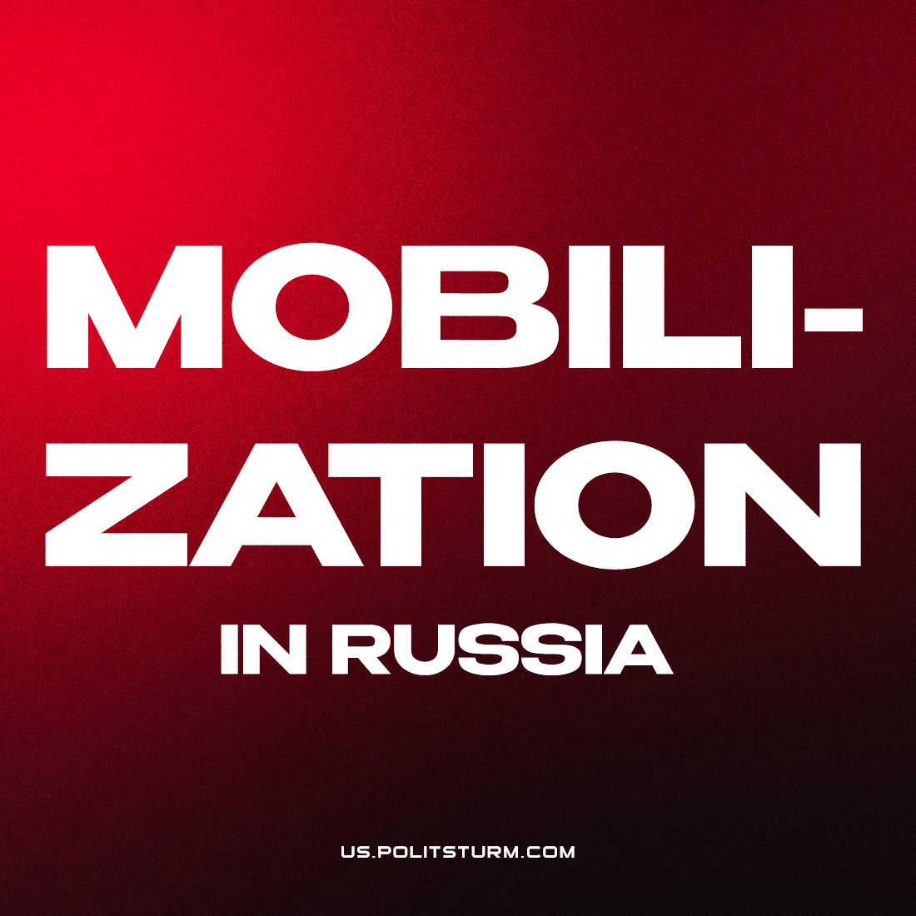

Original article
2022-09-21
5 min read

Today Vladimir Putin announced a partial mobilization in Russia. In the published address, which was supposed to take place last night, the president assessed the undergoing of a “special military operation” as “the right step”. However, in order to protect the “people’s republics” of Donbass, Putin considered it necessary to support the proposal of the Ministry of Defense of the Russian Federation to conduct a partial mobilization.
I. In accordance with the presidential decree, published immediately after the speech, Russian citizens who are in the reserve, who have completed military service, are subject to mobilization. Citizens called up for mobilization will receive the status of those undergoing military service in the Armed Forces of the Russian Federation under a contract. Citizens of the Russian Federation working in the organization of the military-industrial complex receive a deferment from military service.
At the same time, Russia is still not entering a state of war, but continues the “special military operation”, about which Putin has so far said that only professional military personnel take part in it.
II. This move of the Russian bourgeoisie represents a further escalation of events. Mobilization, about which there were many talks and rumors for more than six months, was nevertheless announced. However, in this decision, the authorities’ caution is still visible: official rhetoric says that so far not all citizens of the Russian Federation are subject to mobilization, but only those in the reserve.
The government continues to talk about the “planned conduct of a special operation” and that these events, like the mobilization, will not affect the majority of the population. Nevertheless, despite the introduction of the term “partial mobilization” in the first paragraph of the decree signed by Putin, the rest of the decree does not distinguish between “mobilization” and “partial mobilization” in any way. Its scope and the number of mobilized will be determined by the Ministry of Defense of the Russian Federation.
The ruling class is afraid of the politicization of the masses. No matter how the authorities realize the need for mobilization measures to change the balance of power in the Ukrainian direction, the ghost of 1917 will always loom before them. Until now, the fear of the armed masses of the people and the relative success in the “SMO” have held back big capital from mobilizing.
Now, after the “regrouping” of the Russian Armed Forces from the Kharkiv region and the increased threat to the position of the DPR and LPR and the general uncertainty of future prospects, the fear of defeat has overcome the fear of mass arming of the people.
The decision to mobilize is forced, undesirable for big capital, which is why it has such a deliberately limited character. The capitalists say that they are trying to keep the involvement of Russians in the conflict to a minimum: according to the Minister of Defense Sergei Shoigu, it is planned to mobilize up to 300,000 people (less than 1% of the mobile reserve); in rhetoric, emphasis is placed primarily on citizens with combat experience and a military training specialty.
III. Despite the circumstances, the tasks of the communists remain the same:
- exposure of the bourgeoisie and the plans of the imperialists;
- combating all kinds of opportunism and revisionism, exposing social chauvinism;
- communist agitation and propaganda, the active introduction of class consciousness into the ranks of workers, the establishment of interaction with labor collectives;
- the creation of a communist organization, the education and training of activists, the movement towards the formation of a communist party.
However, the moment escalates and the severity of the conflict increases. Therefore:
- preserving and improving the former communist (organizational, informational and educational) work is necessary to refrain from carrying out ill-conceived actions and antics;
- at the same time, exposing all “communists”, “socialists” and other “leftists” who call for such adventures.
“The conflagration is spreading; the sufferings of the masses are appalling, the efforts of governments, the bourgeoisie and the opportunists to hush up these sufferings proving ever more futile. The war profits being obtained by certain groups of capitalists are monstrously high, and contradictions are growing extremely acute. The smouldering indignation of the masses, the vague yearning of society’s downtrodden and ignorant strata for a kindly (“democratic”) peace, the beginning of discontent among the “lower classes”—all thesc are facts. The longer the war drags on and the more acute it becomes, the more the governments themselves foster—and must foster—the activity of the masses, whom they call upon to make extraordinary effort and self-sacrifice.” (V. I. Lenin, “The Collapse of the Second International”)
The events taking place in the world are increasingly reminiscent of the situation of a hundred years ago. Lenin’s words vividly illustrate the current situation. The actions of the bourgeois authorities will cause a reaction among the broad masses of the population and thereby destroy the very illusions about “stability” that have been imposed by the same government for decades.
However, the working people themselves, no matter how wide the strip of disasters, will not be able to realize their interests and lead the struggle for socialism. This duty is entrusted to the communist vanguard.
A sober assessment of the situation from scientific Marxist-Leninist positions, firm restraint and the establishment of communist work – these are the requirements of the current moment.
We call on conscious workers and communists to join this work in the ranks of the Politsturm. Write us at politsturm.inter@gmail.com

Original article

