Minimum Wage Raises Could Lower Suicide Rates
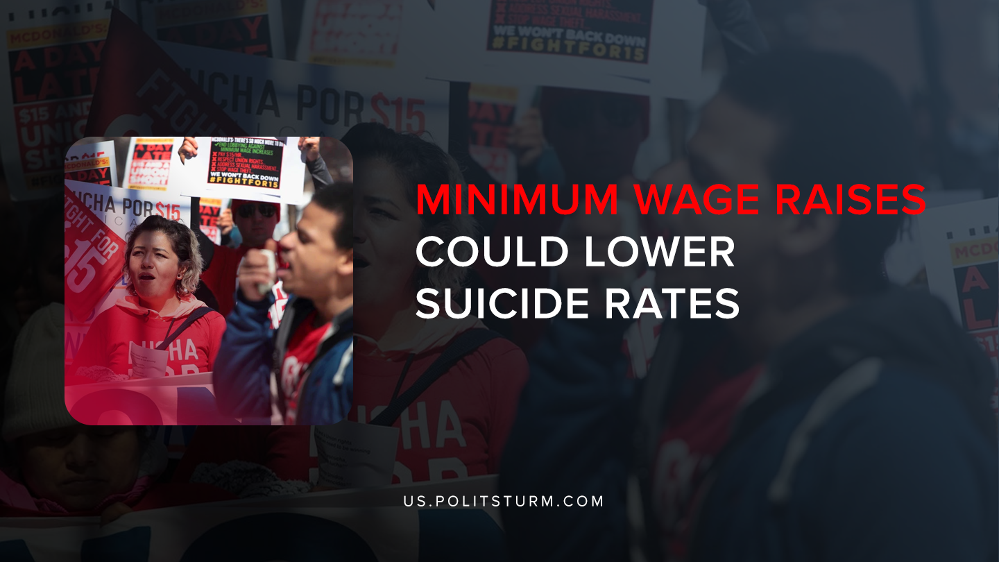

Original article
2020-02-27
1 min read
A shocking find by the capitalists: giving people enough money to pay for food and basic needs might prevent suicidal tendency from the unbearable life the capitalists provide them.
“More than 47,000 Americans died by suicide in 2017, and with other so-called deaths of despair — drug overdoses and alcoholism — it has grown into a slow-motion public health crisis. The phenomenon is difficult to study, and researchers have struggled to find effective prevention strategies.” “Mr. Kaufman said that he did not expect the study to draw so much attention, and that it was part of a series examining changes in economic policy — unemployment programs and tax credits, for example — and how they affect people’s health.” – says NYT.
This discovery only shows how separated the researchers and many other entities in the government are. This only proves the fact that the elite, regardless how patriotic their statements are, simply forget about the proletariat, throwing them aside once drained.
As wages keep falling, if compared to inflation, the workers keep having less and less to live off, and in time this minimum wage rise will mean nothing, returning back to the same position as we once were. However as this slight change might improve many lives, the profits the capitalists are gaining are ever-increasing.
If we keep on allowing this to happen, shrugging it off as our comrades perish, that would be the great betrayal, as it means you are accepting the system and its pressure upon you. We must fight for our freedom, where under socialism we will have proper wages, we will have free healthcare, where we can care for the work we do, as it will affect our environment and not some bourgeois in Wall Street.

Original article

