Milk Producers Dump Supplies As Prices Plunge
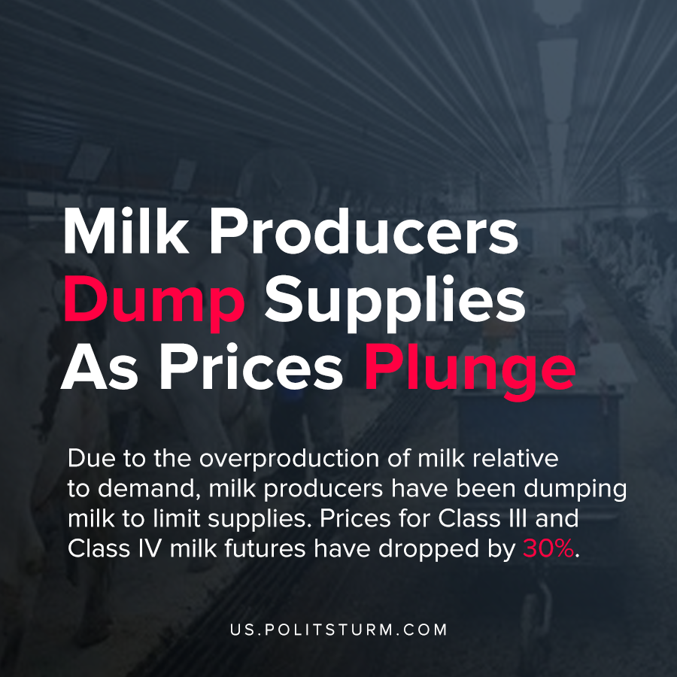

Original article
2020-04-16
1 min read

Due to the overproduction of milk relative to demand, milk producers have been dumping milk to limit supplies. Prices for Class III and Class IV milk futures have dropped by 30%. As a result of the price declines, milk producers are attempting to cut supplies in an attempt to maintain profitability in exchange.
Some of the largest dairy cooperatives and processors are requesting that their members dump their milk on the farm. As of right now, some of the producers are requesting supply decreases of up to 20%.
The United States Department of Agriculture (USDA) has announced new flexibilities to allow for milk to be dumped by producers. The dumped milk is priced through a mechanism by which revenues from milk producers are pooled together, and revenue is received even for milk which is dumped and completely worthless.
During a crisis of overproduction, commodities are overproduced relative to the demand. Under the capitalist economic system, producers destroy their commodities in order to reduce the supply in an attempt to restore profitability.
While there is increasing unemployment and workers need food, milk producers are dumping their supplies at the same time. It is readily apparent that the capitalist system is concerned with the generation of profits. Under the capitalist system, production is “efficient” to the extent that profits can be siphoned to a class of oligarchs, even if it means tremendous waste and suffering to the workers.
https://www.fb.org/market-intel/how-pooling-of-dumped-milk-works

Original article

