Military Equipment Sales to Foreign Governments Up 62%
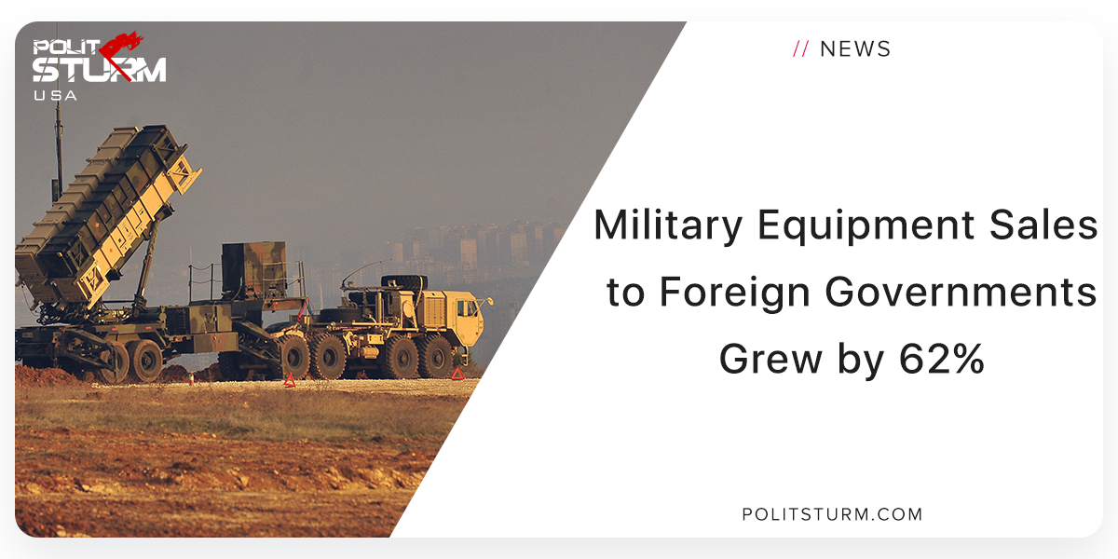

Original article
2018-10-20
1 min read

The U.S sold over $54 billion in military equipment to foreign governments in the last fiscal year ending September 30th, 2018. Department of Defense Comptroller David Norquist stated that this represents an increase of 62%.
When asked whether this robust military spending is increasing production in the U.S industrial economy Norquist stated that “We haven’t seen that so far.”
The U.S manufacturing sector has less real output in the second quarter of 2018 than it did in Q4 2007. The long-term goals of U.S policy are not rooted in the interests that the mass of working people have, nor the optimal production for human need. Rather, it is rooted in imperialism which is a highly developed form of capitalism.
The industrial production in the U.S, albeit while at a highpoint in the current industrial cycle, cannot even produce more real output than it did in 2007. Capitalism sacrifices the growth of the economy and the increased standard of living for the mass of people. Industrial production has been on a long-term decline in the imperialist countries whereas parasitical finance capital has grown in significance.
At the same time a small number of capitalists, the bourgeoisie, are able to profit off the exploitation of the workers. The monopoly profits of the imperialist countries allow the bourgeoisie to bribe the upper strata of the workers thus fostering opportunism.
The sale of military to foreign governments is necessary for the U.S to stunt the economic development of other countries and maintain global hegemony. The actions of the U.S government represent the imperialist interests of the bourgeoisie and not the working class.
https://www.marxists.org/archive/lenin/works/1916/imp-hsc/ch08.htm
Sources: 1 2 3

Original article

