Indian Migrant Laborer Killed in Italy By His Employer
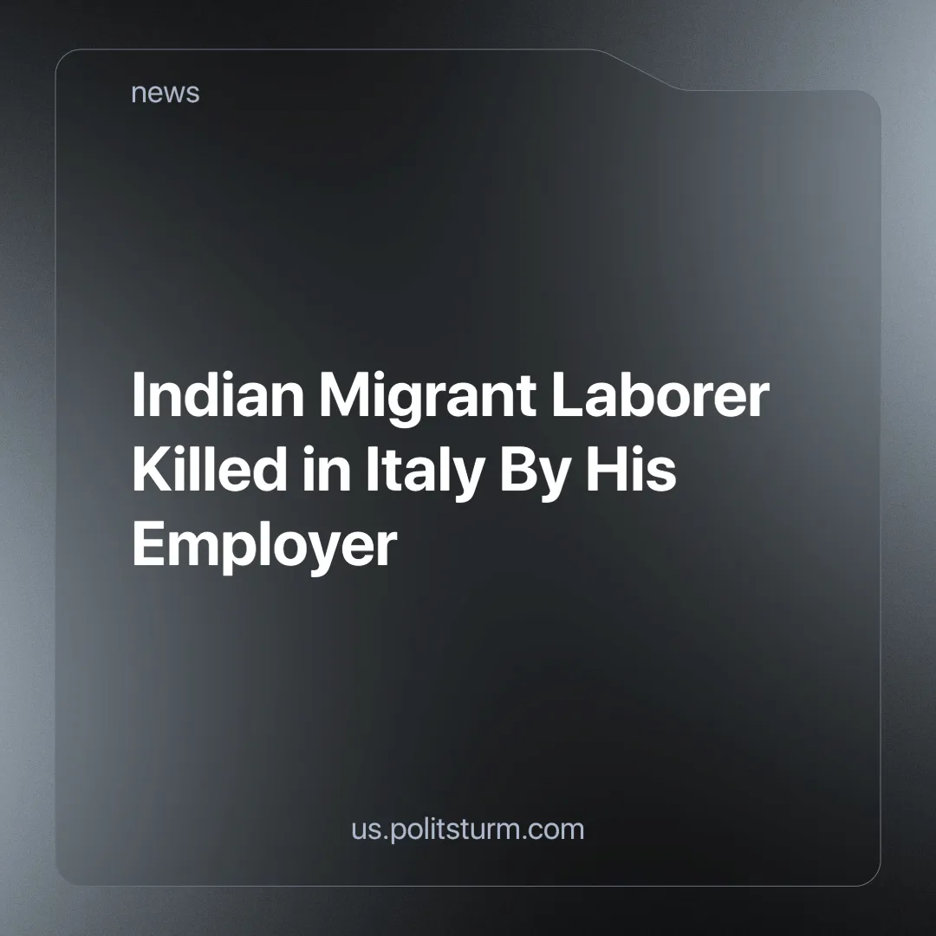

Original article
2024-07-18
3 min read

An Indian farm laborer died in Italy after being left on the side of the road by his employer following a work accident in which he suffered the amputation of an arm and severe leg injuries.
Satnam Singh was working in a vegetable field in the Lazio region of Italy when he was injured by a farm machine. Antonello Lovato, his employer, loaded him into a van with his wife and abandoned him near their home with his amputated arm in a fruit box. Medical help arrived only an hour and a half later, and Singh died in the hospital. The employer is now under investigation for criminal negligence and manslaughter. Singh had been living and working in Italy as an undocumented migrant for about two years [1] [2].
The basis of capitalism is the separation between labor and capital — capitalists regard workers solely as appendages of the machine, a means of making profit. The value of labor power on the market is not set by the workers themselves but is formed in accordance with the laws of capitalist exchange.
According to the Ministry of Labor and Social Policy report published in 2022, foreign workers make up a significant part of the Italian workforce. In 2021, about 10% of workers in Italy were foreigners, mainly from Romania, Albania, Morocco, China and Ukraine. The employment rate of foreigners was 60.6%, slightly higher than that of Italians (60.1%). The main sectors in which they are employed include agriculture, construction, domestic services, catering and manufacturing. 16% of foreign workers are between the ages of 13 and 18 [3][4].
According to Physicians for Human Rights (MEDU), thousands of foreign agricultural workers in Italy live and work in conditions of severe exploitation [5]. INAIL (National Institute for Insurance against Accidents at Work) data show that in 2021, reported accidents by foreign workers accounted for about 17% of the total, with an increase in fatal cases compared to previous years [6][7].
Singh's situation falls under the illegal recruitment system known as “caporalato,” an extreme example of labor dispossession in which workers are treated more as animals rather than humans - in essentially a system of modern slavery. Foreign workers in the agriculture sector, the one to which Singh also belonged, receive payment below minimum wages, often under 5 euros per hour, as opposed to the 9-10 euros stipulated by national contracts. It is also worth noticing that Antonello Lovato's father, Renzo, has been under investigation since 2019 for crimes of “caporalato” and labor exploitation.
Foreign workers, like poor Italian workers, are forced to work in precarious conditions in order not to lose the minimum wage they receive and to avoid poverty due to debt servitude. Their vulnerability is greater because of their lack of knowledge of local language and culture, making them easier to exploit and less likely to unite in solidarity with Italian workers, thus making their labor force more convenient for employers.
However, in response to the death of Satnam Singh, the CGIL union strikes show that despite the efforts of capital, workers can unite to defend their class interests. The general strike saw a strong membership, with high percentages in various enterprises, due to the unsatisfactory responses of the counterparts on wage demands [8].
Singh, like many other workers in the “caporalato” system, was forced to work for extremely low wages, well below the legal level, while the product of his labor was appropriated by his employer. This exploitation is accentuated by his status as an irregular migrant, making him easily blackmailed and without legal rights.
The private owners of the means of production not only appropriate the product of the labor of the working class, but are also ready to cause casualties in order to make profits, they are ready to appropriate the product necessary for the decent life of the worker, his family and the reproduction of the very same class of laborers he relies upon for profit.
Finally, Politsturm expresses its deepest sympathy to all workers victimized by their degraded conditions, whose lives have been tragically cut short by greed and negligence. It is time to recognize that their lives and well-being are being systematically sacrificed for profit. The only way to change this situation is to unite in a single organization that will represent the interests of the workers to raise the political consciousness of the masses - this organization is a Communist Party. Join us
Sources:
- rainews.it - “Morte di Satnam Singh, arrestato il datore di lavoro Antonello Lovato. Gip: “Condotta disumana”” dated July 2, 2024;
- bbc.com - “Farm labourer dies in Italy after arm severed by machine” dated June 20, 2024;
- lavoro.gov.it - “Pubblicato il XIII Rapporto “Gli stranieri nel mercato del lavoro in Italia” del MLPS” dated August 2, 2023;
- lavoro.gov.it - “XIII RAPPORTO ANNUALE Gli stranieri nel mercato del lavoro in Italia”;
- costituzionalismo.it - “Sfruttamento lavorativo e caporalato in Italia: la profughizzazione del lavoro in agricoltura e il caso dei braccianti indiani dell’Agro Pontino”;
- demografica.adnkronos.com - “Tragedia di Casteldaccia, quante sono le morti sul lavoro in Italia e in Europa?” dated May 7, 2024;
- avvenire.it - “La guerra persa. Lavoro, 1.467 morti nel 2023. Per gli stranieri il rischio è doppio” dated January 8, 2024;
- flai.it - “Cooperazione Agricola: forte adesione allo sciopero per il rinnovo del Ccnl” dated July 1st, 2024.

Original article

