Michigan Heavy Machinery Operators Announce Strike
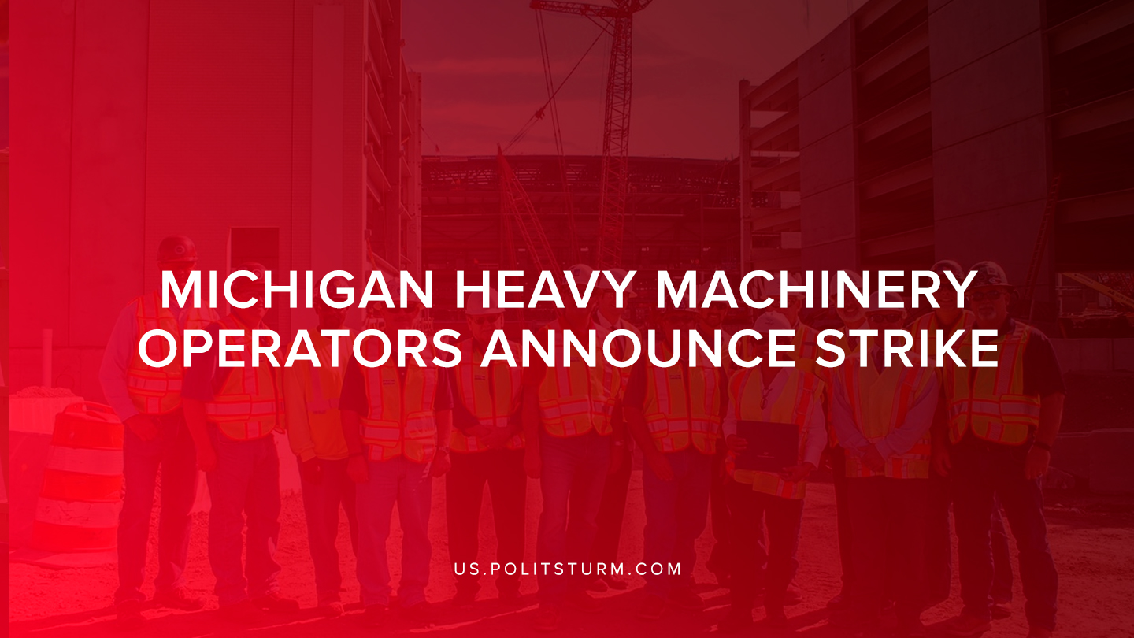

Original article
2019-08-11
1 min read

Michigan heavy-machinery workers who are part of the Operating Engineers 324 union announced that they will be striking over unfair labor practices. The union announced that Indiana-based contractor Rieth-Riley Construction has treated its workers so poorly that they have no other options than to strike.
Rieth-Riley operates construction crews across the state of Michigan, as well as 13 facilities that produce asphalt for the company and other contractors.
The union stated that the company locked out its workers and stranded them at several locations across the state of Michigan.
The company has also been accused of docking workers wages to take back money that was paid to them in 2018. In addition, the company has denied unemployment benefits to workers affected by the lockout.
Rieth-Riley’s standard of conduct entails being honest and open and treating our customers, vendors and employees with respect and equality. The company also claims to be “100% employee owned”.
The announced strike reveals the irreconcilable class differences between the working class and the capitalist class. Despite the company being “100% employee owned” the union alleges that the company is undoubtedly exploiting workers and treating them poorly.
Employee Stock Ownership Plans (ESOP) are programs through which the capitalist class attempts to align the interests of capital with labor. WIth the appreciation in the price of company stock the workers are supposed to have the same interests as capital: in the increased exploitation of the working class.
The strike demonstrates that the bourgeois attempts to reconcile the interests of labor and capital are untenable and impossible. The class struggle between the proletariat and the capitalist classes is ever present and will exist as long as society is divided into classes. Only through a proper understanding of Marxist-Leninist theory can one expose the lies and falsities presented by the bourgeois class and the myth of reconciliation of class differences.
Sources: 1, 2

Original article

